PROFORMA FOR ANNUAL REPORT 2016 (April 2016 to March 2017)

1. GENERAL INFORMATION ABOUT THE KVK

1.1. Name and address of KVK with phone, fax and e-mail

Address | Telephone |  | E mail
 | Office | FAX
Darjeeling KVK  Uttar Banga Krishi Viswavidyalaya  Kalimpong, Darjeeling, West Bengal - 734301 | 03552 256283 | 03552 256283 | djkvk@yahoo.com  djkvk93@gmail.com

1.2 .Name and address of host organization with phone, fax and e-mail

Address | Telephone |  | E mail
 | Office | FAX
Dr. Satyan Chandra Sarkar  Uttar Banga Krishi Viswavidyalaya  P.O Pundibari, Cooch Behar | 03582-270141/986 | 03582-270249/986 | dee_ubkv@gmail.com

1.3. Name of the Programme Coordinator with phone & mobile No.

Name | Telephone / Contact
 | Residence | Mobile | Email
Dr. Mendel Wangchuk Moktan |  | 9635105595 | mendelmw@gmail.com

1.4. Year of sanction of KVK: 1993

1.5. Staff Position (as on 1st April, 2017)

Sl.  No. | Sanctioned post | Name of the incumbent | Designation | Discipline | Pay  Scale with present basic | Date of joining | Permanent  /Temporary | Category (SC/ST/  OBC/  Others)
1 | Senior Scientist- cum- Head | Dr. Mendel Wangchuk Moktan | Senior Scientist- cum- Head | Agril. Extension | PB-4  47800 | 10.12.2001 | Permanent | ST
2 | Subject Matter  Specialist | Dr. Rakesh Roy | SMS | Animal Science | PB-3  30440 | 29.06.2010 | Permanent | SC
3 | Subject Matter  Specialist | Miss Akriti Pradhan | SMS | Home Science | PB – 3  21630 | 14/07/2014 | Permanent | OBC
4 | Subject Matter  Specialist | Dr. Pranab Barma | SMS | Plant Protection | PB – 3  21630 | 21/07/2014 | Permanent | SC
5 | Subject Matter  Specialist | Mrs. Snehlata Lama | SMS | Horticulture | PB – 3  21630 | 25/11/2014 | Permanent | ST
6 | Subject Matter  Specialist | Vacant | SMS | Soil Science
7 | Subject Matter  Specialist | Vacant | SMS | Agril Extension
8 | Computer  Programmer | Sri. Subrata Manna | Programme Assistant (Comp) | M.C.A | PB – 2  18870 | 30.01.2006 | Permanent | OBC
9 | Programme Assistant | Dr. Basu Deo Kharga | Programme Assistant (Training) | Agril. Extension | PB-2  18320 | 20.06.2007 | Permanent | General
10 | Farm Manager | Akash Deep Thapa | Farm Manager | Agril. Extension | PB-2  18320 | 02.07.2007 | Permanent | OBC
11 | Assistant | Dinesh Kr.Diyali | Assistant | M.com. | PB – 2  18870 | 30.01.2006 | Permanent | SC
12 | Stenographer | Vacant
13 | Driver | Ashok Tamang | Driver | HS | PB – 1  10730 | 12.09.2007 | Permanent | ST
14 | Driver | Harish Kr.Chhetri | Driver | HS | PB – 1  10730 | 13.09.2007 | Permanent | General
15 | Supporting staff | Mrs. Mingma Lhamu Lama | Supporting staff | HS | PB-1  7210 | 31/10/2014 | Permanent | ST
16 | Supporting staff | Sri Sandeep Thapa | Supporting staff | B.A. | PB-1  7210 | 03/11/2014 | Permanent | OBC

1.6. Total land with KVK (in ha) : 22 ha

S. No. | Item | Area (ha)
1 | Under Buildings | 0.25
2. | Under Demonstration Units | 1.00
3. | Under Crops | 2.50
4. | Orchard/Agro-forestry | 1.88
5. | Others with details | 16.77
 | Total | 22.4

Total area should be matched with breakup

1.7. Infrastructure Development:

A) Buildings and others

S. No. | Name of infrastructure | Not yet started | Completed up to plinth level | Completed up to lintel level | Completed up to roof level | Totally completed | Plinth area (sq.m) | Under use or not* | Source of funding
1. | Administrative  Building |  |  |  |  | April 2004 | 293 | Yes | ICAR
2. | Farmers Hostel |  |  |  |  | 31/03/2006 | 293 | Yes | ICAR
3. | Staff Quarters (6) |  |  |  |  | 31/03/2009 | 400 | 4 out of 6 | ICAR
4. | Piggery unit |  |  |  |  | 31/03/2012 | 14 | Yes | RKVY Project
5 | Fencing
6 | Rain Water harvesting structure |  |  |  |  | 31/03/2009 | 75000 L | Yes | ICAR
7 | Threshing floor |  |  |  |  | 31/03/2012 | 400 sq ft | Yes | RKVY Project
8 | Farm godown |  |  |  |  | 31/03/2010 | 800 Sq ft | Yes | ICAR
9. | Dairy unit
10. | Poultry unit |  |  |  |  | 31/03/2012 | 450 Sq ft | Yes | RKVY Project
11. | Goatary unit |  |  |  |  | 31/03/2012 | 120 Sq ft | Yes | RKVY Project
12. | Mushroom Lab
13. | Mushroom production unit | Under construction
14. | Shade house |  |  |  |  | 31/03/2012 | 800 Sq ft | No | RKVY Project
15. | Soil test Lab |  |  |  |  | University’s building | 180 Sq ft | Yes | University
16 | Others, Please Specify |  |  |  |  | 31/03/2012 | 300 sq ft | No | RKVY Project
 |  |  |  |  |  | April 2004 | 293 | Yes | ICAR
 |  |  |  |  |  | 31/03/2006 | 293 | Yes | ICAR
* If not in use then since when and reason for non-use

B) Vehicles
Type of vehicle | Year of purchase | Cost (Rs.) | Total km. Run | Present status
Mahendra Max (4 wheel drive) | 2006 | 5.0 lacks | 1,79,519 | Poor

C) Equipment & AV aids

Name of equipment | Year of purchase | Cost (Rs.) | Present status | Source of fund
a. Lab equipment
Spectrophotometer |  | 0.60 |  | ICAR
Flame Photometer |  | 0.50 |  | ICAR
PH Meter |  | 0.10 |  | ICAR
Conductivity bridge |  | 0.10 |  | ICAR
Physical balance |  | 0.10 |  | ICAR
Chemical balance |  | 1.00 |  | ICAR
Digestion unit |  |  |  | ICAR
Kjeldhal Distillation set |  | 0.60 |  | ICAR
Mechanical shaker |  | 0.50 |  | ICAR
Refrigerator |  | 0.20 |  | ICAR
Hot air oven |  | 0.15 |  | ICAR
Hot plate |  | 0.25 |  | ICAR
Grinder |  | 0.30 |  | ICAR
Water distillation unit (double) |  | 1.00 |  | ICAR
Chemical and Glass wares |  | 2.50 |  | ICAR
Soxlet Apparatus (Big &Small) |  | 0.50 |  | ICAR
Laboratory set up |  | 3.30 |  | ICAR
Soil and plant sample processing and storage facility |  | 0.50 |  | ICAR
b. Farm machinery
Power tiller | (2 nos) one from RRS, Hill Zone & another from Khoribari | One is in working condition another working but need some repairing
Rotary power tiller | 2011 | 68500 | working | RKVY
Weed cutter | 2011 | 32800 | Working | RKVY
Mobile sprayer | 2011 | 32600 | Working | RKVY
Rocker sprayer | 2011 | 4800 | Working | RKVY
Branch cutter | 2011 | 61000 (2nos) | Working | RKVY
Paddy cutter | 2011 | 36000 | working | RKVY
Weigh machine | 2011 | 16640(2nos) | Working | RKVY
P.A. System | 2011 | 2860 | working | RKVY
C. AV Aids
Over Head Projector | 1995 | 9042 | Not good
Television | 2004 | 13500 | Good
DVD | 2006 | 4050 | Good
Camera | 1994 | 2350 | Not good
Digital Camera Sony F217 | 2004 | 64990 | Not good
LCD Projector | 2008 | 78000 | Good
LCD Projector | 2009 | 56000 | Not Good
Nikon SLR Camera | 2009 | 30000 | Not Good
Handy Cam | 2009 | 25000 | Not Good
Laptop | 2009 | 30000 | outdated
Laptop | 2011 | 30000 | Not Good
Netbook | 2011 | 25000 | Not Good
Ahuja Sound system for Conference Hall |  |  | Not Good
Canon Photo copier |  |  | Good
FAX Machine |  |  | Good
Laptop | 2011 | 44780 | Working
Desktop | 2011 | 40980 | Not Working
LCD Projector | 2011 | 54000 | Working
Printer | 2011 | 10900 | Not Working
UPS | 2011 | 1750 | Not working

D) Farm implements

Name of equipment | Year of purchase | Cost (Rs.) | Present status | Source of fund
Maize Sheller | 2011 | 1500 (10 pcs) | Working | ICAR
Secateurs | 2011 | 2100 (6pcs) | Working | RKVY
Tree pruner | 2011 | 1645 (1pc) | Working | RKVY
Hedge shear | 2011 | 1000 (1pc) | Working | RKVY
Pruning saw | 2011 | 400 (2pcs) | Working | RKVY
Garden tools | 2011 | 1200 (3 pcs) | Working | RKVY
Spade | 2011 | 3750 (12 pcs) | Working | RKVY
Rake | 2011 | 1344 (6 pcs) | Working | RKVY
Khurpa | 2011 | 900 (8 pcs) | Working | RKVY
Datri | 2011 | 375 (3pcs) | Working | RKVY
Knapsack sprayer | 2011 | 5100 (2 pcs) | Working | RKVY
Turmeric cutter machine | 2016 | 14000 ( 1 Pcs) | Working | TSP
Honey Extractor | 2016 | 6600 (2 pcs) | Working | TSP
Bee Hives | 2016 | 5400 ( 3 Pcs) | Working | TSP

1.8. Details SAC meeting* conducted in the year

Sl.No. | Date | Number of Participants | Salient Recommendations | Action taken | If not conducted, state reason
1.
* Salient recommendation of SAC in bullet form
Attach a copy of SAC proceedings along with list of participants

2.a. District level data on agriculture, livestock and farming situation (2016-17)

Sl. no. | Item | Information
1 | Major Farming system/enterprise | Hill and mountain farming system with horticulture base crop enterprise
2 | Agro-climatic Zone
 | Hill Zone | - Sloppy land – high soil erosion, shallow depth  - Acidity problem  - Low soil fertility – due to NPK and micro nutrient  - Low Nitrogen release from organic matter due to soil acidity and low temperature
 | Tarai Zone | - High leaching loss of nutrient due to light texture soil  - Low availability of P due to soil acidity  - Bo and Mo deficiency
3 | Agro ecological situation | - Due to sub-humid climate organic matter content moderate to high (2%) but decrease with depth  - The eastern Himalayan region acidic to neutral range pH found
4 | Soil type
 | Brown forest soil | - Slow release nutrients from organic matter due to acidity and low temperature  - Micro nutrient deficiency  - Leaching loss of nutrients due to high rainfall
5 | Productivity of major 2-3 crops under cereals, pulses, oilseeds, vegetables, fruits and others | Crop | Productivity (q/ha)
 |  | Rice | 16.98
 |  | Wheat | 13.18
 |  | Maize | 20.42
 |  | Gram | 10.65
 |  | Other Pulses | 6.19
 |  | Mustard | 3.01
 |  | Linseed | 2.05
 |  | Potato | 164.40
 |  | Tea | 18.89
 |  | Chilli (dry) | 7.5
 |  | Ginger | 35
 |  | Mandarin Orange | 92
 |  | Tomato | 160.79
 |  | Cabbage | 340.21
 |  | Cauliflower | 343.55
 |  | Radish | 135.04
 |  | Gladiolus | 146733 spikes
6 | Mean yearly temperature, rainfall, humidity of the district | Month Rainfall (mm) Temperature ⁰ C Relative Humidity (%)  Maximum Minimum  April 16 9.4 22.7 22.2 82  May 16 20.1 23.3 22.5 95  June 16 214.5 22.4 18.6 92  July 16 318.5 23.7 21.4 91  Aug 16 331.0 21.6 20.3 88  Sept 16 237.0 20.6 19.3 82  Oct 16 35.0 16.4 16.3 76  Nov 16 7.4 15.4 15.6 72  Dec 16 0 12.5 7.1 61  Jan 17 0 11.5 7.4 60  Feb 17 8.0 12.8 9.7 67  Mar 17 23.7 17.6 14.8 75
7 | Production of major livestock products like milk, egg, meat etc. | Category |  | Population
 |  | Cattle
 |  | Crossbred |  | 277057
 |  | Indigenous
 |  | Buffalo |  | 5520
 |  | Sheep
 |  | Crossbred |  | 2649
 |  | Indigenous
 |  | Goats |  | 187975
 |  | Pigs |  | 53875
 |  | Crossbred
 |  | Indigenous
 |  | Rabbits
 |  | Poultry |  | 673026
 |  | Hen
 |  | Desi
 |  | Improved
 |  | Duck
 |  | others |  | 71593

2.b. Details of operational area / villages (2016-17)

Sl.  No. | Name of Taluk | Name of the block | Name of the villages | Major crops  & enterprises | Major problems identified (crop-wise) | Identified Thrust Areas
1 | Kalimpong | Kalimpong I | Bong Busty | Paddy, Vegetables, Maize, Ginger | Ginger Rhizome rot, low productivity of paddy and vegetables | Rhizome rot disease of ginger
2 |  | Kalimpong II | Bidyang | Large Cardamom, Maize Potato Vegetables | Blight in Large cardamom, potato, low market price for vegetables | Blight in Large cardamom
3 |  | Algarah | Sangsey | Ginger, Maize, Vegetables, Darjeeling Orange | Fruit drop in orange, Rhizome rot in ginger | Fruit drop in orange, Rhizome rot in ginger
4 |  | Mirik | Chenga Pani | Ginger, Maize, Vegetables, Animal Husbandary, Black pepper & Betal Nut | Fruit drop of Betal Nut, Rhizome rot in ginger | Fruit drop of Betal Nut, Rhizome rot in ginger
5 | Kurseong | Mirik | Sittong | Ginger, Darjeeling Orange, Vegetables | Rhizome rot in ginger, fruit drop and trunk borer in orange and low market rate for vegetables | Fruit drop in orange, Rhizome rot in ginger
8 | Siliguri | Phansidewa | Phansidewa | Animal husbandry | Diseases Problem | Vaccination

2. c. Details of village adoption programme:

Name of the villages adopted by PC and SMS in 2016-17) for its development and action plan

Name of village | Block | Action taken for development
Bidyang | Kalimpong II | Training, Demonstration, OFT, Field day
Sangsey | Kalimpong II
Sittong | Kurseong
Chenga | Mirik
Bong Busty | Kalimpong I

2. d. Sansad Adarsh Gram Yojona

- Name of the village under Sansad Adarsha Gram Yojona: Hatighisa, Siliguri

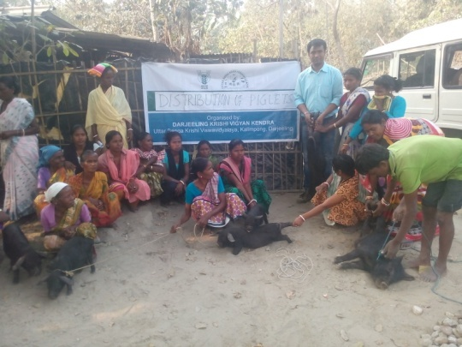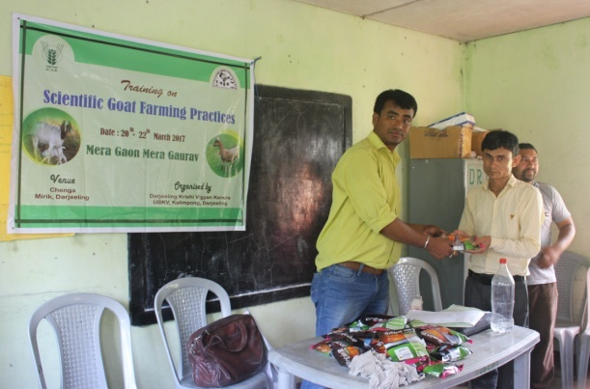

- Contribution of KVK in the programme:

Swacha Bharat Abhiyan, PPV&FRA, Pradhan Mantri Fasal Beema Yozana, Training and Demonstration.

2.1 Priority thrust areas

S. No | Thrust area
1. | Management of declination of Darjeeling Mandarin orange.
2. | Mulching in Citrus orchard (to conserve soil moisture).
3. | Management of Gerbera (cut flowers) & Marigold
4. | Production management of Rice.
5. | Production management of Potato.
6. | Promotion of I.P.M. in Rice and Potato.
7. | Introduction of off season vegetables under plastic house.
8. | Socio-Economic empowerment of women through Preservation, Mushroom production, Backyard Poultry and Goatery.
9. | Entrepreneurship development of rural youth through floriculture, small scale piggery and production of vermi compost.
10. | Production & Management of Large Cardamom and Ginger
11. | Production & Management of Maize.

3. TECHNICAL ACHIEVEMENTS

3. A. Details of target and achievement of mandatory activities by KVK during 2016-17

OFT |  |  |  | FLD
Number of OFTs |  | Number of farmers |  | Number of FLDs |  | Number of farmers
Target | Achievement | Target | Achievement | Target | Achievement | Target | Achievement
8 | 6 | 65 | 52 | 8 | 7 | 125 | 112

Training |  |  |  | Extension activities
Number of Courses |  | Number of Participants |  | Number of activities |  | Number of participants
Target | Achievement | Target | Achievement | Target | Achievement | Target | Achievement
70 | 72 | 2500 | 2498 | 30 | 21 | 1575 | 1227

Seed production (q) |  | Planting material (Nos.)
Target | Achievement | Target | Achievement
30 | 33.5 | 5000 | 8659

3.1 Achievements on technologies assessed and refined

OFT-1: Cultivation and study of growth of oyster mushroom on different agricultural waste substrate

1. | Title of On farm Trial | Cultivation and study of growth of oyster mushroom on different agricultural waste substrate
2. | Problem area | Reduced yield of mushroom through traditional practices
3. | Important cause | Use of paddy straw only for growing mushroom
4. | Technology for testing | Use of various agricultural wastes as a substrate for growing mushroom
5. | Existing practise | Use of chemical treated paddy straw for growing mushroom
6. | Objectives | - To know the most potential substrate for mushroom growth and yield  - Minimize usage of chemical for the treatment of substrate  - Modify the traditional practises followed by the farmers
7. | Hypothesis | Farmers are using chemically treated paddy straw alone for growing mushrooms. Therefore, a trial on usage of different substrates and treatment methods is scheduled for a better and safe yield of mushrooms.
8. | Treatment details | Farmers practice- use of chemically treated paddy straw  T₁- Technology assessed- paddy straw + maize  T₂- Technology assessed- paddy straw + saw dust + hot water treatment  T₃- Technology assessed- hot water treated paddy straw
9. | Source of Technology | Department of Plant Science and Biotechnology, Imo State University, P.M.B 2000 Owerri, Nigeria
10 | Critical inputs | Paddy straw, saw dust, mushroom spawn, chemicals
11 | Unit size | 10 (No. of Cylinder)
12 | No. of replications | 4
13 | Unit cost | Rs. 900/-
14 | Total cost | Rs. 3,600/-
15 | Monitoring indicators | Crop yield- quality and quantity of mushroom, its nutrient content could also be assessed
Thematic area:
Problem definition: Reduced yield of mushroom through traditional practices
Technology assessed: Growth of oyster mushroom on different agricultural waste substrate
Table:
Technology option | No. of trials | Yield component |  |  | Disease/ insect pest incidence (%) | Cost of cultivation  (Rs./cylinder) | Gross return (Rs/cylinder) | Net return  (Rs./Cylinder) | B C ratio
 |  | No. of effective bunch | Weight per bunch (g) | Yield of 1st harvest (Kg)
Farmers Practice | 4 | 3 | 150 | 0.5 | 5% | 40 | 60 | 20 | 1.5:1
T1 | 4 | 5 | 200 | 0.75 | 8% | 30 | 90 | 60 | 3:1
T2 | 4 | 3 | 150 | 0.35 | 12% | 30 | 30 | 12 | 1:1
T3 | 4 | 8 | 250 | 1.0 | 5% | 30 | 120 | 90 | 4:1

OFT-2: Assessment of Integrated Nutrient Management of cauliflower (Brassica oleraceae var botrytis) in Darjeeling Hills..

1. | Title of On farm Trial | Integrated Nutrient Management of cauliflower (Brassica oleraceae var botrytis)
2. | Problem area | Decline in yield and poor quality curds
3. | Important cause | Use of only FYM no use of balance chemical fertilizer
4. | Technology for testing | Integrated nutrient management
5. | Existing practice | User of only FYM @ 20 tons per ha
6. | Objectives | To improve the quality of curds and also to increase the yield per ha
7. | Hypothesis | Farmers of Darjeeling district are using only FYM and unaware about the balance dose of fertilizer. So the yield as well as the quality of the curds are low. So an OFT on the Integrated Nutrient Management of cauliflower has been conducted
8. | Treatment details | Farmers’ practice: Application of FYM @20 t/ha  Tech. option I: Application of 50% NPK i.e (75:50:50)(BasalFullP+K+1/2N,30DAS1/4N,60DAS1/4N) +50% FYM ie 5t/ha +Azospirillium @2kg/ha  Tech. option II: Application of 50% NPK i.e (75:50:50) : Application of 50% NPK i.e (75:50:50)+50% FYM ie 5t/ha +Azospirillium @2kg/ha +50% pigmanureie 10t/ha +Azospirillium @2kg/ha  Tech. option III: Application of 50% NPK i.e (75:50:50) : Application of 50% NPK i.e (75:50:50)+50% FYM ie 5t/ha +Azospirillium @2kg/ha +50% pigmanureie 10t/ha +Azospirillium @2kg/ha
9. | Source of Technology | Nagaland University, Medziphema
10 | Critical inputs | FYM, Urea, SSP, MOP, Azospirillium, Pig manure
11 | Unit size | 5 Decimal
12 | No. of replications | 4
13 | Unit cost | Rs. 1500/-
14 | Total cost | Rs. 6000/-
15 | Monitoring indicators | Average weight of curds, yield per ha
Thematic area:
Problem definition:
Technology assessed:
Table:
Technology option | No. of trials | Yield component |  |  | Disease/ insect pest incidence (%) | Yield  (Kg/unit) | Cost of cultivation  (Rs./unit) | Gross return (Rs/unit) | Net return  (Rs./Unit) | BC ratio
 |  | No. of effective bunch | Weight per curd (g) | Yield of 1st harvest (Kg)
T1 | 4
T2 | 4
T3 | 4
T4 | 4

Crop is not yet harvested

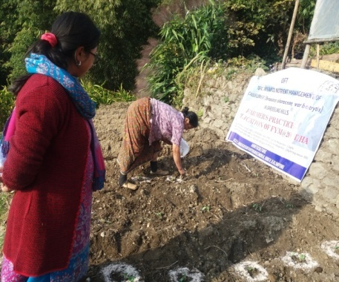
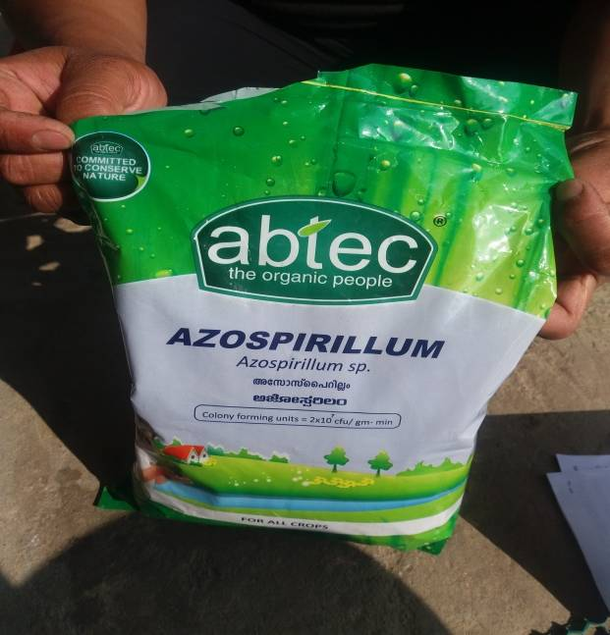
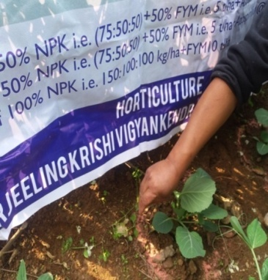
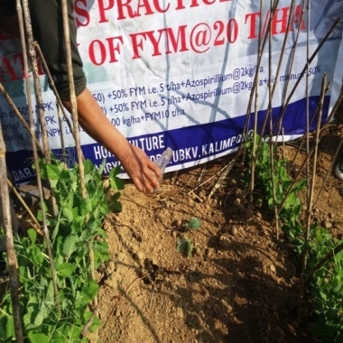
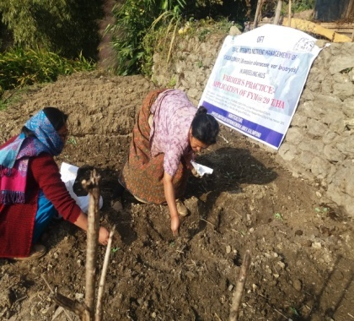

OFT-3: Varietal assessment of potato under Hill Agro-climatic situation

1. | Title of On farm Trial | Varietal assessment of potato under Hill Agro-climatic situation
2. | Problem area | Poor quality potato tuber, low yields.
3. | Important cause | Use of local variety
4. | Technology for testing | Varietal assessment with FYM @ 20tonnes/ha and NPK @ 150:100:150 kg/ha (RDF)
5. | Existing practice | use of local varieties (Darjeeling Red Round) with FYM 15 tonnes/ha
6. | Objectives | To improve the quality of tubers and also to increase the yield per ha
7. | Hypothesis | Farmers of Darjeeling district local variety of poor quality low yield
8. | Treatment details | Farmers’ practice: use of seed tubers (Darjeeling Red Round) with FYM 15 tonnes/ha  Tech. option I: Cultivation of Kufri Himalini with FYM @ 20tonnes/ha and NPK @ 150:100:150 kg/ha (RDF)  Tech. option II: Cultivation of Kufri Kanchanwith FYM @ 20tonnes/ha and NPK @ 150:100:150 kg/ha (RDF)  Tech. option III: Cultivation of Kufri Shailjia with FYM @ 20 tonnes/ha and NPK @ 150:100:150 kg/ha(RDF)
9. | Source of Technology | BCKV
10 | Critical inputs | Seed Tuber, FYM, Urea, SSP, MOP
11 | Unit size | 8
12 | No. of replications | 4
13 | Unit cost | 3,700/-
14 | Total cost | 14,800/-
15 | Monitoring indicators | Average weight of tubers, yield

Thematic area: Vegetable based cropping system.
Technology assessed: Varietal assessment of potato.
Table:
Technology option | No. of trials | Yield component |  | Disease/ insect pest incidence (%) | Total Yield  (q/ha) | Cost of cultivation  (Rs./unit) | Gross return (Rs/unit) | Net return  (Rs./Unit) | BC ratio
 |  | Avg. wt. of tuber (g) | Yield per Unit (Kg)
Farmers practice | 4 | 40.10 | 537 | -- | 167.84 | 3,217 | 4027 | 810 | 1.2:1
T1 | 4 | 111.30 | 774 | -- | 242.88 | 3,700 | 5805 | 2105 | 1.5:1
T2 | 4 | 108.85 | 726 | -- | 227.01 | 3,700 | 5445 | 1745 | 1.4:1
T3 | 4 | 153.64 | 823 | -- | 167.84 | 3,700 | 6172 | 2427 | 1.6:1

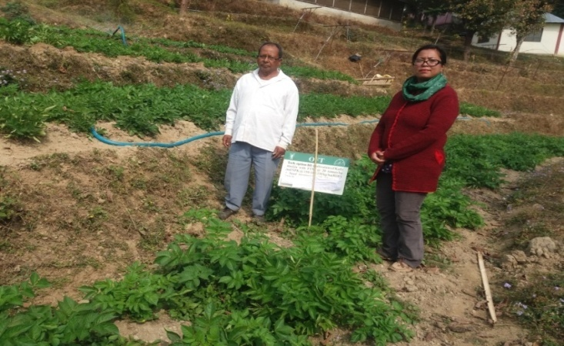
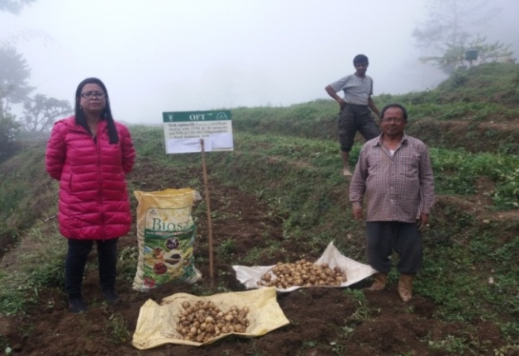

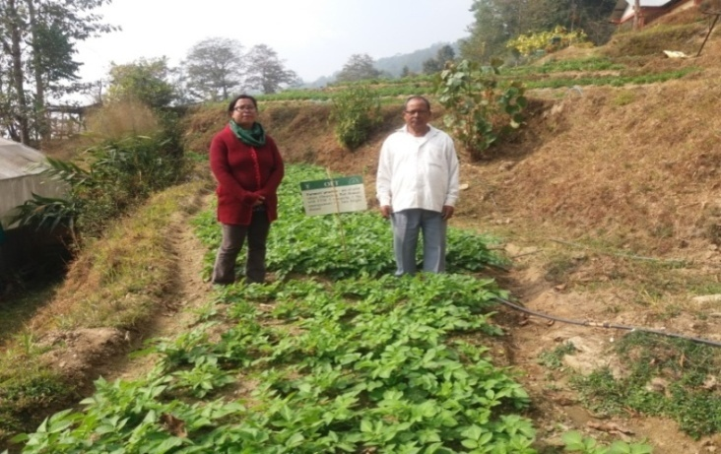
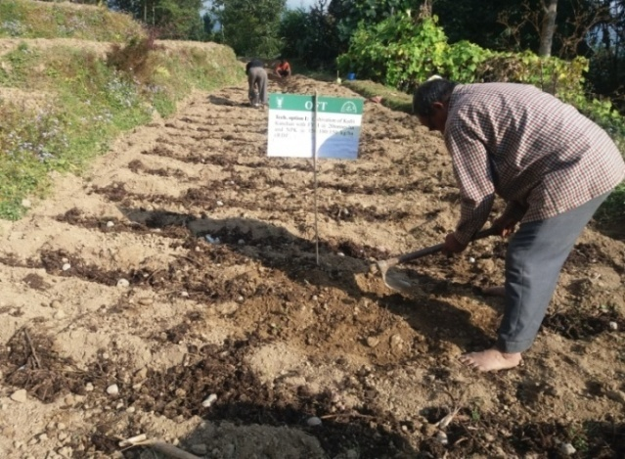

OFT-4: Assessment of Integrated management of rhizome rot in Ginger (Zingiber officinale) grown in Darjeeling Hills.

1. | Title of On farm Trial | Integrated management of rhizome rot of Ginger (Zingiber officinale) grown in Darjeeling Hills.
2. | Problem area | Decline in yield.
3. | Important cause | Rhizome rot complex
4. | Technology for testing | Integrated diseases management
5. | Existing practice | Application of FYM @20 t/ha and no management practices for Rhizome rot diseases complex
6. | Objectives | To reduce the Rhizome rot diseases complex intensity and increase the yield.
7. | Hypothesis | In Darjeeling district the ginger crop is severely affected with Rhizome rot diseases complex and farmers do not aware for the management of this diseases
8. | Treatment details | Farmers’ practice: Application of FYM @20 t/ha  Tech. option I:Rhizome treated with Metalaxil + Mancozeb for 20 minutes and covered with black polythene mulch  Tech. option II:Furrow application of Bleaching powder (2.5 kg/bigha) followed by irrigation + Neem cake + Metalaxil MZ 1 g/l of water in 3 times.  Tech. option III:T. O. I + T. O. II
9. | Source of Technology | BCKV
10 | Critical inputs | Metalaxil + Mancozeb, black polythene, Bleaching powder, Neem cake, Metalaxil MZ
11 | Unit size | 0.05 ha
12 | No. of replications | 2
13 | Unit cost | 2500/-
14 | Total cost | 5000/-
15 | Monitoring indicators | PDI, Yield

Thematic area: Vegetable based cropping system.
Technology assessed:. Management of rhizome rot of Ginger
Table:
Technology option | No. of trials | Yield component |  |  | Disease/ insect pest incidence (%) |  |  | Total Yield  (q/ha) | Cost of cultivation  (Rs./unit) | Gross return (Rs/unit) | Net return  (Rs./Unit) | BC ratio
 |  | Avg. wt. (g) | Weight per curd (g) | Yield per Unit (Kg) | Soft rot |  | Bacterial wilt
Farmers practice | 2 |  |  | 129 | 31.19 | 44.35 |  | 25.90 | 88,433 | 1,34,680 | 46,247 | 1.52
T1 | 2 |  |  | 133 | 24.07 | 32.33 |  | 26.61 | 89,400 | 1,38,355 | 48,954.7 | 1.54
T2 | 2 |  |  | 205 | 9.27 | 13.23 |  | 40.97 | 1,00,185 | 2,13,044 | 1,12,859 | 2.13
T3 | 2 |  |  | 168 | 23.43 | 27.64 |  | 33.64 | 1,04,904 | 1,74,928 | 70,024 | 1.66
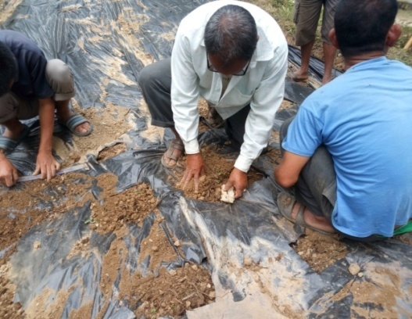
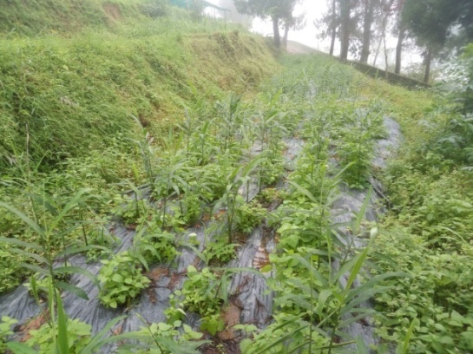
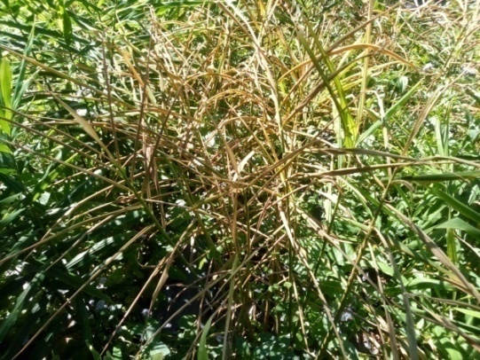
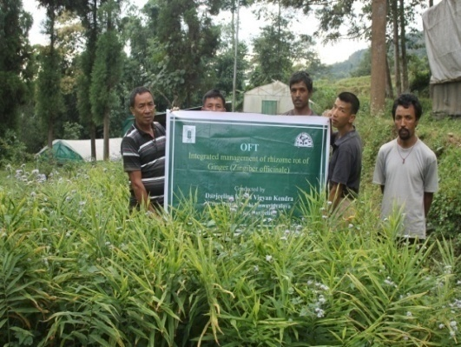

OFT-5: Production performance of Srinidhi poultry breed under backyard poultry farming system in hills.

1. | Title of On farm Trial | Production performance of Srinidhi poultry breed under backyard poultry farming system in hills.
2. | Problem diagnosed | Low production of local poultry under backyard farming
3. | Details of technologies selected for assessment/refinement | Farmers’ practice: Indigenous breed under backyard farming system  Tech. option I: Vanaraja poultry breed under backyard farmingsystem  Tech. option II: Srinidhi poultry breed under backyard farmingsystem
4. | Source of Technology | Project Directorate on Poultry, Hyderabad
5. | Production system and thematic area | Backyard farming system in hills and production performance
6. | Performance of the Technology with performance indicators | Vanaraja shows higher production in terms of both body weight and egg production
7. | Final recommendation for micro level situation | Vanaraja shows higher performance than Srinidhi
8. | Constraints identified and feedback for research | Srinidhi had higher mortality rate than Vanaraja. Sustainability of Srinidhi was found poor for 1stand 2ndyear. Mortality rate of Vanaraja and Srinidhi poultry breeds needs to be done for consecutive 3-5 years.
9. | Process of farmers participation and their reaction | Initial response of the farmers is good on Vanaraja than Srinidhi poultry breed.

Thematic area: Backyard poultry farming system
Problem definition: Low production of local poultry under backyard farming system
Technology assessed: Sustainability and production of Srinidhi Poultry birds under backyard farming system in hill agro climatic zone.

Table: Data on parameter in relation to Technology demonstrated
Technology option | Growth rate  (@8 weeks) |  | Growth rate  (@20 weeks) |  | Growth rate (@40weeks) |  | Egg Production |  | Mortality rate (%) | C:B ratio
 | Male (Mean±SD) | Female (Mean±SD) | Male (Mean±SD) | Female (Mean±SD) | Male (Mean±SD) | Female (Mean±SD) | Sexual Maturity (week) | No. of eggs / hen / annum  (Mean±SD)
Farmers’ practice | 1.29±0.69 | 1.18±0.26 | 2.02±0.35 | 1.76±0.46 | 2.90±0.91 | 2.56±0.12 | 26 | 80.82±25.67 | 15.13 | 1:2.6
Tech. option I | 1.59±0.63 | 1.36±0.77 | 2.61±0.32 | 2.20±0.37 | 3.70±01.07 | 3.02±01.25 | 25 | 133.07±42.36 | 12.10 | 1:4.1
Tech. option II | 1.61±0.21 | 1.32±0.36 | 2.76±0.46 | 2.26±0.96 | 3.76±11.03 | 3.15±01.17 | 23 | 121.82±36.71 | 16.40 | 1:3.2

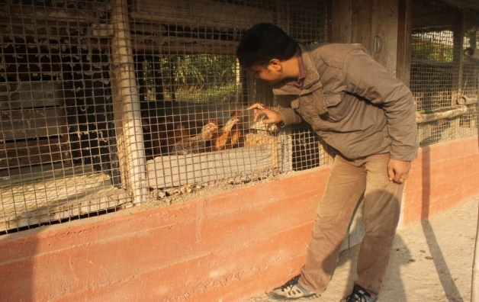
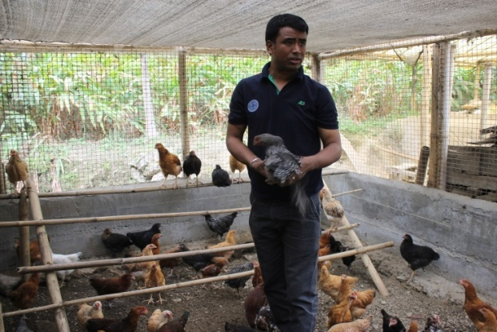
Results: Technology Option II shows early sexual maturity than Technology Option I and Farmers Practice but Technology Option I shows more numbers of egg production per hen per annum and low mortality rate in backyard farming system in hill climatic situation and thereby higher C:B ratio than Technology Option II and Farmers Practice. Therefore, it can be concluded that Technology Option I is better than Technology option II and farmers’ practice.
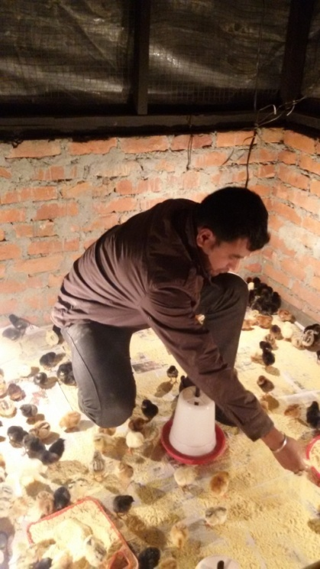
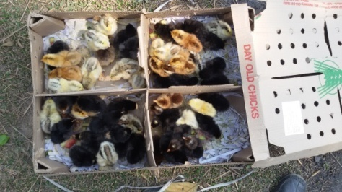
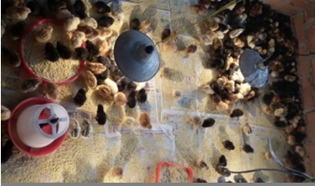
OFT-6: Preparation of low cost feed using local feed ingredients for pig

1. | Title of On farm Trial | Preparation of low cost feed using local feed ingredients for pig
2. | Problem diagnosed | Low growth rate of pig and high mortality of piglet when fed with kitchen waste only under backyard farming system
3. | Details of technologies selected for assessment/refinement | Farmers’ practice: Feeding with kitchen waste only under backyard farming system  Tech. option I: Feeding with commercial feed available at the market  Tech. option II: Feeding of Corn + Oilcake + Vitamin + Minerals  Tech. option III: Tech. option II + Feed additives + antibiotics
4. | Source of Technology | Indian Veterinary Research Institute
5. | Production system and thematic area | Backyard farming system in hills and production performance
6. | Performance of the Technology with performance indicators | Tech. Option III shows higher production in terms of body weight and low mortality rate
7. | Final recommendation for micro level situation | Tech. Option III shows higher production performance which can be taken for frontline demonstration.
8. | Constraints identified and feedback for research | Low knowledge level of the farmers about scientific feeding management practices
9. | Process of farmers participation and their reaction | Active participation by the farmers and response of the farmers was good.
Thematic area: Backyard piggery farming system
Problem definition: Low growth rate of pig and high mortality of piglet when fed with kitchen waste only under backyard farming system
Technology assessed: Preparation of low cost feed using local feed ingredients for pig which will increase growth rate and reduce disease incidence rate and mortality rate.

Table: Data on parameter in relation to Technology demonstrated
Technology option | Growth rate (@3 months) |  | Growth rate (@6 months) |  | Disease incidence (%) | Mortality rate (%) | C:B ratio
 | Male (Mean±SD) | Female (Mean±SD) | Male (Mean±SD) | Female (Mean±SD)
Farmers’ practice | 15.83±8.30 | 13.36±6.71 | 68.17±12.14 | 64.39±13.61 | 22.6 | 13.3 | 1:23
Tech. option I | 20.33±9.05 | 19.41±6.07 | 78.45±11.92 | 73.30±16.10 | 15.1 | 10.2 | 1:2.9
Tech. option II | 21.12±2.32 | 19.15±9.55 | 81.33±14.76 | 77.59±13.13 | 14.4 | 11.5 | 1:3.2
Tech. option III | 22.38±3.72 | 20.58±4.27 | 86.60±18.30 | 79.63±18.18 | 11.7 | 4.5 | 1:3.8

Results: Technology Option III shows increase growth rate and reduce disease incidence rate and mortality rate among other Technology Options and thereby it has higher C:B ratio. Therefore, it can be concluded that Technology Option III is better than the other two options and farmers’ practices. So, it can be recommended to the farmers of this region.
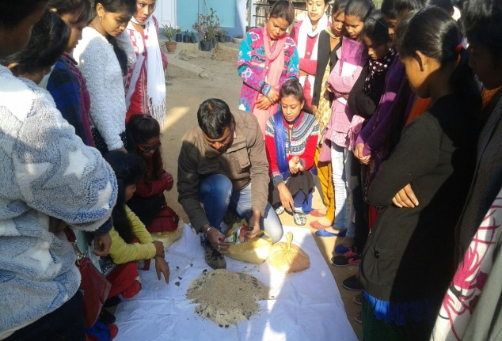
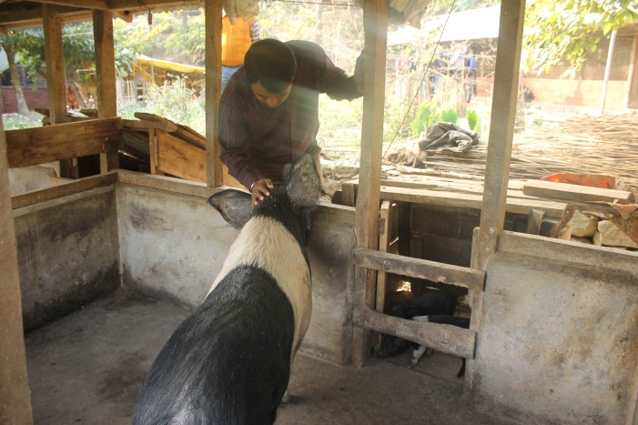

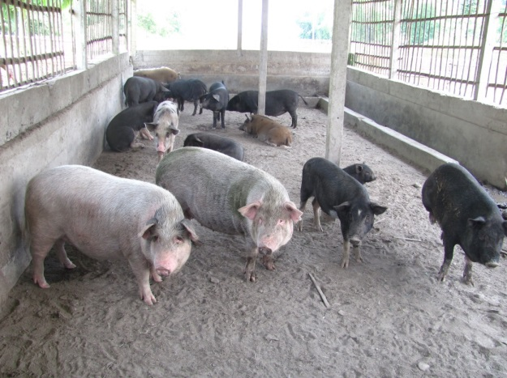
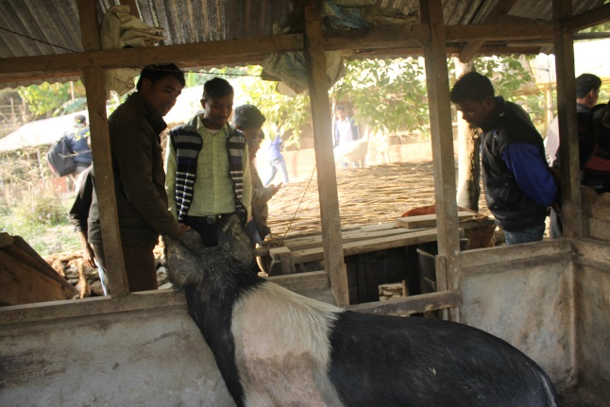

3.2 Achievements of Frontline Demonstrations

A. Details of FLDs conducted during 2016-17

Cereals
Sl.  No. | Crop | Thematic area | Technology Demonstrated with detailed treatments | Area (ha) |  | No. of farmers/  demonstration |  |  | Reasons for shortfall in achievement
 |  |  |  | Proposed | Actual | SC/ST | Others | Total
1. | Darjeeling Mandarin | Crop production | Nutritional Management of Darjeeling Mandarin  NPK300:250:300g/pt B(250g),50%FYM,25%PM | 1 | 1 | 0 | 1 | 1
2. | Kitchen Garden | Nutritional and Food Security | Use of Kitchen waste in Kitchen Garden | 4 Unit each of 100 sq ft | 4 Unit each of 100 sq ft | 1 | 3 | 4
3. | Formulation of Low cost nutrition rich supplements | Nutrition Security of Rural Children | Enhancement and availability of Nutrients | 2 Units each of 20 children | 2 Units each of 20 children | 22 | 18 | 40
4.

Details of farming situation

Crop | Season | Farming situation (RF/Irrigated) | Soil type | Status of soil  (Kg/ha) |  |  | Previous crop | Sowing date | Harvest date | Seasonal rainfall (mm) | No. of rainy days
 |  |  |  | N | P₂O₅ | K₂O
Darjeeling Mandarin | Rabi | Rainfed | Acidic | - | - | - | Perennial | April 16  Oct 16 | January 17 | - | -
Kitchen Garden | Round the year | Irrigated | Acidic | -- | -- | -- | -- | Round the year | Round the year | -- | -

In both the Tables, information of same crop should be provided. For example, if in Table 3.2A crops are mentioned as a,b,c,d etc., in the table for Details of farming situation, the same crop should be mentioned in the identical sequence.

Crop | Thematic area | Name of the technology demonstrated | No. of Farmer | Area  (ha) | Yield (q/ha) |  | *Economics of demonstration (Rs./ha) |  |  |  | *Economics of check  (Rs./ha)
 |  |  |  |  | Demons  ration | Check | Gross  Cost | Gross  Return | Net Return | **  BCR | Gross  Cost | Gross  Return | Net Return | **  BCR
Darjeeling Mandarin | Crop production | Nutritional Management of Darjeeling Mandarin  NPK300:250:300g/pt B(250g),50%FYM,25%PM | 1 | 1 | 370 | 180 | 184149 | 548340 | 364191 | 2.9:1 | 105940 | 266760 | 160820 | 2.5:1
Ginger | Crop protection | Disease management in ginger with Hot water treatment and application of bio agent | 2 | 0.1 | 47.5 | 27.4 | 102450 | 247000 | 144550 | 2.41 | 88433 | 142480 | 54047 | 1.61
Large Cardamom | Crop protection | Management of blight disease of Large Cardamom with 1% Bordeaux mixture | 4 | 0.14 | 4.32 | 3.66 | 60366 | 250260 | 189894 | 4.15 | 57,672 | 212280 | 154608 | 3.68

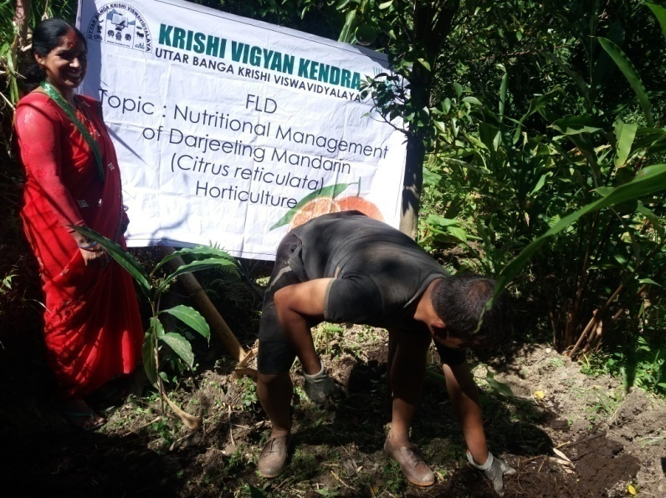
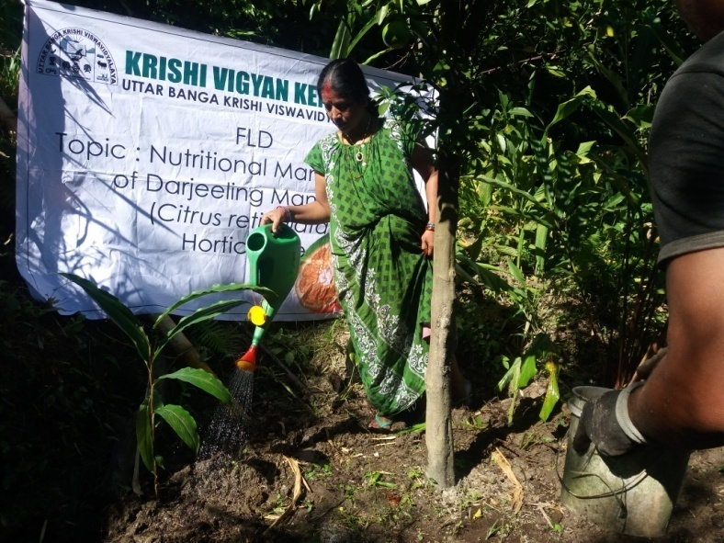

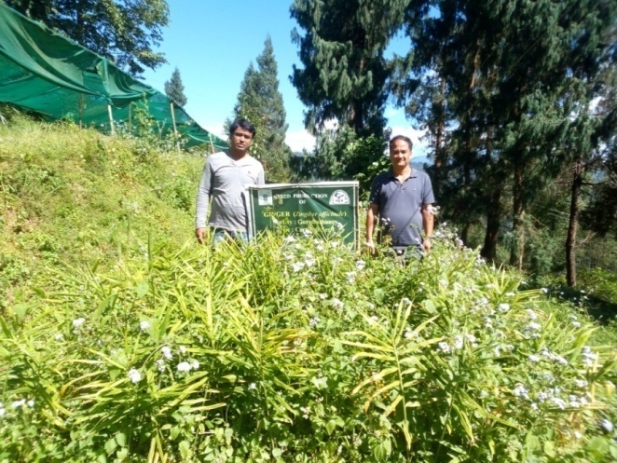
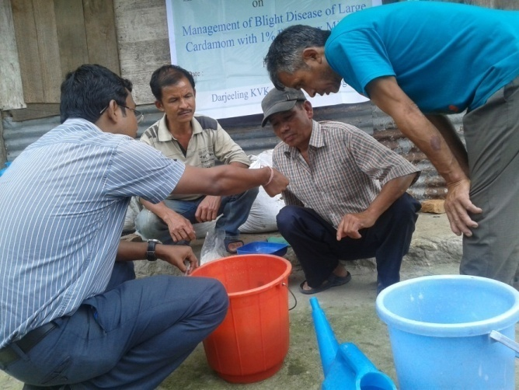
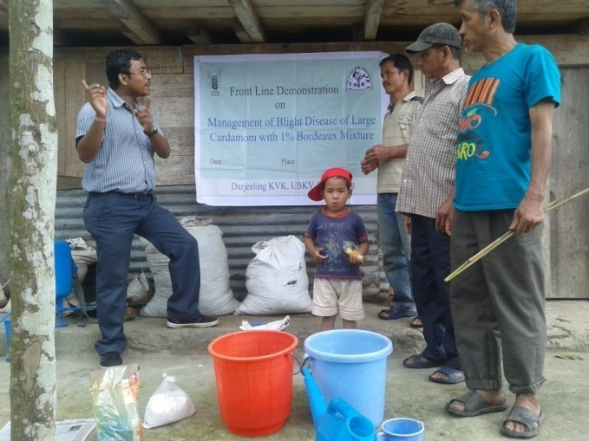

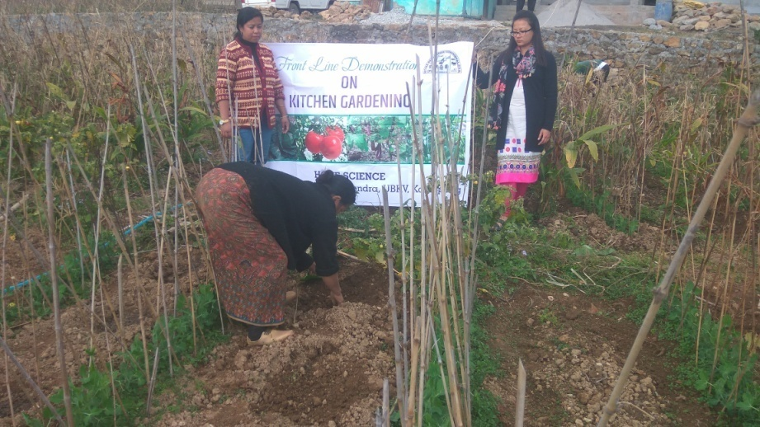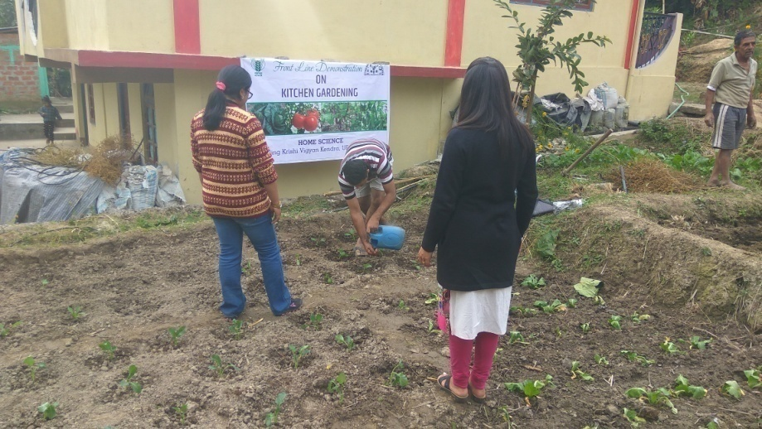

FLD (Home Science)

Beneficiary | Thematic area | Name of the technology demonstrated | No. of children | Area | Weight (Kg)  Initial |  | Weight (Kg)  Final |  | Height (cm)  Initial |  | Height (cm)  Final |  | *Economics of demonstration (Rs./head/month) | *Economics of check  (Rs./head/month)
 |  |  |  |  | Demo | Check | Demo | Check | Demons  ration | Check | Demons  ration | Check
Pre-school children | Nutrition | Formulation of low cost nutrition rich supplements | 40 | 2 | 14.0 | 14.58 | 14.16 | 14.66 | 116.6 | 119.4 | 116.6 | 119.4 | 375/- | 350/-

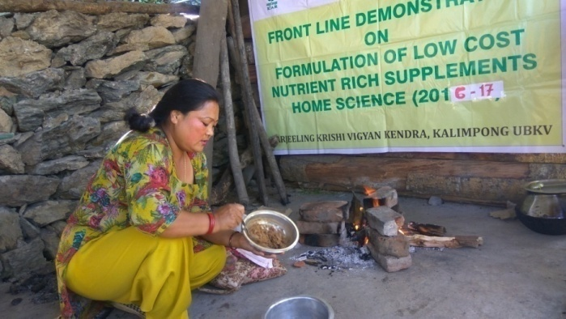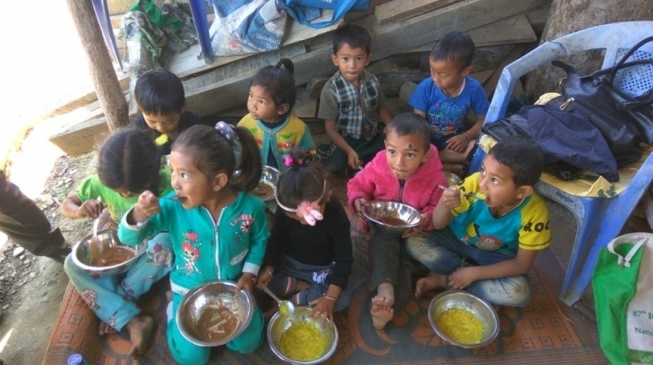

Performance of FLD

Oilseeds:

Frontline demonstrations on oilseed crops

Crop | Thematic Area | Name of the technology demonstrated | No. of Farmers | Area  (ha) | Yield (q/ha) |  | % Increase | *Economics of demonstration (Rs./ha) |  |  |  | *Economics of check  (Rs./ha)
 |  |  |  |  | Demo | Check |  | Gross  Cost | Gross  Return | Net Return | **  BCR | Gross  Cost | Gross  Return | Net Return | **  BCR
Total
* Economics to be worked out based on total cost of production per unit area and not on critical inputs alone.
** BCR= GROSS RETURN/GROSS COST

Pulses
Frontline demonstration on pulse crops
Crop | Thematic Area | Name of the technology demonstrated | No. of Farmers | Area  (ha) | Yield (q/ha) |  | % Increase | *Economics of demonstration (Rs./ha) |  |  |  | *Economics of check  (Rs./ha)
 |  |  |  |  | Demo | Check |  | Gross  Cost | Gross  Return | Net Return | **  BCR | Gross  Cost | Gross  Return | Net Return | **  BCR
 | Total

* Economics to be worked out based on total cost of production per unit area and not on critical inputs alone.
** BCR= GROSS RETURN/GROSS COST

Other crops
Crop | Thematic area | Name of the technology demonstrated | No. of Farmer | Area  (ha) | Yield (q/ha) |  | % change in yield | Other parameters |  | *Economics of demonstration (Rs./ha) |  |  |  | *Economics of check  (Rs./ha)
 |  |  |  |  | Demons  ration | Check |  | Demo | Check | Gross  Cost | Gross  Return | Net Return | **  BCR | Gross  Cost | Gross  Return | Net Return | **  BCR
 | Total

Livestock
Category | Thematic  area | Name of the technology demonstrated | No. of Farmer | No.of units | Major parameters |  | % change in major parameter | Other parameter |  | *Economics of demonstration (Rs.) |  |  |  | *Economics of check  (Rs.)
 |  |  |  |  | Demons  tration | Check |  | Demons  ration | Check | Gross  Cost | Gross  Return | Net Return | **  BCR | Gross  Cost | Gross  Return | Net Return | **  BCR
Dairy
Cow
Buffalo
Poultry | Production performance | Vanaraja | 30 | 30 | Egg production | Egg production | 19 | Weight gain | Weight gain | 6540 | 34700 | 28160 | 1:5.30 | 5560 | 21750 | 16190 | 1:3.91
Rabbitry
Pigerry | Production performance | Hampshire | 30 | 30 | Growth rate | Growth rate | 15 | Litter size | Litter size | 7650 | 15500 | 7850 | 1:2.03 | 6350 | 12200 | 7850 | 1:1.92
* Economics to be worked out based on total cost of production per unit area and not on critical inputs alone.
** BCR= GROSS RETURN/GROSS COST
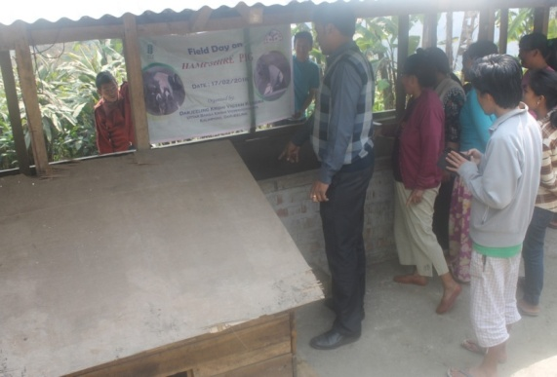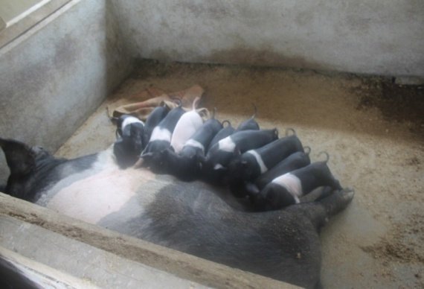

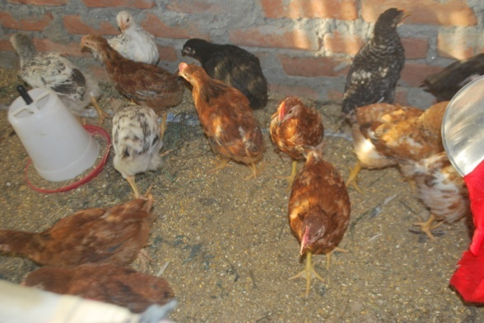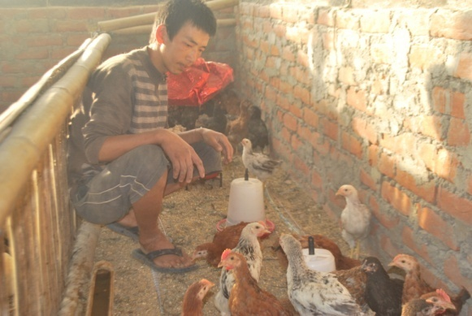

Fisheries
Category | Thematic area |  | Name of the technology demonstrated | No. of Farmer | No.of units | Major parameters |  | % change in major parameter | Other parameter |  | *Economics of demonstration (Rs.) |  |  |  | *Economics of check  (Rs.)
 |  |  |  |  |  | Demons  ration | Check |  | Demons  ration | Check | Gross  Cost | Gross  Return | Net Return | **  BCR | Gross  Cost | Gross  Return | Net Return | **  BCR
Common carps
Mussels
Ornamental fishes
Others (pl.specify)
 |  | Total

* Economics to be worked out based on total cost of production per unit area and not on critical inputs alone.
** BCR= GROSS RETURN/GROSS COST

Other enterprises
Category | Name of the technology demonstrated | No. of Farmer | No.of units | Major parameters |  | % change in major parameter | Other parameter |  | *Economics of demonstration (Rs.) or Rs./unit |  |  |  | *Economics of check  (Rs.) or Rs./unit
 |  |  |  | Demons  ration | Check |  | Demons  ration | Check | Gross  Cost | Gross  Return | Net Return | **  BCR | Gross  Cost | Gross  Return | Net Return | **  BCR
Oyster mushroom | Enterprise development
Button mushroom
Vermicompost
Sericulture
Apiculture
Others (pl.specify)
Total

* Economics to be worked out based on total cost of production per unit area and not on critical inputs alone.
** BCR= GROSS RETURN/GROSS COST

Women empowerment
Category | Name of technology | No. of demonstrations | Observations |  | Remarks
 |  |  | Demonstration | Check
Farm Women | Cultivation of Oyster Mushroom | 6
Pregnant women | Low cost nutritional supplements | 3
Adolescent Girl | Preservation and Value addition | 2
Other women | Kitchen Gardening for nutrition and food security | 4
Children | Nutrition, health and sanitation | 1
Neonatal
Infants | Preparation of low cost Malted Supplements | 2

Farm implements and machinery

Name of the implement | Crop | Name of the technology demonstrated | No. of Farmer | Area (ha) | Filed observation (output/man hour) |  | % change in major parameter | Labor reduction (man days) |  |  |  | Cost reduction (Rs./ha or Rs./Unit)
 |  |  |  |  | Demons  ration | Check
-- | -- | -- | -- | -- | -- | -- | -- | -- | -- | -- | -- | -- | -- | -- | --
* Economics to be worked out based on total cost of production per unit area and not on critical inputs alone.
** BCR= GROSS RETURN/GROSS COST

Demonstration details on crop hybrids
Crop | Name of the Hybrid | No. of  farmers | Area  (ha) | Yield (kg/ha) / major parameter |  |  | Economics (Rs./ha)
Cereals |  |  |  | Demo | Local check | % change | Gross  Cost | Gross  Return | Net  Return | BCR
Bajra
Maize | F7001 | 9 | 0.6 | 26.4 | 20.8 | 21.2 | 21500 | 39600 | 18100 | 1.84
Paddy | PS -5 | 8 | 0.1 | 17.8 | 12.7 | 28.6 | 25334 | 62300 | 36966 | 2.45
Sorghum
Wheat
Others (pl.specify)

Total
Oilseeds
Castor
Mustard
Safflower
Sesame
Sunflower
Groundnut
Soybean
Others (pl.specify)
Total
Pulses
Greengram
Blackgram
Bengalgram
Redgram
Others (pl.specify)

Total
Vegetable crops
Bottle gourd
Capsicum
Cucumber
Tomato
Brinjal
Okra
Onion
Potato
Field bean
Others (pl.specify)

Total
Commercial crops
Cotton
Coconut
Others (pl.specify)

Total
Fodder crops
Napier (Fodder)
Maize (Fodder)
Sorghum (Fodder)
Others (pl.specify)

Total

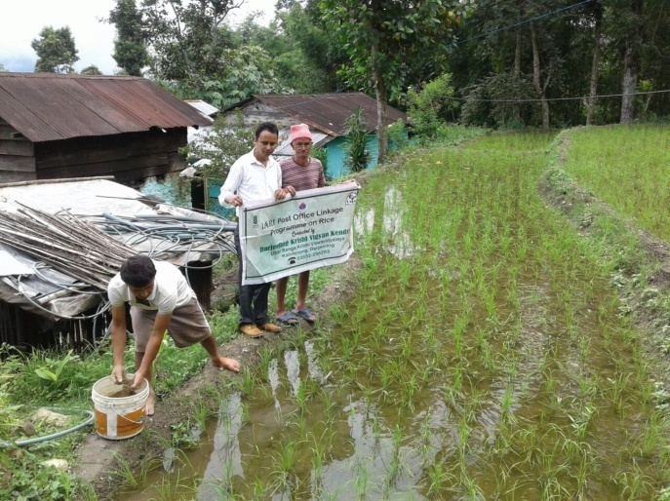
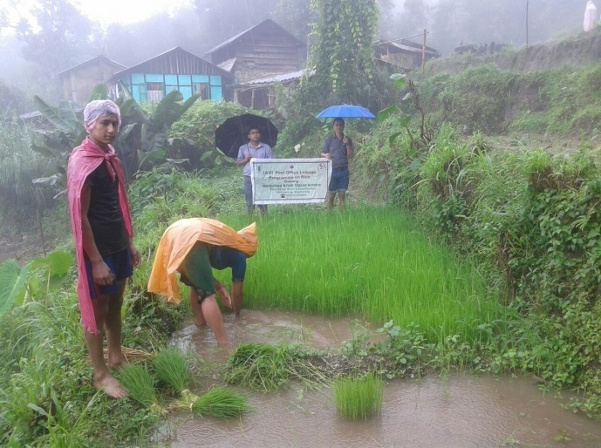
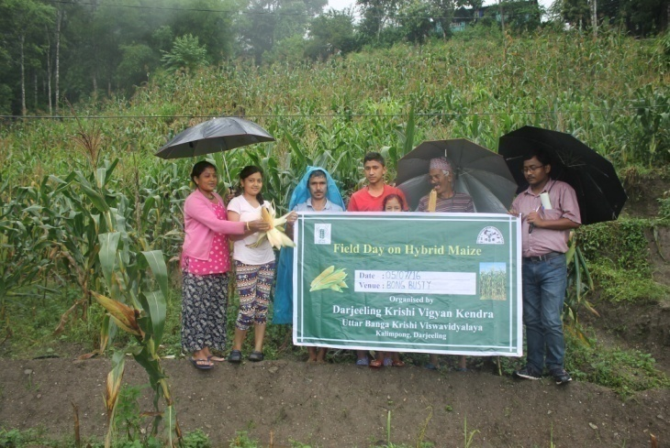

Technical Feedback on the demonstrated technologies

S. No | Crop | Feed Back
1 | Mandarin Orange | After nutritional management size and yield of fruits were increased.
2 | Maize – F7001 | The performance of this Hybrid variety is good in terms of corn size and yield.
3 | Paddy –PS5 | Production of this scented rice is satisfactory, but the milling performance is not at per due to the long grain
4 | Ginger | Rhizome rot was effectively managed and yield was good.
5 | Large Cardamom | Blight diseases was effectively managed.
6 | Kitchen Garden | It is well accepted among rural family with horizontal expansion
7 | Low cost malted supplements | For effective acceptability more awareness is required.
8 | Hampshire pig | Hampshire pig have good litter size and growth rate compared to desi pig
9 | Vanaraja poultry | Vanaraja poultry have high growth rate and egg laying efficiency compared to desi poultry birds

Extension and Training activities under FLD

SL.No. | Activity | Date | No. of activities organized | Number of participants | Remarks
1. | Field days | 05/07/2016  11/07/2016  09/06/2016  15/03/2017 | 1  1  1  1 | 9  8  18  7 | Hybrid Maize  PS-5 Paddy  Kiwi fruit  Potato
2. | Farmers Training | 24/11/2016 | 1 | 36 | Low cost Malted supplements
3. | Media coverage
4. | Training for extension functionaries

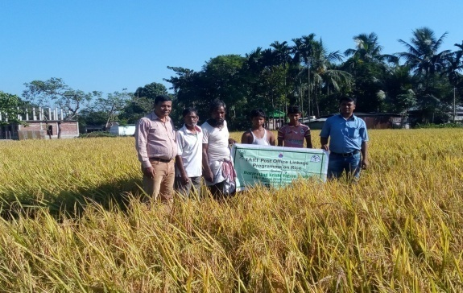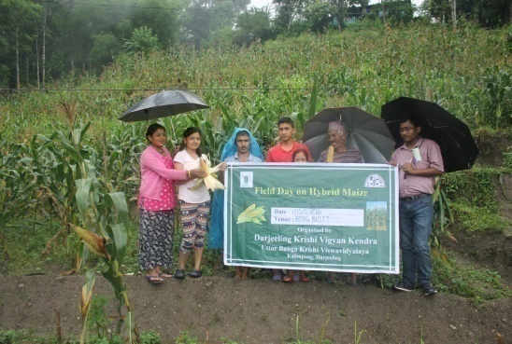

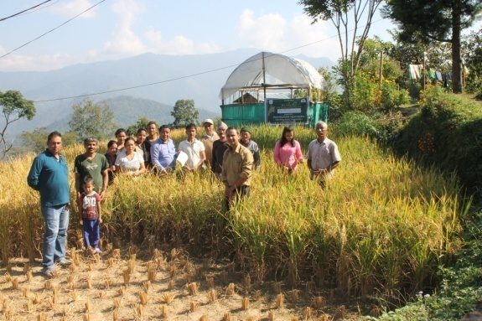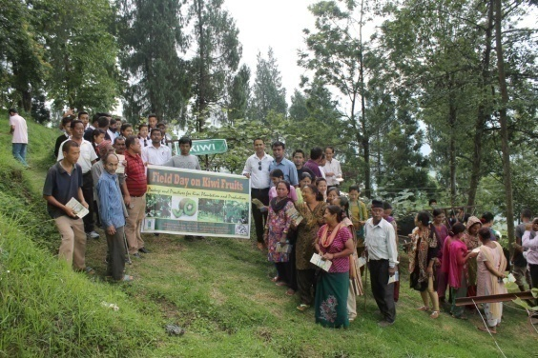

Performance of the demonstration under CFLD on Pulse and Oilseed Crops during Kharif 2016 and Rabi 2016-17:

- Technical Parameters:
Sl.  No. | Crop demonstrated | Existing (Farmer's) variety name | Existing yield  (q/ha) | Yield gap (Kg/ha)  w.r.to |  |  | Name of Variety + Technology  demonstrated | Number of farmers | Area in ha | Yield obtained (q/ha) |  |  | Yield gap minimized  (%)
 |  |  |  | District  yield (D) | State  yield (S) | Potential  yield (P)
 |  |  |  |  |  |  |  |  |  | Max. | Min. | Av. | D | S | P
1 | Blackgram  Sarada  WBU108 | Local | 4.6 | 482 | 580 |  | Sarada  (WBU 108) | 153 | 20 | 7.9 | 3.8 | 6.01 | 19.8 | 3.49
2 | Mustard  B9  (Yellow) | PT303 | 11.61 | 330 | 764 | 1400 | Variety  Bio fertilizer  PSB  Nutrient  Mngt. | 60 | 15 | 11.20  11.78  12.68 | 9.28  10.23  10.58 | 10.02  10.62  11.08 | 67.1  68.9  70.02 | 23.7  28.1  31.1
3 | Mustard  Garima  (Black) | NS212 | 10.32 | 330 | 764 | 1400 | Variety  Bio fertilizer  PSB  Nutrient Mngt. | 60 | 15 | 9.52  9.83  10.36 | 7.65  8.24  8.65 | 8.12  8.91  9.33 | 59.3  62.9  67.5 | 5.9  14.2  18.1
4* | Green Gram  Sukumar

* Green Gram in field
- Economic parameters
Sl.  No. | Variety demonstrated & Technology demonstrated | Farmer’s Existing plot |  |  |  | Demonstration plot
 |  | Gross Cost  (Rs/ha) | Gross return  (Rs/ha) | Net Return  (Rs/ha) | B:C  ratio | Gross Cost  (Rs/ha) | Gross return  (Rs/ha) | Net Return  (Rs/ha) | B:C  ratio
1 | Blackgram | 17456 | 20700 | 3244 | 1.18 | 18732 | 27045 | 8313 | 1.44
2 | Mustard  B9  (Yellow) | 4048 | 14362 | 10314 | 3.54 | 3868 | 17048 | 13180 | 4.40
3 | Mustard  Garima  (Black) | 4048 | 12216 | 8168 | 3.01 | 3868 | 14628 | 10760 | 3.78
4 | Green Gram  Sukumar

- Socio-economic impact parameters
Sl.  No. | Crop and variety  Demonstrated | Total Produce  Obtained (kg) | Produce sold  (Kg/household) | Selling  Rate  (Rs/Kg) | Produce used for own sowing (Kg) | Produce distributed to other farmers (Kg) | Purpose for which income gained was utilized | Employment Generated (Mandays/house hold)
1 | Blackgram  Sarada  WBU 108 | 12020 | 200 | 45 | 17 | 8 | Household Activity  & Child Edu. | 6
2 | Mustard  B9  (Yellow) | 7515
3 | Mustard  Garima  (Black) | 6090
4 | Green Gram  Sukumar

- Oilseed Farmers’ perception of the intervention demonstrated
Sl.  No. | Technologies demonstrated  (with name) | Farmers' Perception parameters
 |  | Suitability to their farming system | Likings  (Preference) | Affordability | Any negative effect | Is Technology acceptable to all in the group/village | Suggestions, for change/improvement, if any
1 | Blackgram | Yes | Yield | Yes | No | Yes | --
2 | Variety  Bio ferz  PSB  Nutrient Mgnt | Yes | Good | Affordable | No | Yes | --
3 | Variety  Bio ferz  PSB  Nutrient Mgnt | Yes | Good | Affordable | No | Yes | --
4 | Green gram

- Specific Characteristics of Technology and Performance

Specific Characteristic | Performance | Performance of Technology vis-a vis Local Check | Farmers Feedback
Blackgram  Sarada  WBU 108 | Pod formation per plant is higher | Line sowing with application of Bio fertilizer (Rhizobium) performed well than the local practice | Produce higher yield than the local one. Infestation of pest and diseases was lower.
Mustard  B9  (Yellow) | Height of the crop is shorter with higher number of branches and resistant to lodging  Pod formation is higher  Seed per pod is higher  Survive well in low moisture in soil | Line sowing with application of Bio fertilizer (PSB) performed well than the local practice | Produce higher yield than the local check with the application of Bio fertilizer and nutrient management.  Duration of the crop is shorter
Mustard
Garima
(Black)
Green Gram
Sukumar

- Extension activities under FLD conducted till dates:

Sl. No. | Extension Activities organized | Date and place of activity | Number of farmer attended
 | Training | 26/08/16, Sumbuk | 34
 |  | 29/08/16, Sindebong | 30
 |  | 31/08/16, Sittong | 44
 |  | 31/08/16, Bong Busty | 22
 |  | 01/09/16, Bidyang | 15
 |  | 01/09/16, Khamdong | 8
 | Demonstration | 26/08/16, Sumbuk | 34
 |  | 29/08/16, Sindebong | 30
 |  | 31/08/16, Sittong | 44
 |  | 31/08/16, Bong Busty | 22
 |  | 01/09/16, Bidyang | 15
 |  | 01/09/16, Khamdong | 8
 | Field Visit | 31/10/16, Sumbuk | 7
 |  | 28/10/16, Sindebong | 12
 |  | 27/10/16, Sittong | 7
 |  | 31/10/16, Bong Busty | 8
 |  | 27/10/16, Bidyang | 10
 |  | 28/10/16, Khamdong | 2

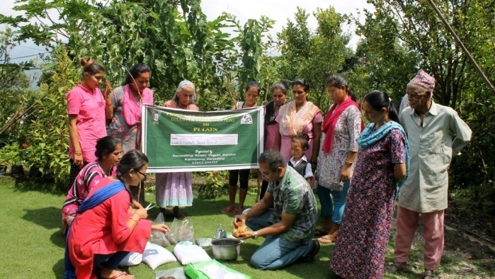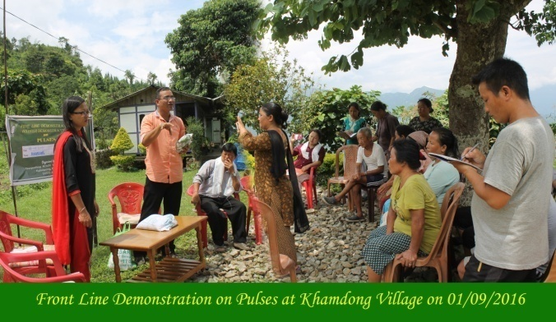

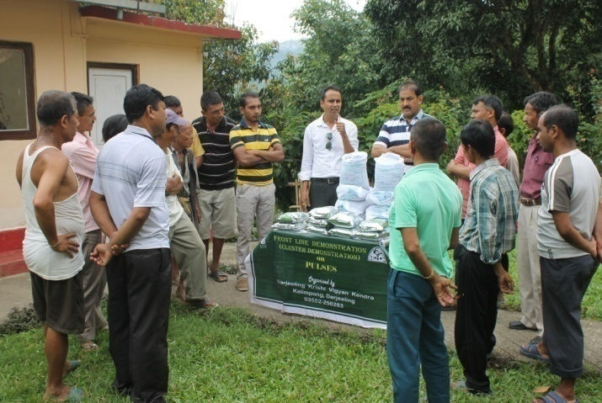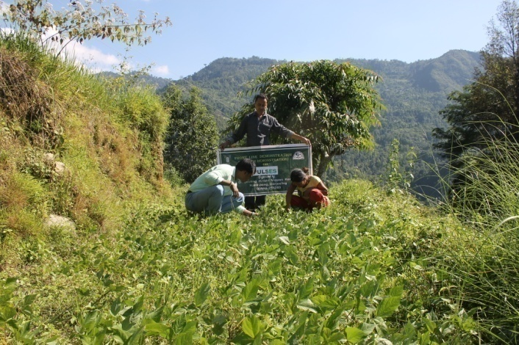
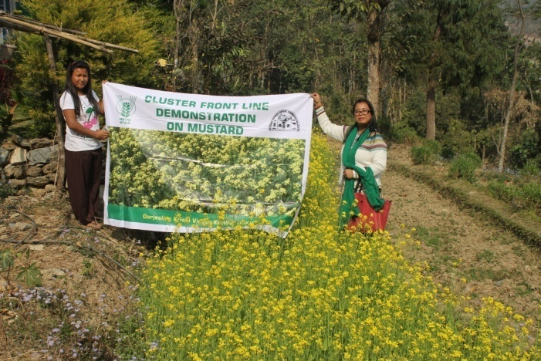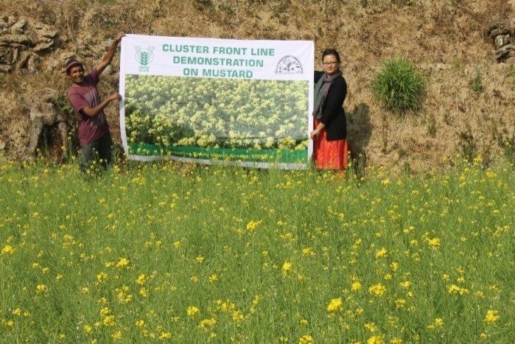
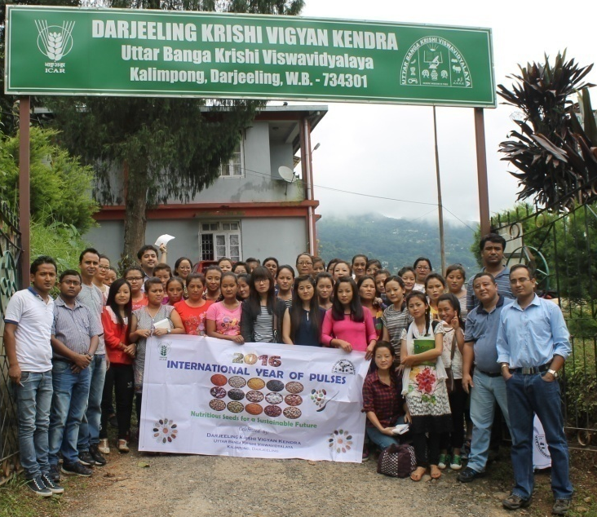

- Sequential good quality photographs (as per crop stages i.e. growth & development)

- Farmers' training photographs

- Quality Photographs of field visits/field days and technology demonstrated.

J. Details of budget utilization

Crop  (provide crop wise information ) | Items | Budget  Received  (Rs.) | Budget  Utilization  (Rs.) | Balance  (Rs.)
 | i) Critical input
 | ii) TA/DA/POL etc. for monitoring
 | iii) Extension Activities (Field day)
 | iv)Publication of literature
 | Total

K. List of Farmer under FLD (Crop wise)

- Crop 1

Name of farmer | Father’s name | Village | Block | Mobile No. | Email ID | GPS Coordinates (DDMMSS format) |  | Soil testing done (Yes/No) | Recommendations based on soil test value | Brief technology intervention | Variety | Seed quantity used | Demo. Yield (q/ha) |  |  | Yield of local check q/ha | % increase
 |  |  |  |  |  | Latitude | Longitude |  |  |  |  |  | H | L | A

- Crop2

Name of farmer | Father’s name | Village | Block | Mobile No. | Email ID | GPS Coordinates (DDMMSS format) |  | Soil testing done (Yes/No) | Recommendations based on soil test value | Brief technology intervention | Variety | Seed quantity used | Demo. Yield (q/ha) |  |  | Yield of local check q/ha | % increase
 |  |  |  |  |  | Latitude | Longitude |  |  |  |  |  | H | L | A

  - Achievements on Training (Including the sponsored and FLD training programmes):

- Farmers and farm women (on campus)

Thematic Area | No. of Courses | No. of Participants |  |  |  |  |  |  |  |  |  | Grand Total
 |  | Other |  |  | SC |  |  |  | ST
 |  | M | F | T | M | F |  | T | M | F | T | M | F | T
I. Crop Production
Weed Management
Resource Conservation Technologies
Cropping Systems
Crop Diversification
Integrated Farming
Water management
Seed production
Nursery management
Integrated Crop Management
Fodder production | 1 | 0 | 1 | 1 | 0 | 0 |  | 0 | 2 | 27 | 29 | 2 | 28 | 30
Production of organic inputs
Others, (cultivation of crops )
II. Horticulture
a) Vegetable Crops
Integrated nutrient management
Water management
Enterprise development
Skill development
Yield increment
Production of low volume and high value crops
Off-season vegetables | 1 | 24 | 38 | 62 | 2 | 0 |  | 2 | 7 | 6 | 13 | 33 | 44 | 77
Nursery raising
Export potential vegetables
Grading and standardization
Protective cultivation (Green Houses, Shade Net etc.) | 1 | 18 | 12 | 30 | 0 | 1 |  | 1 | 6 | 8 | 14 | 24 | 21 | 45
Others, if any (Cultivation of Vegetable) | 1 | 20 | 16 | 36 | 1 | 0 |  | 1 | 8 | 9 | 17 | 29 | 25 | 54
Training and Pruning
b) Fruits
Layout and Management of Orchards
Cultivation of Fruit | 1 | 9 | 25 | 34 | 0 | 0 |  | 0 | 3 | 1 | 4 | 0 | 0 | 38
Management of young plants/orchards
Rejuvenation of old orchards
Export potential fruits
Micro irrigation systems of orchards
Plant propagation techniques
Others, if any(INM)
c) Ornamental Plants
Nursery Management
Management of potted plants
Export potential of ornamental plants | 1 | 0 | 0 | 0 | 0 | 0 |  | 0 | 0 | 63 | 63 | 0 | 63 | 63
Propagation techniques of Ornamental Plants
Others, if any
d) Plantation crops
Production and Management technology
Processing and value addition | 1 | 0 | 5 | 5 | 0 | 1 |  | 1 | 0 | 1 | 1 | 0 | 7 | 7
Others, if any
e) Tuber crops
Production and Management technology
Processing and value addition
Others, if any
f) Spices
Production and Management technology
Processing and value addition
Others, if any
g) Medicinal and Aromatic Plants
Nursery management
Production and management technology
Post harvest technology and value addition
Others, if any
III. Soil Health and Fertility Management
Soil fertility management
Soil and Water Conservation
Integrated Nutrient Management
Production and use of organic inputs
Management of Problematic soils
Micro nutrient deficiency in crops
Nutrient Use Efficiency
Soil and Water Testing
Others, if any
IV. Livestock Production and Management
Dairy Management | 1 | 8 | 2 | 10 | 0 | 0 |  | 0 | 23 | 4 | 27 | 31 | 6 | 37
Poultry Management | 1 | 13 | 0 | 13 | 7 | 0 |  | 7 | 1 | 1 | 2 | 21 | 1 | 22
Piggery Management
Rabbit Management
Disease Management | 1 | 9 | 3 | 12 | 7 | 0 |  | 7 | 0 | 0 | 0 | 16 | 3 | 19
Feed management
Production of quality animal products | 1 | 16 | 19 | 35 | 0 | 1 |  | 1 | 12 | 6 | 18 | 28 | 26 | 54
Others, if any Goat farming | 1 | 16 | 0 | 16 | 3 | 0 |  | 3 | 0 | 0 | 0 | 19 | 0 | 19
V. Home Science/Women empowerment
Household food security by kitchen gardening and nutrition gardening
Design and development of low/minimum cost diet | 1 | 0 | 3 | 3 | 0 | 21 |  | 21 | 0 | 6 | 6 | 0 | 30 | 30
Designing and development for high nutrient efficiency diet
Minimization of nutrient loss in processing
Gender mainstreaming through SHGs
Storage loss minimization techniques
Enterprise development
Value addition | 4 | 0 | 27 | 27 | 0 | 5 |  | 5 | 0 | 28 | 28 | 0 | 14 | 60
Income generation activities for empowerment of rural Women | 2 | 15 | 18 | 33 | 0 | 24 |  | 24 | 4 | 13 | 17 | 19 | 55 | 74
Location specific drudgery reduction technologies
Rural Crafts
Capacity building | 1 | 2 | 3 | 5 | 5 | 9 |  | 14 | 2 | 3 | 5 | 9 | 15 | 24
Women and child care
Others, if any
VI. Agril. Engineering
Installation and maintenance of micro irrigation systems
Use of Plastics in farming practices
Production of small tools and implements
Repair and maintenance of farm machinery and implements
Small scale processing and value addition
Post Harvest Technology
Others, if any
VII. Plant Protection
Integrated Pest Management | 6 | 67 | 29 | 67 | 61 | 29 |  | 61 | 39 | 61 | 69 | 109 | 59 | 139
Integrated Disease Management | 2 | 21 | 17 | 38 | 10 | 2 |  | 12 | 16 | 11 | 27 | 47 | 30 | 77
Bio-control of pests and diseases | 1 | 20 | 0 | 20 | 26 | 13 |  | 39 | 1 | 0 | 1 | 0 | 0 | 60
Production of bio control agents and bio pesticides
Others, if any
VIII. Fisheries
Integrated fish farming
Carp breeding and hatchery management
Carp fry and fingerling rearing
Composite fish culture & fish disease
Fish feed preparation & its application to fish pond, like nursery, rearing & stocking pond
Hatchery management and culture of freshwater prawn
Breeding and culture of ornamental fishes
Portable plastic carp hatchery
Pen culture of fish and prawn
Shrimp farming
Edible oyster farming
Pearl culture
Fish processing and value addition
Others, if any
IX. Production of Inputs at site
Seed Production
Planting material production
Bio-agents production
Bio-pesticides production
Bio-fertilizer production
Vermi-compost production
Organic manures production
Production of fry and fingerlings
Production of Bee-colonies and wax sheets
Small tools and implements
Production of livestock feed and fodder
Production of Fish feed
Others, if any
X. Capacity Building and Group Dynamics
Leadership development
Group dynamics
Formation and Management of SHGs
Mobilization of social capital
Entrepreneurial development of farmers/youths
WTO and IPR issues
Others, if any
XI Agro-forestry
Production technologies
Nursery management
Integrated Farming Systems
XII. Others (Pl. Specify)
TOTAL | 29 | 258 | 218 | 447 | 122 |  | 106 | 199 | 124 | 248 | 341 | 387 | 427 | 929

B) Rural Youth (on campus)

Thematic Area | No. of Courses | No. of Participants |  |  |  |  |  |  |  |  |  | Grand Total
 |  | Other |  |  | SC |  |  |  | ST
 |  | M | F | T | M | F |  | T | M | F | T | M | F | T
Mushroom Production | 1 | 3 | 22 | 25 | 0 |  | 0 | 0 | 0 | 1 | 1 | 3 | 23 | 26
Bee-keeping | 1 | 16 | 19 | 35 | 0 |  | 1 | 1 | 12 | 6 | 18 | 28 | 26 | 54
Integrated farming
Seed production
Production of organic inputs
Integrated Farming | 1 | 20 | 16 | 36 | 1 |  | 0 | 1 | 8 | 9 | 17 | 29 | 25 | 54
Planting material production
Vermi-culture
Sericulture
Protected cultivation of vegetable crops
Commercial fruit production
Repair and maintenance of farm machinery and implements
Nursery Management of Horticulture crops
Training and pruning of orchards
Value addition
Production of quality animal products
Dairying | 1 | 13 | 0 | 13 | 8 |  | 0 | 8 | 0 | 0 | 0 | 21 | 0 | 21
Sheep and goat rearing | 1 | 16 | 19 | 35 | 0 |  | 1 | 1 | 12 | 6 | 18 | 28 | 26 | 54
Quail farming
Piggery
Rabbit farming
Poultry production | 2 | 18 | 19 | 37 | 11 |  | 1 | 12 | 17 | 6 | 23 | 46 | 26 | 72
Ornamental fisheries
Enterprise development
Para vets
Para extension workers | 1 | 0 | 0 | 0 | 0 |  | 0 | 0 | 0 | 30 | 30 | 0 | 30 | 30
Composite fish culture
Freshwater prawn culture
Shrimp farming
Pearl culture
Cold water fisheries
Fish harvest and processing technology
Fry and fingerling rearing
Small scale processing
Post Harvest Technology
Tailoring and Stitching
Rural Crafts
TOTAL | 8 | 86 | 95 | 181 | 20 |  | 3 | 23 | 49 | 58 | 107 | 155 | 156 | 311

C) Extension Personnel (on campus)

Thematic Area | No. of Courses | No. of Participants |  |  |  |  |  |  |  |  |  | Grand Total
 |  | Other |  |  | SC |  |  |  | ST
 |  | M | F | T | M | F |  | T | M | F | T | M | F | T
Productivity enhancement in field crops
Value addition
Integrated Pest Management
Integrated Nutrient management
Rejuvenation of old orchards
Protected cultivation technology
Formation and Management of SHGs
Group Dynamics and farmers organization
Information networking among farmers
Capacity building for ICT application
Care and maintenance of farm machinery and implements
WTO and IPR issues
Management in farm animals
Livestock feed and fodder production
Household food security
Women and Child care
Low cost and nutrient efficient diet designing
Production and use of organic inputs
Gender mainstreaming through SHGs
TOTAL

D) Farmers and farm women (off campus)

Thematic Area | No. of Courses | No. of Participants |  |  |  |  |  |  |  |  |  | Grand Total
 |  | Other |  |  | SC |  |  |  | ST
 |  | M | F | T | M | F |  | T | M | F | T | M | F | T
I. Crop Production
Weed Management
Resource Conservation Technologies
Cropping Systems
Crop Diversification
Integrated Farming
Water management
Seed production
Nursery management
Integrated Crop Management
Fodder production
Production of organic inputs
Others, (cultivation of crops ) | 1 | 4 | 4 | 8 | 0 | 0 |  | 0 | 0 | 0 | 0 | 4 | 4 | 8
II. Horticulture
a) Vegetable Crops
Integrated nutrient management | 1 | 14 | 17 | 31 | 3 | 2 |  | 5 | 4 | 0 | 4 | 21 | 19 | 40
Water management
Enterprise development
Skill development
Yield increment
Production of low volume and high value crops
Off-season vegetables | 1 | 6 | 1 | 7 | 0 | 0 |  | 0 | 3 | 18 | 21 | 9 | 19 | 28
Nursery raising
Export potential vegetables
Grading and standardization
Protective cultivation (Green Houses, Shade Net etc.) | 1 | 1 | 1 | 2 | 0 | 0 |  | 0 | 8 | 9 | 17 | 9 | 10 | 19
Others, if any (Cultivation of Vegetable)
Training and Pruning
b) Fruits
Layout and Management of Orchards
Cultivation of Fruit
Management of young plants/orchards
Rejuvenation of old orchards
Export potential fruits
Micro irrigation systems of orchards
Plant propagation techniques
Others, if any(INM)
c) Ornamental Plants
Nursery Management
Management of potted plants
Export potential of ornamental plants
Propagation techniques of Ornamental Plants
Others, if any
d) Plantation crops
Production and Management technology | 1 | 12 | 8 | 20 | 5 | 6 |  | 11 | 6 | 7 | 13 | 23 | 21 | 44
Processing and value addition
Others, if any
e) Tuber crops
Production and Management technology | 1 | 4 | 28 | 32 | 0 | 1 |  | 1 | 0 | 6 | 6 | 4 | 35 | 39
Processing and value addition
Others, if any
f) Spices
Production and Management technology | 2 | 45 | 15 | 60 | 0 | 0 |  | 0 | 36 | 5 | 41 | 81 | 20 | 101
Processing and value addition | 1 | 6 | 15 | 21 | 0 | 0 |  | 0 | 2 | 6 | 8 | 8 | 21 | 29
Others, if any
g) Medicinal and Aromatic Plants
Nursery management
Production and management technology
Post harvest technology and value addition
Others, if any
III. Soil Health and Fertility Management
Soil fertility management
Soil and Water Conservation
Integrated Nutrient Management
Production and use of organic inputs
Management of Problematic soils
Micro nutrient deficiency in crops
Nutrient Use Efficiency
Soil and Water Testing
Others, if any
IV. Livestock Production and Management
Dairy Management | 1 | 13 | 2 | 15 | 7 | 0 |  | 7 | 3 | 0 | 3 | 23 | 2 | 25
Poultry Management | 3 | 8 | 27 | 35 | 10 | 10 |  | 20 | 6 | 36 | 42 | 24 | 73 | 97
Piggery Management
Rabbit Management
Disease Management
Feed management
Production of quality animal products
Others, if any Goat farming
V. Home Science/Women empowerment
Household food security by kitchen gardening and nutrition gardening | 1 | 0 | 17 | 17 | 0 | 0 |  | 0 | 0 | 0 | 0 | 0 | 17 | 17
Design and development of low/minimum cost diet | 1 | 16 | 0 | 16 | 0 | 0 |  | 0 | 2 | 6 | 8 | 18 | 6 | 24
Designing and development for high nutrient efficiency diet | 1 | 21 | 2 | 23 | 0 | 0 |  | 0 | 6 | 7 | 13 | 27 | 9 | 36
Minimization of nutrient loss in processing
Gender mainstreaming through SHGs
Storage loss minimization techniques
Enterprise development
Value addition
Income generation activities for empowerment of rural Women | 1 | 11 | 8 | 19 | 0 | 0 |  | 0 | 12 | 4 | 16 | 23 | 12 | 35
Location specific drudgery reduction technologies
Rural Crafts
Capacity building
Women and child care | 3 | 3 | 42 | 45 | 0 | 1 |  | 1 | 0 | 33 | 33 | 3 | 76 | 79
Others, if any
VI. Agril. Engineering
Installation and maintenance of micro irrigation systems
Use of Plastics in farming practices
Production of small tools and implements
Repair and maintenance of farm machinery and implements
Small scale processing and value addition
Post Harvest Technology
Others, if any
VII. Plant Protection
Integrated Pest Management | 2 | 42 | 16 | 58 | 3 | 1 |  | 4 | 45 | 20 | 65 | 90 | 37 | 127
Integrated Disease Management | 2 | 24 | 19 | 43 | 3 | 4 |  | 7 | 10 | 1 | 11 | 37 | 24 | 61
Bio-control of pests and diseases
Production of bio control agents and bio pesticides
Others, if any
VIII. Fisheries
Integrated fish farming
Carp breeding and hatchery management
Carp fry and fingerling rearing
Composite fish culture & fish disease
Fish feed preparation & its application to fish pond, like nursery, rearing & stocking pond
Hatchery management and culture of freshwater prawn
Breeding and culture of ornamental fishes
Portable plastic carp hatchery
Pen culture of fish and prawn
Shrimp farming
Edible oyster farming
Pearl culture
Fish processing and value addition
Others, if any
IX. Production of Inputs at site
Seed Production
Planting material production
Bio-agents production
Bio-pesticides production
Bio-fertilizer production
Vermi-compost production
Organic manures production
Production of fry and fingerlings
Production of Bee-colonies and wax sheets
Small tools and implements
Production of livestock feed and fodder
Production of Fish feed
Others, if any
X. Capacity Building and Group Dynamics
Leadership development
Group dynamics
Formation and Management of SHGs
Mobilization of social capital
Entrepreneurial development of farmers/youths
WTO and IPR issues
Others, if any
XI Agro-forestry
Production technologies
Nursery management
Integrated Farming Systems
XII. Others (Pl. Specify)
TOTAL | 24 | 230 | 222 | 452 | 31 |  | 25 | 56 | 143 | 158 | 301 | 404 | 405 | 809

E) RURAL YOUTH (Off Campus)
Thematic Area | No. of Courses | No. of Participants |  |  |  |  |  |  |  |  |  | Grand Total
 |  | Other |  |  | SC |  |  |  | ST
 |  | M | F | T | M | F |  | T | M | F | T | M | F | T
Mushroom Production | 1 | 9 | 0 | 9 | 11 |  | 0 | 11 | 25 | 11 | 36 | 45 | 11 | 56
Bee-keeping
Integrated farming
Seed production
Production of organic inputs
Integrated Farming
Planting material production | 1 | 16 | 2 | 18 | 0 |  | 0 | 0 | 11 | 9 | 20 | 0 | 0 | 38
Vermi-culture
Sericulture
Protected cultivation of vegetable crops
Commercial fruit production
Repair and maintenance of farm machinery and implements
Nursery Management of Horticulture crops
Training and pruning of orchards
Value addition
Production of quality animal products
Dairying | 2 | 65 | 29 | 94 | 11 |  | 3 | 14 | 42 | 12 | 54 | 96 | 36 | 162
Sheep and goat rearing | 2 | 26 | 3 | 29 | 12 |  | 4 | 16 | 15 | 0 | 15 | 30 | 0 | 60
Quail farming
Piggery | 3 | 5 | 0 | 5 | 7 |  | 6 | 13 | 36 | 29 | 65 | 27 | 31 | 83
Rabbit farming
Poultry production | 2 | 11 | 3 | 14 | 5 |  | 4 | 9 | 6 | 21 | 27 | 0 | 20 | 50
Ornamental fisheries
Para vets
Para extension workers
Composite fish culture
Freshwater prawn culture
Shrimp farming
Pearl culture
Cold water fisheries
Fish harvest and processing technology
Fry and fingerling rearing
Small scale processing
Post Harvest Technology
Tailoring and Stitching
Rural Crafts
Others, if any
TOTAL | 11 | 132 | 37 | 169 | 46 |  | 17 | 63 | 135 | 82 | 217 | 198 | 98 | 449

F) Extension Personnel (Off Campus)
Thematic Area | No. of Courses | No. of Participants |  |  |  |  |  |  |  |  | Grand Total
 |  | Other |  |  | SC |  |  | ST
 |  | M | F | T | M | F | T | M | F | T | M | F | T
Productivity enhancement in field crops
Integrated Pest Management
Integrated Nutrient management
Rejuvenation of old orchards
Protected cultivation technology
Formation and Management of SHGs
Group Dynamics and farmers organization
Information networking among farmers
Capacity building for ICT application
Care and maintenance of farm machinery and implements
WTO and IPR issues
Management in farm animals | 2 | 13 | 1 | 14 | 11 | 1 | 12 | 11 | 0 | 1 | 35 | 2 | 37
Livestock feed and fodder production
Household food security
Women and Child care
Low cost and nutrient efficient diet designing
Production and use of organic inputs
Gender mainstreaming through SHGs
Crop intensification
TOTAL | 2 | 13 | 1 | 14 | 11 | 1 | 12 | 11 | 0 | 1 | 35 | 2 | 37

G) Consolidated table (ON and OFF Campus)
i. Farmers & Farm Women
Thematic Area | No. of Courses | No. of Participants |  |  |  |  |  |  |  |  | Grand Total
 |  | Other |  |  | SC |  |  | ST
 |  | M | F | T | M | F | T | M | F | T | M | F | T
I. Crop Production | 0 | 0 | 0 | 0 | 0 | 0 | 0 | 0 | 0 | 0 | 0 | 0 | 0
Weed Management | 0 | 0 | 0 | 0 | 0 | 0 | 0 | 0 | 0 | 0 | 0 | 0 | 0
Resource Conservation Technologies | 0 | 0 | 0 | 0 | 0 | 0 | 0 | 0 | 0 | 0 | 0 | 0 | 0
Cropping Systems | 0 | 0 | 0 | 0 | 0 | 0 | 0 | 0 | 0 | 0 | 0 | 0 | 0
Crop Diversification | 0 | 0 | 0 | 0 | 0 | 0 | 0 | 0 | 0 | 0 | 0 | 0 | 0
Integrated Farming | 0 | 0 | 0 | 0 | 0 | 0 | 0 | 0 | 0 | 0 | 0 | 0 | 0
Water management | 0 | 0 | 0 | 0 | 0 | 0 | 0 | 0 | 0 | 0 | 0 | 0 | 0
Seed production | 0 | 0 | 0 | 0 | 0 | 0 | 0 | 0 | 0 | 0 | 0 | 0 | 0
Nursery management | 0 | 0 | 0 | 0 | 0 | 0 | 0 | 0 | 0 | 0 | 0 | 0 | 0
Integrated Crop Management | 0 | 0 | 0 | 0 | 0 | 0 | 0 | 0 | 0 | 0 | 0 | 0 | 0
Fodder production | 1 | 0 | 1 | 1 | 0 | 0 | 0 | 2 | 27 | 29 | 2 | 28 | 30
Production of organic inputs | 0 | 0 | 0 | 0 | 0 | 0 | 0 | 0 | 0 | 0 | 0 | 0 | 0
Others, (cultivation of crops ) | 1 | 4 | 4 | 8 | 0 | 0 | 0 | 0 | 0 | 0 | 4 | 4 | 8
II. Horticulture | 0 | 0 | 0 | 0 | 0 | 0 | 0 | 0 | 0 | 0 | 0 | 0 | 0
a) Vegetable Crops | 0 | 0 | 0 | 0 | 0 | 0 | 0 | 0 | 0 | 0 | 0 | 0 | 0
Integrated nutrient management | 1 | 14 | 17 | 31 | 3 | 2 | 5 | 4 | 0 | 4 | 21 | 19 | 40
Water management | 0 | 0 | 0 | 0 | 0 | 0 | 0 | 0 | 0 | 0 | 0 | 0 | 0
Enterprise development | 0 | 0 | 0 | 0 | 0 | 0 | 0 | 0 | 0 | 0 | 0 | 0 | 0
Skill development | 0 | 0 | 0 | 0 | 0 | 0 | 0 | 0 | 0 | 0 | 0 | 0 | 0
Yield increment | 0 | 0 | 0 | 0 | 0 | 0 | 0 | 0 | 0 | 0 | 0 | 0 | 0
Production of low volume and high value crops | 0 | 0 | 0 | 0 | 0 | 0 | 0 | 0 | 0 | 0 | 0 | 0 | 0
Off-season vegetables | 2 | 30 | 39 | 69 | 2 | 0 | 2 | 10 | 24 | 34 | 42 | 63 | 105
Nursery raising | 0 | 0 | 0 | 0 | 0 | 0 | 0 | 0 | 0 | 0 | 0 | 0 | 0
Export potential vegetables | 0 | 0 | 0 | 0 | 0 | 0 | 0 | 0 | 0 | 0 | 0 | 0 | 0
Grading and standardization | 0 | 0 | 0 | 0 | 0 | 0 | 0 | 0 | 0 | 0 | 0 | 0 | 0
Protective cultivation (Green Houses, Shade Net etc.) | 2 | 19 | 13 | 32 | 0 | 1 | 1 | 14 | 17 | 31 | 33 | 31 | 64
Others, if any (Cultivation of Vegetable) | 1 | 20 | 16 | 36 | 1 | 0 | 1 | 8 | 9 | 17 | 29 | 25 | 54
Training and Pruning | 0 | 0 | 0 | 0 | 0 | 0 | 0 | 0 | 0 | 0 | 0 | 0 | 0
b) Fruits | 0 | 0 | 0 | 0 | 0 | 0 | 0 | 0 | 0 | 0 | 0 | 0 | 0
Layout and Management of Orchards | 0 | 0 | 0 | 0 | 0 | 0 | 0 | 0 | 0 | 0 | 0 | 0 | 0
Cultivation of Fruit | 1 | 9 | 25 | 34 | 0 | 0 | 0 | 3 | 1 | 4 | 0 | 0 | 38
Management of young plants/orchards | 0 | 0 | 0 | 0 | 0 | 0 | 0 | 0 | 0 | 0 | 0 | 0 | 0
Rejuvenation of old orchards | 0 | 0 | 0 | 0 | 0 | 0 | 0 | 0 | 0 | 0 | 0 | 0 | 0
Export potential fruits | 0 | 0 | 0 | 0 | 0 | 0 | 0 | 0 | 0 | 0 | 0 | 0 | 0
Micro irrigation systems of orchards | 0 | 0 | 0 | 0 | 0 | 0 | 0 | 0 | 0 | 0 | 0 | 0 | 0
Plant propagation techniques | 0 | 0 | 0 | 0 | 0 | 0 | 0 | 0 | 0 | 0 | 0 | 0 | 0
Others, if any(INM) | 0 | 0 | 0 | 0 | 0 | 0 | 0 | 0 | 0 | 0 | 0 | 0 | 0
c) Ornamental Plants | 0 | 0 | 0 | 0 | 0 | 0 | 0 | 0 | 0 | 0 | 0 | 0 | 0
Nursery Management | 0 | 0 | 0 | 0 | 0 | 0 | 0 | 0 | 0 | 0 | 0 | 0 | 0
Management of potted plants | 0 | 0 | 0 | 0 | 0 | 0 | 0 | 0 | 0 | 0 | 0 | 0 | 0
Export potential of ornamental plants | 1 | 0 | 0 | 0 | 0 | 0 | 0 | 0 | 63 | 63 | 0 | 63 | 63
Propagation techniques of Ornamental Plants | 0 | 0 | 0 | 0 | 0 | 0 | 0 | 0 | 0 | 0 | 0 | 0 | 0
Others, if any | 0 | 0 | 0 | 0 | 0 | 0 | 0 | 0 | 0 | 0 | 0 | 0 | 0
d) Plantation crops | 0 | 0 | 0 | 0 | 0 | 0 | 0 | 0 | 0 | 0 | 0 | 0 | 0
Production and Management technology | 1 | 12 | 8 | 20 | 5 | 6 | 11 | 6 | 7 | 13 | 23 | 21 | 44
Processing and value addition | 1 | 0 | 5 | 5 | 0 | 1 | 1 | 0 | 1 | 1 | 0 | 7 | 7
Others, if any | 0 | 0 | 0 | 0 | 0 | 0 | 0 | 0 | 0 | 0 | 0 | 0 | 0
e) Tuber crops | 0 | 0 | 0 | 0 | 0 | 0 | 0 | 0 | 0 | 0 | 0 | 0 | 0
Production and Management technology | 1 | 4 | 28 | 32 | 0 | 1 | 1 | 0 | 6 | 6 | 4 | 35 | 39
Processing and value addition | 0 | 0 | 0 | 0 | 0 | 0 | 0 | 0 | 0 | 0 | 0 | 0 | 0
Others, if any | 0 | 0 | 0 | 0 | 0 | 0 | 0 | 0 | 0 | 0 | 0 | 0 | 0
f) Spices | 0 | 0 | 0 | 0 | 0 | 0 | 0 | 0 | 0 | 0 | 0 | 0 | 0
Production and Management technology | 2 | 45 | 15 | 60 | 0 | 0 | 0 | 36 | 5 | 41 | 81 | 20 | 101
Processing and value addition | 1 | 6 | 15 | 21 | 0 | 0 | 0 | 2 | 6 | 8 | 8 | 21 | 29
Others, if any | 0 | 0 | 0 | 0 | 0 | 0 | 0 | 0 | 0 | 0 | 0 | 0 | 0
g) Medicinal and Aromatic Plants | 0 | 0 | 0 | 0 | 0 | 0 | 0 | 0 | 0 | 0 | 0 | 0 | 0
Nursery management | 0 | 0 | 0 | 0 | 0 | 0 | 0 | 0 | 0 | 0 | 0 | 0 | 0
Production and management technology | 0 | 0 | 0 | 0 | 0 | 0 | 0 | 0 | 0 | 0 | 0 | 0 | 0
Post harvest technology and value addition | 0 | 0 | 0 | 0 | 0 | 0 | 0 | 0 | 0 | 0 | 0 | 0 | 0
Others, if any | 0 | 0 | 0 | 0 | 0 | 0 | 0 | 0 | 0 | 0 | 0 | 0 | 0
III. Soil Health and Fertility Management | 0 | 0 | 0 | 0 | 0 | 0 | 0 | 0 | 0 | 0 | 0 | 0 | 0
Soil fertility management | 0 | 0 | 0 | 0 | 0 | 0 | 0 | 0 | 0 | 0 | 0 | 0 | 0
Soil and Water Conservation | 0 | 0 | 0 | 0 | 0 | 0 | 0 | 0 | 0 | 0 | 0 | 0 | 0
Integrated Nutrient Management | 0 | 0 | 0 | 0 | 0 | 0 | 0 | 0 | 0 | 0 | 0 | 0 | 0
Production and use of organic inputs | 0 | 0 | 0 | 0 | 0 | 0 | 0 | 0 | 0 | 0 | 0 | 0 | 0
Management of Problematic soils | 0 | 0 | 0 | 0 | 0 | 0 | 0 | 0 | 0 | 0 | 0 | 0 | 0
Micro nutrient deficiency in crops | 0 | 0 | 0 | 0 | 0 | 0 | 0 | 0 | 0 | 0 | 0 | 0 | 0
Nutrient Use Efficiency | 0 | 0 | 0 | 0 | 0 | 0 | 0 | 0 | 0 | 0 | 0 | 0 | 0
Soil and Water Testing | 0 | 0 | 0 | 0 | 0 | 0 | 0 | 0 | 0 | 0 | 0 | 0 | 0
Others, if any | 0 | 0 | 0 | 0 | 0 | 0 | 0 | 0 | 0 | 0 | 0 | 0 | 0
IV. Livestock Production and Management | 0 | 0 | 0 | 0 | 0 | 0 | 0 | 0 | 0 | 0 | 0 | 0 | 0
Dairy Management | 2 | 21 | 4 | 25 | 7 | 0 | 7 | 26 | 4 | 30 | 54 | 8 | 62
Poultry Management | 4 | 21 | 27 | 48 | 17 | 10 | 27 | 7 | 37 | 44 | 45 | 74 | 119
Piggery Management | 0 | 0 | 0 | 0 | 0 | 0 | 0 | 0 | 0 | 0 | 0 | 0 | 0
Rabbit Management | 0 | 0 | 0 | 0 | 0 | 0 | 0 | 0 | 0 | 0 | 0 | 0 | 0
Disease Management | 1 | 9 | 3 | 12 | 7 | 0 | 7 | 0 | 0 | 0 | 16 | 3 | 19
Feed management | 0 | 0 | 0 | 0 | 0 | 0 | 0 | 0 | 0 | 0 | 0 | 0 | 0
Production of quality animal products | 1 | 16 | 19 | 35 | 0 | 1 | 1 | 12 | 6 | 18 | 28 | 26 | 54
Others, if any Goat farming | 1 | 16 | 0 | 16 | 3 | 0 | 3 | 0 | 0 | 0 | 19 | 0 | 19
V. Home Science/Women empowerment | 0 | 0 | 0 | 0 | 0 | 0 | 0 | 0 | 0 | 0 | 0 | 0 | 0
Household food security by kitchen gardening and nutrition gardening | 1 | 0 | 17 | 17 | 0 | 0 | 0 | 0 | 0 | 0 | 0 | 17 | 17
Design and development of low/minimum cost diet | 2 | 16 | 3 | 19 | 0 | 21 | 21 | 2 | 12 | 14 | 18 | 36 | 54
Designing and development for high nutrient efficiency diet | 1 | 21 | 2 | 23 | 0 | 0 | 0 | 6 | 7 | 13 | 27 | 9 | 36
Minimization of nutrient loss in processing | 0 | 0 | 0 | 0 | 0 | 0 | 0 | 0 | 0 | 0 | 0 | 0 | 0
Gender mainstreaming through SHGs | 0 | 0 | 0 | 0 | 0 | 0 | 0 | 0 | 0 | 0 | 0 | 0 | 0
Storage loss minimization techniques | 0 | 0 | 0 | 0 | 0 | 0 | 0 | 0 | 0 | 0 | 0 | 0 | 0
Enterprise development | 0 | 0 | 0 | 0 | 0 | 0 | 0 | 0 | 0 | 0 | 0 | 0 | 0
Value addition | 4 | 0 | 27 | 27 | 0 | 5 | 5 | 0 | 28 | 28 | 0 | 14 | 60
Income generation activities for empowerment of rural Women | 3 | 26 | 26 | 52 | 0 | 24 | 24 | 16 | 17 | 33 | 42 | 67 | 109
Location specific drudgery reduction technologies | 0 | 0 | 0 | 0 | 0 | 0 | 0 | 0 | 0 | 0 | 0 | 0 | 0
Rural Crafts | 0 | 0 | 0 | 0 | 0 | 0 | 0 | 0 | 0 | 0 | 0 | 0 | 0
Capacity building | 1 | 2 | 3 | 5 | 5 | 9 | 14 | 2 | 3 | 5 | 9 | 15 | 24
Women and child care | 3 | 3 | 42 | 45 | 0 | 1 | 1 | 0 | 33 | 33 | 3 | 76 | 79
Others, if any | 0 | 0 | 0 | 0 | 0 | 0 | 0 | 0 | 0 | 0 | 0 | 0 | 0
VI. Agril. Engineering | 0 | 0 | 0 | 0 | 0 | 0 | 0 | 0 | 0 | 0 | 0 | 0 | 0
Installation and maintenance of micro irrigation systems | 0 | 0 | 0 | 0 | 0 | 0 | 0 | 0 | 0 | 0 | 0 | 0 | 0
Use of Plastics in farming practices | 0 | 0 | 0 | 0 | 0 | 0 | 0 | 0 | 0 | 0 | 0 | 0 | 0
Production of small tools and implements | 0 | 0 | 0 | 0 | 0 | 0 | 0 | 0 | 0 | 0 | 0 | 0 | 0
Repair and maintenance of farm machinery and implements | 0 | 0 | 0 | 0 | 0 | 0 | 0 | 0 | 0 | 0 | 0 | 0 | 0
Small scale processing and value addition | 0 | 0 | 0 | 0 | 0 | 0 | 0 | 0 | 0 | 0 | 0 | 0 | 0
Post Harvest Technology | 0 | 0 | 0 | 0 | 0 | 0 | 0 | 0 | 0 | 0 | 0 | 0 | 0
Others, if any | 0 | 0 | 0 | 0 | 0 | 0 | 0 | 0 | 0 | 0 | 0 | 0 | 0
VII. Plant Protection | 0 | 0 | 0 | 0 | 0 | 0 | 0 | 0 | 0 | 0 | 0 | 0 | 0
Integrated Pest Management | 8 | 109 | 45 | 125 | 64 | 30 | 65 | 84 | 81 | 134 | 199 | 96 | 266
Integrated Disease Management | 4 | 45 | 36 | 81 | 13 | 6 | 19 | 26 | 12 | 38 | 84 | 54 | 138
Bio-control of pests and diseases | 1 | 20 | 0 | 20 | 26 | 13 | 39 | 1 | 0 | 1 | 0 | 0 | 60
Production of bio control agents and bio pesticides | 0 | 0 | 0 | 0 | 0 | 0 | 0 | 0 | 0 | 0 | 0 | 0 | 0
Others, if any | 0 | 0 | 0 | 0 | 0 | 0 | 0 | 0 | 0 | 0 | 0 | 0 | 0
VIII. Fisheries | 0 | 0 | 0 | 0 | 0 | 0 | 0 | 0 | 0 | 0 | 0 | 0 | 0
Integrated fish farming | 0 | 0 | 0 | 0 | 0 | 0 | 0 | 0 | 0 | 0 | 0 | 0 | 0
Carp breeding and hatchery management | 0 | 0 | 0 | 0 | 0 | 0 | 0 | 0 | 0 | 0 | 0 | 0 | 0
Carp fry and fingerling rearing | 0 | 0 | 0 | 0 | 0 | 0 | 0 | 0 | 0 | 0 | 0 | 0 | 0
Composite fish culture & fish disease | 0 | 0 | 0 | 0 | 0 | 0 | 0 | 0 | 0 | 0 | 0 | 0 | 0
Fish feed preparation & its application to fish pond, like nursery, rearing & stocking pond | 0 | 0 | 0 | 0 | 0 | 0 | 0 | 0 | 0 | 0 | 0 | 0 | 0
Hatchery management and culture of freshwater prawn | 0 | 0 | 0 | 0 | 0 | 0 | 0 | 0 | 0 | 0 | 0 | 0 | 0
Breeding and culture of ornamental fishes | 0 | 0 | 0 | 0 | 0 | 0 | 0 | 0 | 0 | 0 | 0 | 0 | 0
Portable plastic carp hatchery | 0 | 0 | 0 | 0 | 0 | 0 | 0 | 0 | 0 | 0 | 0 | 0 | 0
Pen culture of fish and prawn | 0 | 0 | 0 | 0 | 0 | 0 | 0 | 0 | 0 | 0 | 0 | 0 | 0
Shrimp farming | 0 | 0 | 0 | 0 | 0 | 0 | 0 | 0 | 0 | 0 | 0 | 0 | 0
Edible oyster farming | 0 | 0 | 0 | 0 | 0 | 0 | 0 | 0 | 0 | 0 | 0 | 0 | 0
Pearl culture | 0 | 0 | 0 | 0 | 0 | 0 | 0 | 0 | 0 | 0 | 0 | 0 | 0
Fish processing and value addition | 0 | 0 | 0 | 0 | 0 | 0 | 0 | 0 | 0 | 0 | 0 | 0 | 0
Others, if any | 0 | 0 | 0 | 0 | 0 | 0 | 0 | 0 | 0 | 0 | 0 | 0 | 0
IX. Production of Inputs at site | 0 | 0 | 0 | 0 | 0 | 0 | 0 | 0 | 0 | 0 | 0 | 0 | 0
Seed Production | 0 | 0 | 0 | 0 | 0 | 0 | 0 | 0 | 0 | 0 | 0 | 0 | 0
Planting material production | 0 | 0 | 0 | 0 | 0 | 0 | 0 | 0 | 0 | 0 | 0 | 0 | 0
Bio-agents production | 0 | 0 | 0 | 0 | 0 | 0 | 0 | 0 | 0 | 0 | 0 | 0 | 0
Bio-pesticides production | 0 | 0 | 0 | 0 | 0 | 0 | 0 | 0 | 0 | 0 | 0 | 0 | 0
Bio-fertilizer production | 0 | 0 | 0 | 0 | 0 | 0 | 0 | 0 | 0 | 0 | 0 | 0 | 0
Vermi-compost production | 0 | 0 | 0 | 0 | 0 | 0 | 0 | 0 | 0 | 0 | 0 | 0 | 0
Organic manures production | 0 | 0 | 0 | 0 | 0 | 0 | 0 | 0 | 0 | 0 | 0 | 0 | 0
Production of fry and fingerlings | 0 | 0 | 0 | 0 | 0 | 0 | 0 | 0 | 0 | 0 | 0 | 0 | 0
Production of Bee-colonies and wax sheets | 0 | 0 | 0 | 0 | 0 | 0 | 0 | 0 | 0 | 0 | 0 | 0 | 0
Small tools and implements | 0 | 0 | 0 | 0 | 0 | 0 | 0 | 0 | 0 | 0 | 0 | 0 | 0
Production of livestock feed and fodder | 0 | 0 | 0 | 0 | 0 | 0 | 0 | 0 | 0 | 0 | 0 | 0 | 0
Production of Fish feed | 0 | 0 | 0 | 0 | 0 | 0 | 0 | 0 | 0 | 0 | 0 | 0 | 0
Others, if any | 0 | 0 | 0 | 0 | 0 | 0 | 0 | 0 | 0 | 0 | 0 | 0 | 0
X. Capacity Building and Group Dynamics | 0 | 0 | 0 | 0 | 0 | 0 | 0 | 0 | 0 | 0 | 0 | 0 | 0
Leadership development | 0 | 0 | 0 | 0 | 0 | 0 | 0 | 0 | 0 | 0 | 0 | 0 | 0
Group dynamics | 0 | 0 | 0 | 0 | 0 | 0 | 0 | 0 | 0 | 0 | 0 | 0 | 0
Formation and Management of SHGs | 0 | 0 | 0 | 0 | 0 | 0 | 0 | 0 | 0 | 0 | 0 | 0 | 0
Mobilization of social capital | 0 | 0 | 0 | 0 | 0 | 0 | 0 | 0 | 0 | 0 | 0 | 0 | 0
Entrepreneurial development of farmers/youths | 0 | 0 | 0 | 0 | 0 | 0 | 0 | 0 | 0 | 0 | 0 | 0 | 0
WTO and IPR issues | 0 | 0 | 0 | 0 | 0 | 0 | 0 | 0 | 0 | 0 | 0 | 0 | 0
Others, if any | 0 | 0 | 0 | 0 | 0 | 0 | 0 | 0 | 0 | 0 | 0 | 0 | 0
XI Agro-forestry | 0 | 0 | 0 | 0 | 0 | 0 | 0 | 0 | 0 | 0 | 0 | 0 | 0
Production technologies | 0 | 0 | 0 | 0 | 0 | 0 | 0 | 0 | 0 | 0 | 0 | 0 | 0
Nursery management | 0 | 0 | 0 | 0 | 0 | 0 | 0 | 0 | 0 | 0 | 0 | 0 | 0
Integrated Farming Systems | 0 | 0 | 0 | 0 | 0 | 0 | 0 | 0 | 0 | 0 | 0 | 0 | 0
XII. Others (Pl. Specify) | 0 | 0 | 0 | 0 | 0 | 0 | 0 | 0 | 0 | 0 | 0 | 0 | 0
TOTAL | 53 | 488 | 440 | 899 | 153 | 131 | 255 | 267 | 406 | 642 | 791 | 832 | 1738

ii. RURAL YOUTH (On and Off Campus)
Thematic Area | No. of Courses | No. of Participants |  |  |  |  |  |  |  |  | Grand Total
 |  | Other |  |  | SC |  |  | ST
 |  | M | F | T | M | F | T | M | F | T | M | F | T
Mushroom Production | 2 | 12 | 22 | 34 | 11 | 0 | 11 | 25 | 12 | 37 | 48 | 34 | 82
Bee-keeping | 1 | 16 | 19 | 35 | 0 | 1 | 1 | 12 | 6 | 18 | 28 | 26 | 54
Integrated farming
Seed production
Production of organic inputs
Integrated Farming | 1 | 20 | 16 | 36 | 1 | 0 | 1 | 8 | 9 | 17 | 29 | 25 | 54
Planting material production | 1 | 16 | 2 | 18 | 0 | 0 | 0 | 11 | 9 | 20 | 0 | 0 | 38
Vermi-culture
Sericulture
Protected cultivation of vegetable crops
Commercial fruit production
Repair and maintenance of farm machinery and implements
Nursery Management of Horticulture crops
Training and pruning of orchards
Value addition
Production of quality animal products
Dairying | 3 | 78 | 29 | 107 | 19 | 3 | 22 | 42 | 12 | 54 | 117 | 36 | 183
Sheep and goat rearing | 3 | 42 | 22 | 64 | 12 | 5 | 17 | 27 | 6 | 33 | 58 | 26 | 114
Quail farming
Piggery | 3 | 5 | 0 | 5 | 7 | 6 | 13 | 36 | 29 | 65 | 27 | 31 | 83
Rabbit farming
Poultry production | 4 | 29 | 22 | 51 | 16 | 5 | 21 | 23 | 27 | 50 | 46 | 46 | 122
Ornamental fisheries
Enterprise development
Para vets
Para extension workers | 1 | 0 | 0 | 0 | 0 | 0 | 0 | 0 | 30 | 30 | 0 | 30 | 30
Composite fish culture
Freshwater prawn culture
Shrimp farming
Pearl culture
Cold water fisheries
Fish harvest and processing technology
Fry and fingerling rearing
Small scale processing
Post Harvest Technology
Tailoring and Stitching
Rural Crafts
TOTAL | 19 | 218 | 132 | 350 | 66 | 20 | 86 | 184 | 140 | 324 | 353 | 254 | 760

iii. Extension Personnel (On and Off Campus)

Thematic Area | No. of Courses | No. of Participants |  |  |  |  |  |  |  |  | Grand Total
 |  | Other |  |  | SC |  |  | ST
 |  | M | F | T | M | F | T | M | F | T | M | F |  | T
Productivity enhancement in field crops
Integrated Pest Management
Integrated Nutrient management
Rejuvenation of old orchards
Value addition
Protected cultivation technology
Formation and Management of SHGs
Group Dynamics and farmers organization
Information networking among farmers
Capacity building for ICT application
Care and maintenance of farm machinery and implements
WTO and IPR issues
Management in farm animals | 2 | 13 | 1 | 14 | 11 | 1 | 12 | 11 | 0 | 1 | 35 |  | 2 | 37
Livestock feed and fodder production
Household food security
Women and Child care
Low cost and nutrient efficient diet designing
Production and use of organic inputs
Gender mainstreaming through SHGs
Crop intensification
Others if any
TOTAL | 2 | 13 | 1 | 14 | 11 | 1 | 12 | 11 | 0 | 11 | 35 |  | 2 | 37

Please furnish the details of training programmes as Annexure in the proforma given below
Discipline | Clientele |  | Title of the training programme | Duration in days | Venue (Off / On Campus) | Number of participants |  |  | Number of SC/ST
 |  |  |  |  |  | Male | Female | Total | Male | Female | Total

H) Vocational training programmes for Rural Youth

Details of training programmes for Rural Youth
Crop / Enterprise | Identified Thrust Area | Training title* | Duration (days) | No. of Participants |  |  | Self employed after training |  |  | Number of persons employed else where
 |  |  |  | Male | Female | Total | Type of units | Number  of units | Number of persons employed
*training title should specify the major technology /skill transferred

Sponsored Training Programmes

Sl.No | Title | Thematic area | Month | Duration (days) | Client | No. of courses | No. of Participants |  |  |  |  |  |  |  |  |  | Sponsoring Agency
 |  |  |  |  | PF/RY/EF |  | Male |  |  | Female |  |  | Total
 |  |  |  |  |  |  | Others | SC | ST | Others | SC | ST | Others | SC | ST | Total
1. | Training Programme on capacity building | Animal Science | May | 23/05/2016 to 27/05/2016 | RY | 1 | 16 | 0 | 12 | 19 | 1 | 6 | 35 | 1 | 18 | 54 | MLDB
2. | Workshop on Petrolium Conservation | Horticulture | May | 27/05/2016 | RY | 1 | 20 | 1 | 8 | 16 | 0 | 9 | 36 | 1 | 17 | 54 | UBKV
3. | IPM on vegetable cultivation | Plant Protection | June | 27/06/2016 | RY | 1 | 10 | 11 | 0 | 0 | 0 | 0 | 10 | 11 | 0 | 21 | NABARD
4 | Integrated diseases management on ginger | Plant Protection | June | 28/06/2016 | RY | 1 | 10 | 11 | 0 | 0 | 0 | 0 | 10 | 11 | 0 | 21 | NABARD
5 | Capacity Building in Animal Science techniques | Animal Science | Jul  Aug | 27/07/16 TO 02/08/16 | RY | 1 | 0 | 0 | 0 | 0 | 0 | 30 | 0 | 0 | 30 | 30 | MLDB
6 | Capacity Building on Floriculture | Horticulture | Aug | 29/08/2016 TO 31/08/2016 | RY | 1 | 0 | 0 | 0 | 0 | 0 | 63 | 0 | 0 | 63 | 63 | MLDB
7 | Entrepreneurship development through pig farming | Animal Science | Dec | 19/12 TO 28/12 | RY | 1 | 0 | 0 | 27 | 0 | 0 | 0 | 0 | 0 | 27 | 27 | SSB
8 | Post Harvest management & value addition of fruits & vegetables | Horticulture | Jan | 04/01/2017 | RY | 1 | 0 | 0 | 0 | 5 | 1 | 1 | 5 | 1 | 1 | 7 | NABARD
9 | Preparation of Jam, Marmalade of mandarin orange | Home Science | Jan | 14/01/2017 | RY | 1 | 0 | 0 | 0 | 5 | 1 | 1 | 5 | 1 | 1 | 7 | NABARD
10 | Preparation of Jam, Marmalade of mandarin orange | Home Science | Jan | 14/01/2017 | RY | 1 | 0 | 0 | 0 | 5 | 1 | 1 | 5 | 1 | 1 | 7 | NABARD
11 | Cultivation of Oyster Mushroom | Home Science | Feb | 13/02/2017 | RY | 1 | 2 | 5 | 2 | 3 | 9 | 3 | 5 | 14 | 5 | 24 | NABARD
12 | Cultivation of Oyster Mushroom | Home Science | Feb | 10/02/2017 | RY | 1 | 9 | 11 | 25 | 0 | 0 | 11 | 9 | 11 | 36 | 56 | NABARD
13 | Cultivation of Large Cardamom | Horticulture | Feb | 16-02-2017 | RY | 1 | 20 | 0 | 8 | 11 | 0 | 5 | 31 | 0 | 13 | 44 | NABARD
14 | IPM on vegetable cultivation | Plant Protection | Feb | 15/02/2017 to 16/02/2017 | RY | 1 | 0 | 1 | 2 | 3 | 11 | 2 | 3 | 12 | 4 | 19 | NABARD
15 | Broiler Poultry farm worker | Animal Science | Feb Mar | 21/02/2017 to 25/03/2017 | RY | 1 | 16 | 3 | 0 | 0 | 0 | 0 | 16 | 3 | 0 | 19 | NSDC
16 | Breeding & Commercialization of goatery | Animal Science | Feb | 26/02/2017 to 28/02/2017 | RY | 1 | 17 | 5 | 8 | 0 | 0 | 0 | 17 | 5 | 8 | 30 | NABARD
17 | Preservation and Value addition of fruits and vegetables | Home Science | Mar | 06-08 /03/2017 | RY | 1 | 0 | 0 | 0 | 9 | 1 | 16 | 0 | 0 | 0 | 0 | NABARD
18 | Preservation and Value addition of fruits and vegetables | Home Science | Mar | 09-11 /03/2017 | RY | 1 | 0 | 0 | 0 | 8 | 2 | 10 | 0 | 0 | 0 | 0 | NABARD
19 | Skill Development Training on Bee Keeping | Plant Protection | Mar | 01-28 /03/2017 | RY | 1 | 7 | 1 | 6 | 0 | 0 | 0 | 0 | 0 | 0 | 0 | NSDC
20 | Introduction of Bio Based Pest and Diseases Management | Plant Protection | Mar | 30/03/2017 | RY | 1 | 20 | 26 | 1 | 0 | 13 | 0 | 0 | 0 | 0 | 0 | NABARD
21 | Package and Practices of Peach Pear and Plum | Horticulture | Mar | 06-07 / 03/2017 | RY | 1 | 9 | 0 | 3 | 25 | 0 | 1 | 0 | 0 | 0 | 0 | NABARD
22 | Scientific Diary Management Practices | Animal Science | Mar | 4-6/03/17 | RY | 1 | 9 | 8 | 5 | 3 | 3 | 2 | 0 | 0 | 0 | 0 | NABARD

3.4. A. Extension Activities (including activities of FLD programmes)
Nature of Extension Activity | No. of activities | Farmers |  |  | Extension Officials |  |  | Total
 |  | Male | Female | Total | Male | Female | Total | Male | Female | Total
Field Day | 5 | 42 | 13 | 55 | 5 | 0 | 5 | 47 | 13 | 60
Kisan Mela | 2 | 447 | 375 | 822 | 6 | 1 | 7 | 453 | 376 | 811
Kisan Ghosthi | 0 | 0 | 0 | 0 | 0 | 0 | 0 | 0 | 0 | 0
Exhibition | 4 | 51 | 13 | 64 | 0 | 0 | 0 | 51 | 13 | 64
Film Show | 15 | 211 | 63 | 274 | 0 | 0 | 0 | 211 | 63 | 274
Method Demonstrations | 14 | 63 | 14 | 77 | 0 | 0 | 0 | 63 | 14 | 77
Farmers Seminar | 3 | 113 | 37 | 150 | 0 | 0 | 0 | 113 | 37 | 150
Workshop | 0 | 0 | 0 | 0 | 0 | 0 | 0 | 0 | 0 | 0
Group meetings | 3 | 72 | 11 | 83 | 0 | 0 | 0 | 72 | 11 | 83
Lectures delivered as resource persons | 22 | 119 | 75 | 194 | 0 | 0 | 0 | 119 | 75 | 194
Advisory Services | 164 | 0 | 0 | 0 | 0 | 0 | 0 | 0 | 0 | 1475
Scientific visit to farmers field | 145 | 275 | 75 | 350 | 0 | 0 | 0 | 275 | 75 | 350
Farmers visit to KVK | 4523 | 0 | 0 | 0 | 0 | 0 | 0 | 0 | 0 | 4523
Diagnostic visits | 25 | 20 | 5 | 25 | 0 | 0 | 0 | 20 | 5 | 25
Exposure visits | 15 | 47 | 23 | 70 | 0 | 0 | 0 | 47 | 23 | 70
Ex-trainees Sammelan | 0 | 0 | 0 | 0 | 0 | 0 | 0 | 0 | 0 | 0
Soil health Camp | 0 | 0 | 0 | 0 | 0 | 0 | 0 | 0 | 0 | 0
Animal Health Camp | 12 | 77 | 63 | 140 | 0 | 0 | 0 | 77 | 63 | 140
Agri mobile clinic | 0 |  |  |  | 0 | 0 | 0
Soil test campaigns | 3 | 134 | 77 | 211 | 0 | 0 | 0 | 134 | 77 | 211
Farm Science Club Conveners meet | 0 | 0 | 0 | 0 | 0 | 0 | 0 | 0 | 0 | 0
Self Help Group Conveners meetings | 0 | 0 | 0 | 0 | 0 | 0 | 0 | 0 | 0 | 0
Mahila Mandals Conveners meetings | 0 | 0 | 0 | 0 | 0 | 0 | 0 | 0 | 0 | 0
Celebration of important days (specify) | 12 | 332 | 113 | 445 | 0 | 0 | 0 | 332 | 113 | 445
Any Other (Specify) | 0 | 0 | 0 | 0 | 0 | 0 | 0 | 0 | 0 | 0
Total | 4967 | 2003 | 957 | 2960 | 11 | 1 | 12 | 2014 | 958 | 8952

Celebration of Important Day

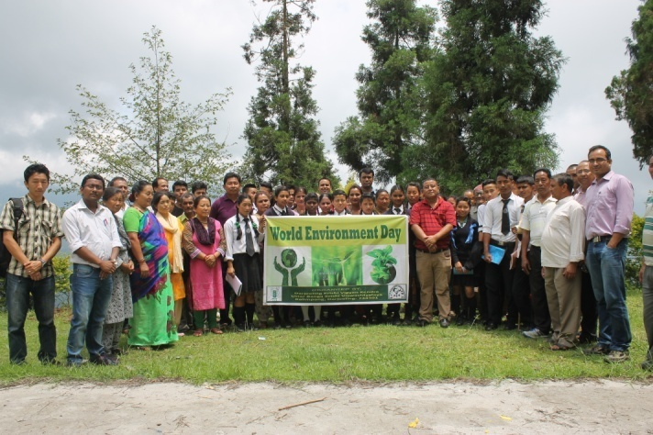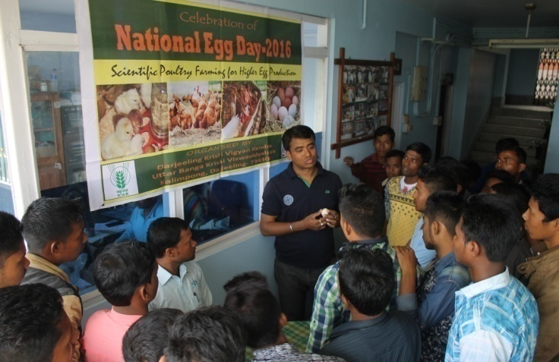
World Environment Day National Egg Day
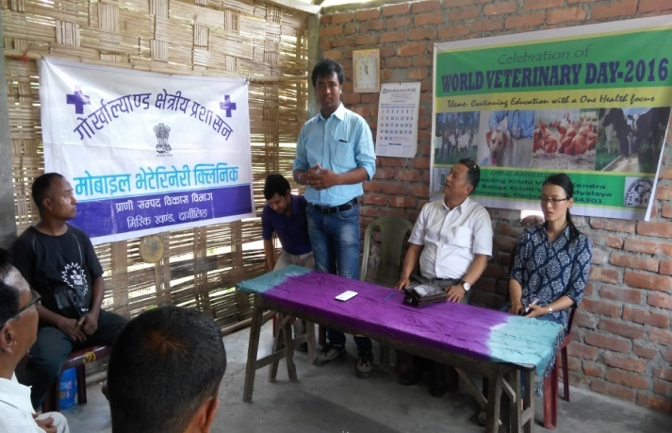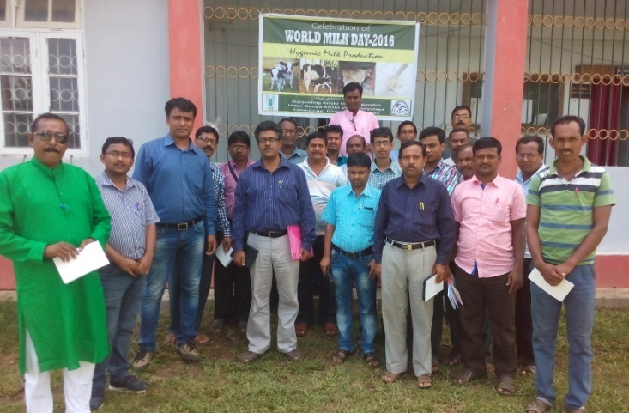
World Veterinary Day World Milk Day
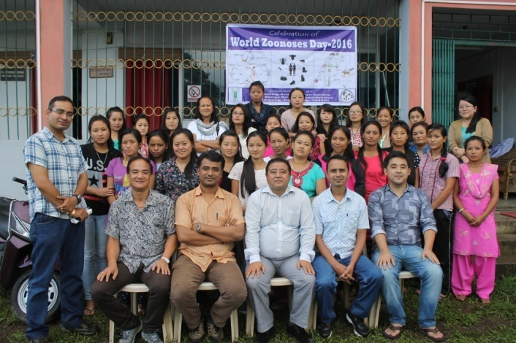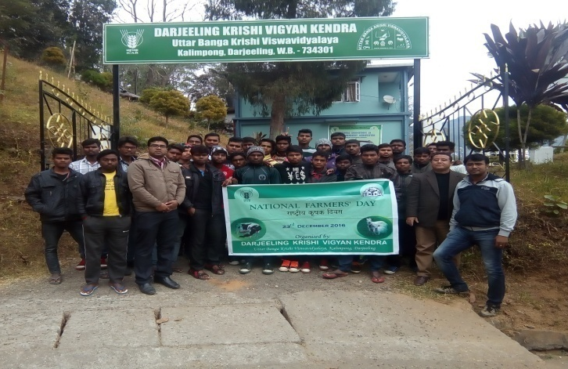
World Zoonosis Day National Farmers Day
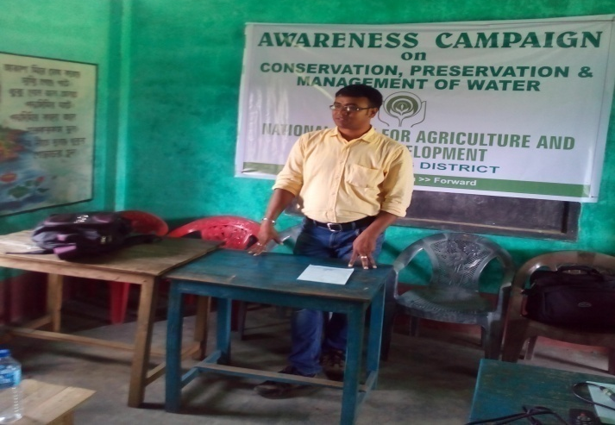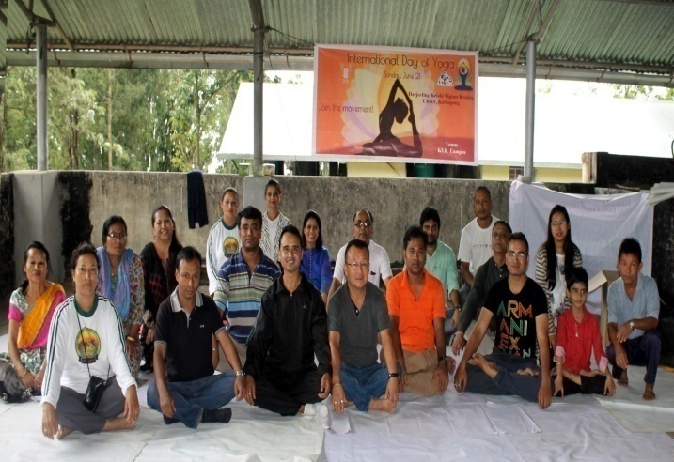
Awareness Programme on Water Conservation International Yoga Day

B. Other Extension activities
Nature of Extension Activity | No. of activities
Newspaper coverage | 27
Radio talks | 1
TV talks | 3
Popular articles | 2
Extension Literature | 2
Other, if any

3.5 Production and supply of Technological products

Village seed
Crop | variety | Quantity of seed  (q) | Value  (Rs) | Provided to number of farmers
Total

KVK farm

Crop | variety | Quantity of seed  (q) | Value  (Rs) | Provided to number of farmers

Production of planting materials by the KVKs
Crop | Variety | No. of planting materials | Value  (Rs) | Provided to number of farmers
Vegetable seedlings
Cauliflower
Cabbage
Tomato
Brinjal
Chilli
Onion
Gerbera |  | 204 | 932 | 5
Fruits
Mango
Guava
Lime
Papaya
Banana
Orange Seedling | Darjeeling Mandarin | 2000 Nos | 44000 | 50
Ornamental plants
Medicinal and Aromatic
Plantation
Large Cardamom Sapling | Bharlangay | 6000 No.s | 57000 | 25
Turmeric | Local | 1.0 | 6000 | 5
Ginger | Gorubathaney | 15 | 60000 | 50
Potato | Jalandhar | 13.05 | 16965 | 30
Elephant yams
Fodder crop saplings
Forest Species
Others, pl.specify
Total

Production of Bio-Products

Name of product | Quantity | Value (Rs.) | No. of Farmers
 | Kg
Bio Fertilisers
Bio-pesticide
Bio-fungicide
Bio Agents
Others
Total

Production of livestock materials
Particulars of Live stock | Name of the breed | Number | Value (Rs.) | No. of Farmers
Dairy animals
Cows
Buffaloes
Calves
Others (Pl. specify)
Poultry
Broilers
Layers
Duals (broiler and layer)
Japanese Quail
Turkey
Emu
Ducks
Others (Pl. specify)
Piggery
Piglet
Others (Pl. specify)
Fisheries
Indian carp
Exotic carp
Others (Pl. specify)
Grand Total

3.6. (A) Literature Developed/Published (with full title, author & reference)

Item | Title | Authors name | Number | Circulation
Research paper | - Interactive ICT tools for goat management.  - Knowledge level and adoption of scientific kid health management among goat owners under field conditions.  - Productive and reproduction performance of dairy animal in Karnal district of Haryana.  - Contract goat farming: an emerging model for livelihood generation among resource poor farmers of western Odisha.  - Adoption level of recommended buffalo husbandry practices by dairy farmers in Uttar Pradesh. | Roy Rakesh and Tiwari Rupasi(2016).  Roy Rakesh, Tiwari Rupasi, Bharti PK and DuttTriveni (2017).  ManjushaJyoti, Roy Rakesh, Kumar Vijay and Gupta Jancy (2016).  ChinmayaSahoo, Rupasi Tiwari,Rakesh Roy,Bharti P.K.and TriveniDutt(2016)  SachanRanjana, Sankhala Gopal, Roy Rakesh and ManjushaJyoti (2016). | - Journal of communication studies. 34(1): 42-49.  - Indian Journal of Animal Science. 87(1):78-79.  - Indian Veterinary Journal. 93(6):38-40  - Indian Journal of Animal Science. 86 (5):609–611  - Indian Journal of Dairy Science69(5): 613-617
Seminar/conference/ symposia papers | Effect of mobile radiation in hill agriculture | Subrata Manna  Kaushik Saha
Books
Bulletins
News letter
Popular Articles
Book Chapter | Trichogramma: An Egg Parasitoid in Insect-Pest Management | Tarak Nath Goswami, Anil, Tarak Brambha Maji, Pranab Barma, and Shree Niwas Ray
 | Coccinellids in Insect Pest Management: Problems and Prospects | Pranab Barma, Suprakash Pal, and Tarak Nath Goswami
Extension Pamphlets/ literature | Importance of Breast feeding | Akriti Pradhan  Subrata Manna
Technical reports
Electronic Publication (CD/DVD etc) | Cultivation of Oyster Mushroom | Akriti Pradhan  Subrata Manna  Basu Deo Kharga
TOTAL
N.B. Please enclose a copy of each. In case of literature prepared in local language please indicate the title in English
(B) Details of HRD programmes undergone by KVK personnel:

S. No. | Name of programme | Name of course | Name of KVK personnel and designation | Date and Duration | Organized by
1. | Gender budgeting for main streaming women in agriculture | Gender budgeting for main streaming women in agriculture | Akriti Pradhan,  SMS Home Science | 6-11th June 2016 | MANAGE
2. | Training of Trainers of KVK trainers at NIRD | Training of Trainers of KVK trainers at NIRD | Dr. Rakesh Roy  Dr. Pranab Barma  Mr. Subrata Manna | 10-12 November 2016 | ASCI
3. | Short Course | Empowerment of farm women through livestock and poultry intervention | Dr. Rakesh Roy | 21-30 November 2016 | ICAR-CIWA, Bhubaneswar
4. | National Conference on Enhancing Nutritional Security through climate smart farming practices | National Conference on Enhancing Nutritional Security through climate smart farming practices | Dr. M W Moktan  Dr. Rakesh Roy  Dr. Pranab Barma  Miss Akriti Pradhan  Mrs. Snehlata Lama  Mr. Subrata Manna  Dr. Basu Deo Kharga | 17-18th March 2017 | COBACAS
5. | HRD & Review Workshop for KVK staff under UBKV |  | Dr. M W Moktan  Miss Akriti Pradhan  Mr. Subrata Manna  Mr. Akash Deep Thapa | 20-21st March 2017 | UBKV
6. | Sensitization Workshop | “Technology Application in Animal and Fishery Sciences” | Dr. Rakesh Roy | 16-17th March | ICAR-ATARI, Zone II

3.7. Success stories/Case studies, if any (two or three pages write-up on each case with suitable action photographs)

3.8. Give details of innovative methodology or innovative technology of Transfer of Technology developed and used during the year

3.9 Give details of indigenous technology practiced by the farmers in the KVK operational area which can be considered for technology development (in detail with suitable photographs)

S. No. | Crop / Enterprise | ITK Practiced | Purpose of ITK
1 | Rice | Brooming of rice plants when there is leaf folder incidence in the field. | To control leaf folder larvae,
2 | Livestock | Feeding of Ganja (Cannabis indica) Juice. | To treat indigestion, diarrhea and dysentery.
3 | Management of soil acidity | Application of wood ash in soil. | To increase in soil acidity.
4 | Soybean | Preparation of fermented Soybean (Kinema). | Used as protein substitute.
5 | Rayo Sag (mustard) | Preparation of dry fermented vegetable for cooking soup, achar etc. | It is also appetizer and for emergency cooking.
6 | Livestock | Leaves of Tetaypati, (Artemisia vulgaris L.) are crushed and extract is applied externally on skin to treat itching. Fresh leaves are cleaned, ground and the sap extracted. | It is used as nasal drop to stop nose bleeding.

3.10 Indicate the specific training need analysis tools/methodology followed by KVKs

3.11. a. Details of equipment available in Soil and Water Testing Laboratory

Sl. No | Name of the Equipment | Qty.
1. | Spectrophotometer | 1
2. | Flame Photometer | 1
3. | PH Meter | 1
4. | Conductivity bridge | 1
5. | Physical balance | 1
6. | Chemical balance | 1
7. | Digestion unit | 1
8. | Kjeldhal Distillation set | 2
9. | Mechanical shaker | 1
10. | Refrigerator | 1
11. | Hot air oven | 1
12. | Hot plate | 1
13. | Grinder | 1
14. | Water distillation unit (double) | 1
15. | Chemical and Glass wares
16. | Soxlet Apparatus (Big &Small) | 2
17. | Laboratory set up
18. | Soil and plant sample processing and storage facility
Total |  | 17

3.11.b. Details of samples analyzed so far :
Details | No. of Samples | No. of Farmers | No. of Villages | Amount realized
-- | -- | -- | -- | --
Total

3.12. Activities of rain water harvesting structure and micro irrigation system

No of training programme | No of demonstrations | No of plant material produced | Visit by the farmers | Visit by the officials
-- | -- | -- | -- | --

3.13 Technology week celebration

Type of activities | No. of activities | Number of participants | Related crop/livestock technology
Training | 5 | 122 | Orange, Ginger, Goatery, Poultry, Piggery
Demonstration | 15 | 500 | Agricultural and Livelihood
Exhibition | 1 | 162 | All agricultural, Horticultural and Animal exhibits

3.14. RAWE programme - is KVK involved?

No of student/ARS trained | No of days stayed
10 | 21

3.15. List of VIP visitors (MP/MLA/DM/VC/Zila Sabhadipati/Other Head of Organization/Foreigners)

Date | Name of the person | Purpose of visit
21/02/2017 | MLA, Kalimpong | Mela Inauguration
 | VC, UBKV | For monitoring
15-16 December 2016 | Director, NICRA | NICRA zonal workshop
15-16 December 2016 | ZPD, ICAR, Zone II | NICRA zonal workshop

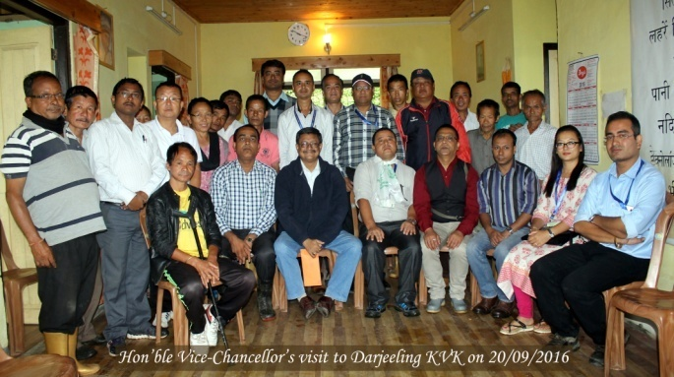
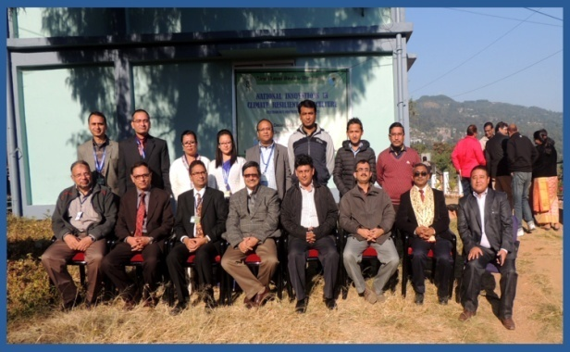

4.0 IMPACT

  - Impact of KVK activities (Not to be restricted for reporting period).

Name of specific technology/skill transferred | No. of participants | % of adoption | Change in income (Rs.)
 |  |  | Before (Rs./Unit) | After (Rs./Unit)
Off season production of vegetable crops under low cost polyhouse | 2 | 100 | 2000 | 3500
NB: Should be based on actual study, questionnaire/group discussion etc. with ex-participants

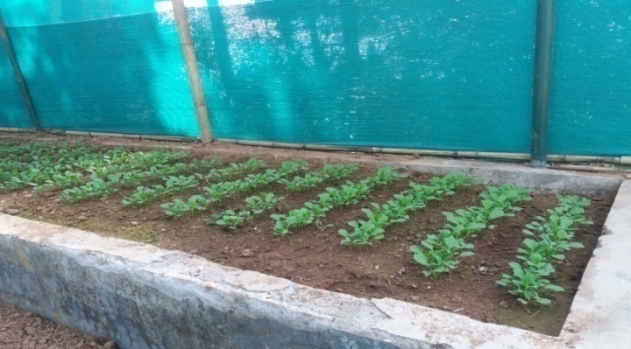

4.2 Cases of large scale adoption
(Please furnish detailed information for each case)
Horizontal spread of technologies
Technology | Horizontal spread
Nutritional management of Darjeeling Mandarin | The technology is horizontally spreading in the village where it was demonstrated

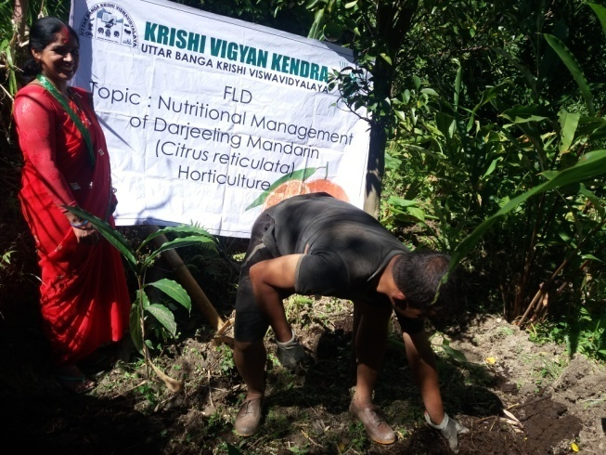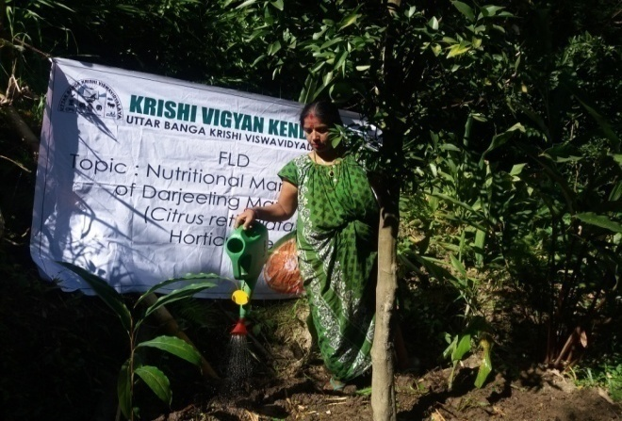

4.3 Details of impact analysis of KVK activities carried out during the reporting period
4.4 Details of innovations recorded by the KVK

Thematic area | --
Name of the Innovation | --
Details of Innovator | --
Back ground of innovation | --
Technology details | --
Practical utility of innovation | --

4.5 Details of entrepreneurship development

Entrepreneurship development
Name of the enterprise | --
Name & complete address of the entrepreneur | --
Intervention of KVK with quantitative data support: | --
Time line of the entrepreneurship development | --
Technical Components of the Enterprise | --
Status of entrepreneur before and after the enterprise | --
Present working condition of enterprise in terms of raw materials availability, labour availability, consumer preference, marketing the product etc. ( Economic viability of the enterprise): | --
Horizontal spread of enterprise | --
4.6 Any other initiative taken by the KVK

5.0 LINKAGES

5.1 Functional linkage with different organizations

Name of organization | Nature of linkage
State Agriculture Dept., Govt. of West Bengal | Training
Regional Research Station (Hill Zone), Uttar Banga Krishi Viswavidyalaya, Kalimpong
Dept. of Animal Recourses Development, Govt. of West Bengal
Sasastra Seema Bal (SSB), Siliguri Frontier
Regional Station, Indian Agricultural Research Institute, Kalimpong
Regional Research Station (Hill Zone), Uttar Banga Krishi Viswavidyalaya, Kalimpong | Demonstration
State Agriculture Dept., Govt. of West Bengal
Regional Research Station (Hill Zone), Uttar Banga Krishi Viswavidyalaya, Kalimpong | Joint Survey
State Agriculture Dept., Govt. of West Bengal
State Agriculture Dept., Govt. of West Bengal | Technical Support
Regional Research Station (Hill Zone), Uttar Banga Krishi Viswavidyalaya, Kalimpong
Dept. of Animal Recourses Development, Govt. of West Bengal
Spices Board, Kalimpong, Govt. of India
Regional Station, Indian Agricultural Research Institute, Kalimpong

5.2. List of special programmes undertaken during 2016-17 by the KVK, which have been financed by ATMA/ Central Govt/ State Govt./NABARD/NHM/NFDB/Other Agencies (information of previous years should not be provided)

a) Programmes for infrastructure development

Name of the programme/scheme | Purpose of programme | Date/ Month of initiation | Funding agency | Amount (Rs.)
Repairing and maintenance of Building | Repairing | March 17 | ICAR | 400000
Repairing and maintenance of Farm Road | Repairing | March 17 | ICAR | 200000
Support to IFS | IFS | March 17 | ICAR | 490000
Repairing and maintenance of Electric work | Repairing | March 17 | ICAR | 200000

(b) Programme for other activities (training, FLD,OFT, Mela, Exhibition etc.)

Total
Name of the programme/scheme | Purpose of programme | Date/ Month of initiation | Funding agency | Amount (Rs.)

- PERFORMANCE OF INFRASTRUCTURE IN KVK

6.1 Performance of demonstration units (other than instructional farm)

Sl. No. | Name of demo Unit | Year of estt. | Area(Sq.mt) | Details of production |  |  | Amount (Rs.) |  | Remarks
 |  |  |  | Variety/breed | Produce | Qty. | Cost of inputs | Gross income
1.
2.
3.
4.
5.
6.
7.
 | Total

6.2 Performance of instructional farm (Crops)
Name  Of the crop | Date of sowing | Date of harvest | Area (ha) | Details of production |  |  | Amount (Rs.) |  | Remarks
 |  |  |  | Variety | Type of Produce | Qty.(q) | Cost of inputs | Gross income
Potato |  | 29/05/2016 |  | Jalandhar | Tuber | 13.05 |  | 16965
Gerbera |  |  |  |  | Cutflower | 204 |  | 932
Orange Seedling |  |  |  | Darjeeling Mandarin |  | 2000 Nos |  | 44000
Large Cardamom Sapling |  |  |  | Bharlangay |  | 6000 No.s |  | 57000
Ginger |  |  |  | Gorubathaney |  | 15 |  | 60000
Turmeric |  |  |  | Local |  | 1.0 |  | 6000
Large Cardamom |  |  |  | Bharlangay |  | .01 |  | 8000

  - Performance of Production Units (bio-agents / bio pesticides/ bio fertilizers etc.,)

Sl.  No. | Name of the Product | Qty (Kg) | Amount (Rs.) |  | Remarks
 |  |  | Cost of inputs | Gross income
1. | -- | -- | -- | -- | --

  - Performance of instructional farm (livestock and fisheries production)

Sl.  No | Name  of the animal / bird / aquatics | Details of production |  |  | Amount (Rs.) |  | Remarks
 |  | Breed | Type of Produce | Qty. | Cost of inputs | Gross income
1. | -- | -- | -- | -- | -- | -- | --
2.
3.

6.5 Utilization of hostel facilities

Accommodation available (No. of beds) : 30

Months | No. of trainees stayed | Trainee days  (days stayed) | Reason for short fall (if any)
April 16 | 15 | 3 | --
July 16 | 20 | 3 | --
Aug 16 | 18 | 3 | --
Oct 16 | 21 | 2 | --
Dec 16 | 30 | 10 | --
Jan 17 | 30 | 10 | --
Total : | 134 | 31 | --
(For whole of the year)

6.6 Utilization of staff quarters

Whether staff quarters has been completed: Yes
No. of staff quarters: 6
Date of completion: 2009

Occupancy details: All Quarters Occupied except Senior Scientist & Farm manager’s Quarters

Months | Q I | QII | Q III | QIV | Q V | QVI

- FINANCIAL PERFORMANCE

7.1 Details of KVK Bank accounts

Bank account | Name of the bank | Location | Account Number
Darjeeling KVK | State Bank of India | Kalimpong | 11283931150
Darjeeling KVK | Bank of India | Kalimpong | 429310110000033

  - Utilization of funds under FLD on Oilseed (Rs. In Lakhs)

Item | Released by ICAR |  | Expenditure |  | Unspent balance as on -
 | Kharif | Rabi | Kharif | Rabi
Mustard |  | 90000 |  | 89327 | 770

7.3 Utilization of funds under FLD on Pulses (Rs. In Lakhs)
Item | Released by ICAR |  | Expenditure |  | Unspent balance as on 1st April 2013
 | Kharif | Rabi | Kharif | Rabi
Blackgram | 150000 |  | 149515 |  | 485
Greengram | 150000 |  | 149690 |  | 310

7.4 Utilization of funds under FLD on Maize (Rs. In Lakh)

Item | Released by ICAR |  | Expenditure |  | Unspent balance as on 1st April 2012
 | Kharif | Rabi | Kharif | Rabi
TOTAL

7.5 Utilization of KVK funds during the year 2016-17 (Not audited)

S.  No. | Particulars | Sanctioned | Released | Expenditure
A. Recurring Contingencies
1 | Pay & Allowances | 91.25 | 91.25 | 90.61275
2 | Traveling allowances | 1.50 | 1.50 | 1.50
3 | Contingencies
A | Stationaries, Telephone, Postage and other office charges | 4.40 | 4.40 | 4.39950
B | POL, Reapair of vehicle, Tractor & Equipment
C | Training of farmers | 1.80 | 1.80 | 1.79540
D | Training materials( Posters, chart, Demonstration materials including chemnical etc require for conducting the training
E | Training of Extension functionaries
F | Training of rural youths
G | Front Line Demonstration (minimum of 100 demonstration in a year) | 1.20 | 1.20 | 1.1943
H | On Farm Testing (Only based, location specific & newely generated information in the major production of the year) | 0.60 | 0.60 | 0.60
I | Maintenance of Building (Repairing and maintenance of Building 4.0, Support to IFS 4.90, Repairing and maintenance of farm Road 2.00, Repairing and maintenance of electrical work, sanitation and water supply 2.00, Contractual salary0.75) | 13.65 | 13.65 | 13.65
J | TSP | 6.00 | 6.00 | 5.98250
TOTAL (A)
B. Non-Recurring Contingencies
1 | Office furniture and furnishing | 2.00 | 2.00 | 2.00
2
TOTAL (B)
C. REVOLVING FUND
GRAND TOTAL (A+B+C)

7.6. Status of revolving fund (Rs. in lakh) for last three years

Year | Opening balance as on 1st April | Income during the year | Expenditure during the year | Net balance in hand as on 1st April of each year (Kind + cash)
2014-15 | 235652 | 228661 | 47472 | 416841
2015-16 | 416841 | 1724056 | 1637151.52 | 503745.48
2016-17 | 503745.48 | 211967 | 278520 | 437192.48

7.6.

- Number of SHGs formed by KVKs : NIL

- Association of KVKs with SHGs formed by other organizations indicating the area of SHG activities.

MLLDB
World Vision
CADC
DRDC
Krishak Kalyan Sangathan

  - Details of marketing channels created for the SHGs
NA

  - Special programme on Food and Nutrition :
- Training and awareness on preparation of Weaning food for children
- Preparation of low cost supplementary foods for pregnant and lactating mothers
- Celebration of International Breast Feeding Week.
- Awareness programme for primary school children on nutrition health & sanitation
- Health checkup and nutrition programme for farm tribal women

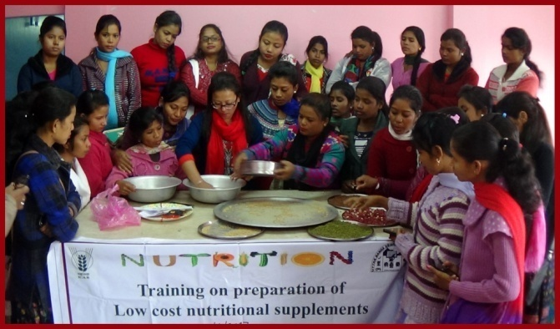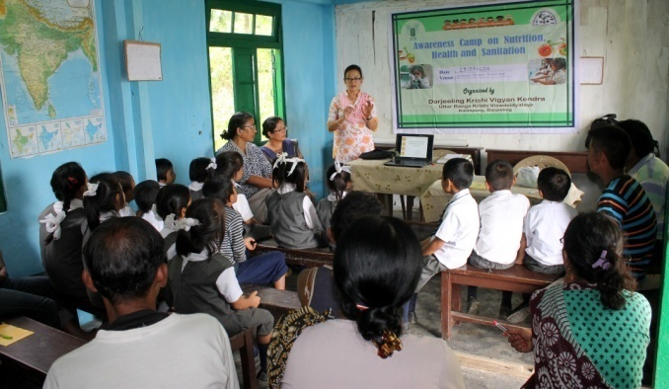

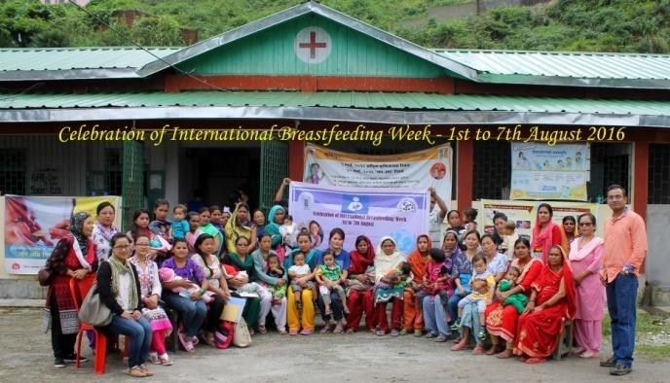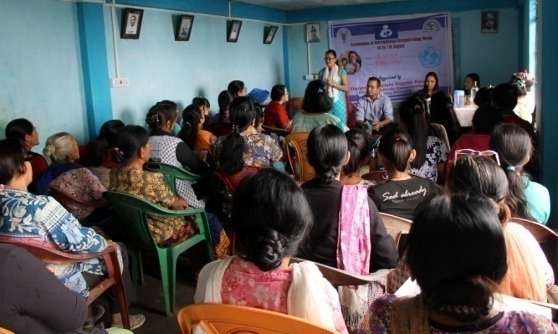

  - Joint activity carried out with line departments and ATMA

Name of activity | Number of activity | Season | With line department | With ATMA | Both
Exposure Visit | 15 | Not specified |  | 15

8. Initiative taken towards organic farming by the KVK (area brought under organic farming, crops cultivated through organic means and other relevant information)

9. Other information

9.1. Prevalent diseases in Livestock/Crops/Fishery

Name of the disease | Crop/animal | Date of outbreak | Number of death/ % commodity loss | Number of animals vaccinated
9.2. Nehru Yuva Kendra (NYK) Training :NA

Title of the training programme | Period |  | No. of the participant |  | Amount of Fund Received (Rs)
 | From | To | M | F
-- | -- | -- | -- | -- | --

9.3. PPV & FR Sensitization training Programme
Date of organizing the programme | Resource Person | No. of participants | Registration (crop wise)
 |  |  | Name of crop | No. of registration
-- | -- | -- | -- | --

9.4.a SMS PORTAL
Date of start of functioning of SMS portal
No. of messages | No. of calls | No. of farmers covered | Types of messages (No.)
 |  |  | Crop | Livestock | Weather | Marketing | Awareness | Other
381 | - | 288468 | 10 | 361 | - | - | 10 | -

9.4.b Information in uploading KVK Portal by KVKs during 2016-17
Sr. No. | Name of item/ events/ component | Uploading status (Yes/No) | No. uploaded | Remarks, if any
1 | KVK Profile | Yes
2 | Employee details | Yes
3 | Post | Yes
4 | Finance | Yes
5 | Soil Health Card | No
6 | Appliance | Yes
7 | Crops
8 | Resources
9 | Fish
10 | Past events | Yes
11 | Future/ upcoming events | No
12 | Facilities available at KVKs | Yes
13 | Package and practices | Yes
14 | Crop
15 | Livestock
16 | Fishery
17 | Horticulture
18 | CFLD on Pulses | Yes
19 | 2016-17
20 | 2015-16
21 | CFLD Oilseeds
22 | 2016-17
23 | 2015-16

9.5 Observation of Swacha Bharat Programme
Date of Observation | Activities undertaken
24/10/16  25/10/16  26/10/16  27/10/16  28/10/16 | Imparted knowledge about the cleanliness, recycling of kitchen wastes, vermi-compost preparation.

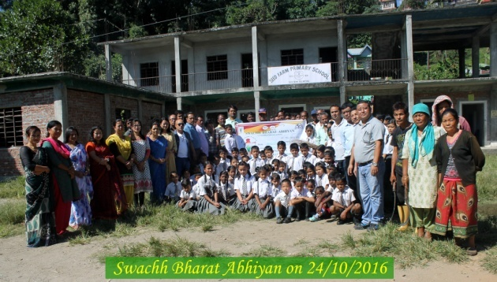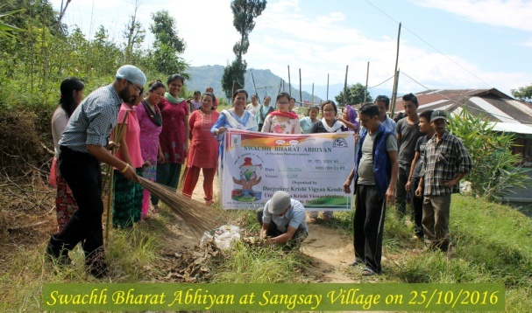

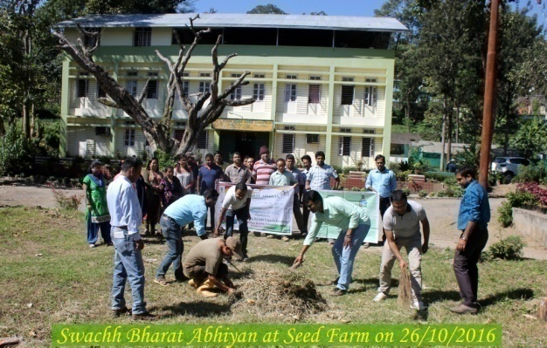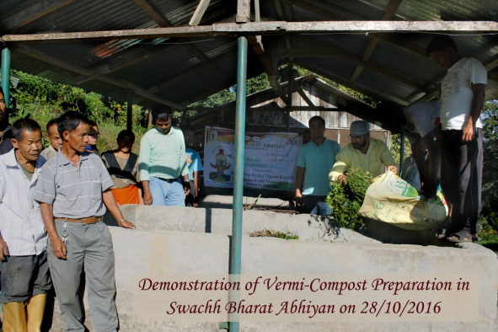

9.6 Observation of National Science day

Date of Observation | Activities undertaken
-- | --

9. 7.Programme with Sashratra Seema Bal (SSB)
Title of Programme | Date | No. of participants
Entrepreneurship development of through Goatery | 08/01/17 | 30
Entrepreneurship development of through Piggery | 15/01/17 | 30
9.8 Agriculture Knowledge in rural school:

Name and address of school | Date of visit to school | Areas covered | Teaching aids used
Gangotri HS School, Kpg | 10/03/2017 | Agriculture | A/V aid

9.9. Details of Kharif and Rabi Sammelan (Information should be provided in two separate tables – one for Kharif and another for Rabi Sammelan)

Name of the state | Name of district/KVK | Date on which conducted | Number of participants |  | Name of public representative | Details of Technology Demonstrated and other programmes organized
 |  |  | Farmers | Others
WB | Darjeeling | 22-23 Dec 2016 | 190 | 145 | ADA Mirik | Training, Exhibition, Film Show and Demonstration
 |  | 21-23 Feb 2017 | 227 | 163 | MLA Kaimpong | Training, Exhibition, Film Show and Demonstration

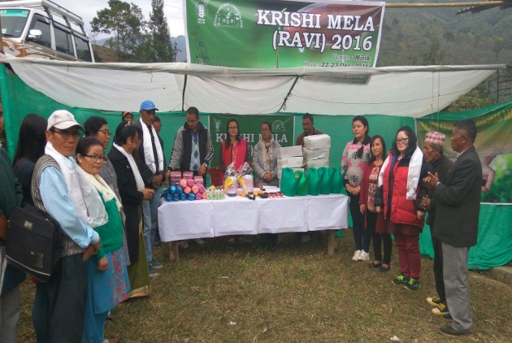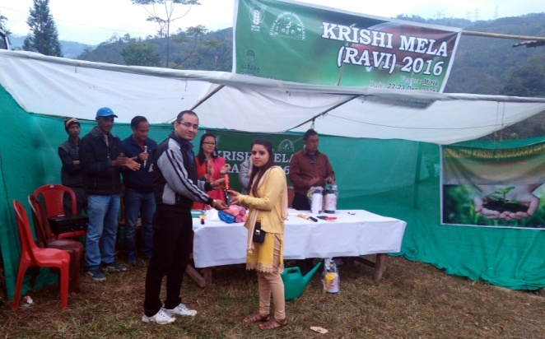

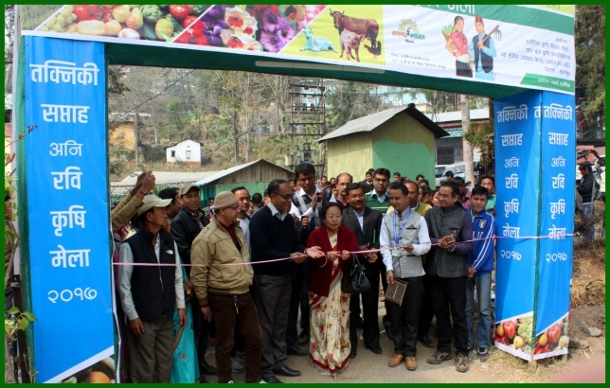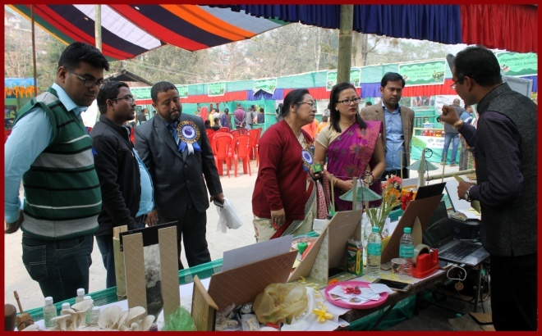

9.10. Details of Pradhan Mantri Fasal Bima Yojana programme organized

Name of the state | Name of district/KVK | Date on which conducted | Number of participants |  | Name of public representative | Details of awareness created and other programmes organized
 |  |  | Farmers | Others
WB | Darjeeling | 05/07/2016  11/01/2017 | 42 | 16 | Not attended | In Darjeeling district Maize and Paddy is covered under PMFBY  Awareness camp were conducted for this programme.

9.11. Contingent crop planning

Name of the state | Name of district/ KVK | Thematic area | Number of programmes organized | Number of Farmers contacted | A brief about contingent plan executed by the KVK
-- | -- | -- | -- | -- | --

9.12. Report on Citizens’ Client Charter (attending the requests seeking guidance on agricultural
technology and technology products)

Sl. No. | Services/ Transaction | Process | Service Standard | No. of such services attended by KVKs and ATICs during the year | No. of such services pending with KVK/ATIC beyond 30 days
1. | Guidance on Agricultural technology and technology products | Personal contact by the Service Sectors with the responsible person of KVK/ATIC | -- | -- | --

9.13. Community Radio Station : NA

Date of establishment:

Amount of fund received year wise :

Source of fund:

Achievements:

Sr. no | Community Radio Stations (CRS) | No of programmes in the year | Total broadcast hrs in a month | Please specify details of the broadcasts
A.  B. | Agricultural broadcasts  - Talks/interviews/discussions with experts, PG students/ and farmers on Agricultural technologies  - Agro-climatic conditions, weather and marketing advisory  - Phone–in programme of interface with experts  - Phone-in programme with interface of progressive/innovative farmers  - Success stories of progressive farmers  - Success stories in FLD/OFT/ Trainings /Extension activities  - Women in agriculture programme  - Discussions on current issues in agriculture and allied sectors.  - KVK happenings  - Agricultural University professors.  - Any other(please specify)  Community development broadcasts  Please specify the programmes like rural development, educational, health, environment, public service broadcasts, sports etc.

9.14 No. of Progressive/Innovative/Lead farmer identified (category wise) :
Agriculture : 3
Horticulture:5
Animal Husbandry: 5

9.15 HRD programmes organized by the KVK

Training programme/ Seminar/ Symposia/ Workshop etc attended | Duration | Name of the  participants | Designation | Organizer of the training Programme
NICRA Workshop | 2

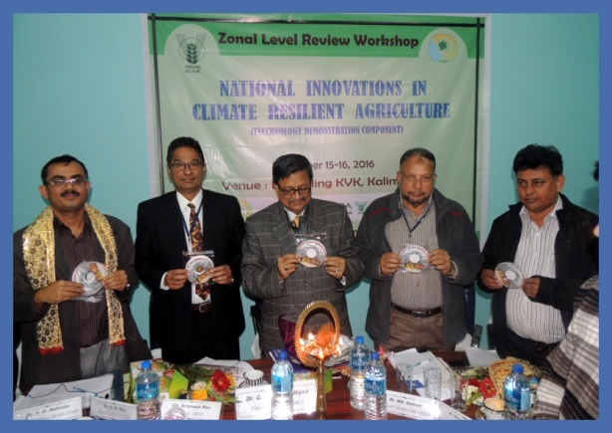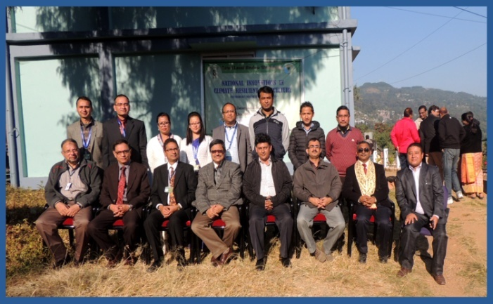

9.16. Revenue generation:
SL.No. | Name of Head | Income(Rs.) | Sponsoring agency
1. | Hostel Feed | 60000 | SSB, Kishanganj
2. | Rent of Conference hall | 20000 | SSB, Kishanganj
3. | Institutional Charges | 56000 | SSB, Kishanganj

9.17. Resource Generation:
SL.No. | Name of the programme | Purpose of the programme | Sources of fund | Amount  (Rs. lakhs) | Infrastructure created
-- | -- | -- | -- | -- | --

9. 18. Performance of Automatic Weather Station in KVK
Date of establishment | Source of funding i.e. IMD/ICAR/Others (pl. specify) | Present status of functioning
NA | -- | --

10. Details of TSP Project

Name of the village adopted under TSP | Block | Population of the village |  |  | ST Population of the village |  |  | Percentage of ST population to total population
 |  | M | F | T | M | F | T
Sangsay | Block II | 3215 | 2618 | 5833 | 1446 | 916 | 2362 | 40.5
Bidyang | Block I | 2155 | 1916 | 4071 | 926 | 785 | 1711 | 42.1
Chenga | Mirik | 2644 | 2168 | 4812 | 846 | 650 | 1496 | 31.1
Sittong | Kurseong I | 2388 | 2138 | 4526 | 1098 | 940 | 2038 | 45.1

Physical achievements under TSP during 2016-17

Programmes | Physical achievements 2016-17
Asset creation (Number; Sprayer, ridge maker, pump set, weeder etc.) | Secateuar 20 No.  Garden Tools – 20 No.  Budding & Grafting Kinife – 20  Knapsack sprayer – 2  Hand Sprayer – 20 No.  Watering Can – 20 No. (10L)  Watering Can – 20 No. (5L)  Water Tank – 1000L – 2 No.  Poly pipe – 10 Coil (1 Inch)  Salpaulin – 20 No.
On-farm trials (Number) | 1
Frontline demonstrations (Number) | 2
Farmers training (in lakh)
Extension personnel training (in lakh)
Participants in extension activities (in lakh)
Seed production (in tonnes) | 1.5 t
Planting material production (in lakh) | 2000
Livestock strains and fingerlings production (in lakh) | 10 pig, 8 goat
Soil, water, plant, manures samples testing (in lakh) | 0
Provision of mobile agro – advisory to farmers (in lakh) | 80000
Others (Swachha Bharat Abhiyaan, Agriculture knowledge in rural school, Planting material distribution, Vaccination camp etc.) | 10

Fund received under TSP in 2016-17: 6.00 lakh

11. Progress Report OF NICRA KVK (Technology Demonstration component) 2016-17
(Applicable for KVKs identified under NICRA)

Natural Resource Management
Name of intervention undertaken | Numbers under taken | No of units | Area (ha) | No of farmers covered / benefitted | Remarks

Crop Management
Name of intervention undertaken | Area (ha) | No of farmers covered / benefitted | Remarks

Livestock and fisheries
Name of intervention undertaken | Number of animal covered | Number of units | Area (ha) | No of farmers covered / benefitted | Remarks

Institutional interventions
Name of intervention undertaken | No of units | Area (ha) | No of farmers covered / benefitted | Remarks

Capacity building
Thematic area | No. of Courses | No. of beneficiaries
 |  | Males | Females | Total
Extension activities
Thematic area | No. of activities | No. of beneficiaries
 |  | Males | Females | Total
Detailed report should be provided in the circulated Performa

12. Information on NFDB Funded Capacity building programme during 2016-17

Sl. No. | Name of capacity building training programme | Duration (days) | Date of programme | Fund (Rs.) sanctioned by NFDB, Hyderabad | No. of Farmers  trained | Remarks, if any
1
2
Total

13. National Initiative on Fodder Technology Demonstration (NIFTD)
(Applicable for KVKs identified under NIFTD)

Name of the fodder crop | Date of sowing | Area (ha) | No. of farmers  involved | Demonstration  Yield (q/ha) |  |  | Check Yield |  |  | % increase
 |  |  |  | H | L | A | H | L | A
-- | -- | -- | -- | -- | -- | -- | -- | -- | -- | --

Economic of Demonstration
Name of the fodder crop | Demonstration Cost/Rs/ha |  |  | Check Cost (Rs/ha)
 | Gross cost | Gross return | BC ratio | Gross cost | Gross return | BC ratio
-- | -- | -- | -- | -- | -- | --

14. Awards/Recognition received by the KVK

Sl. No. | Name of the Award | Year | Conferring Authority | Amount | Purpose
--- | -- | --- | -- | --- | --

Award received by Farmers from the KVK district
Sl. No. | Name of the Award | Name of the Farmer | Year | Conferring Authority | Amount | Purpose
1 | Best farmer | Yogendra Kharga | 2017 | UBKV | Felicitation
2 | Best Florist | Arun Kr. Chettri | 2017 | UBKV | Felicitation

15. Any significant achievement of the KVK with facts and figures as well as quality photograph

Livestock Business Farming in hills: A sustainable employment for youth
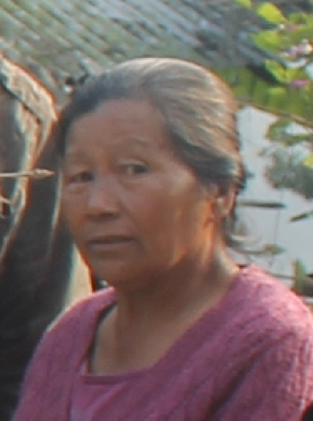
Premkit Simick Lepcha, an enthusiastic tribal lady also an ex-army at the age of more than 60 years had shown a way of livestock business farming in the low hills. In her service life she had serve the nation with her dedication, sincerity and hard work. After her retirement she always had a zeal to do somethings which itself will be an example. She had started trying out backyard livestock farming. Now, she is one of the leading livestock farmers in the region. She is living in one of the remote village in the district where there was no approach road few years back.
She is one of the successful pig breeders in the area. She had a breeder stock of three Hampshire and two Duroc pig. She had more than 250 numbers of poultry birds comprising Vanaraja, Australop, cross breed of Vanaraja and Autralop and desi poultry birds. She also had 4 Siri type dairy cattle.
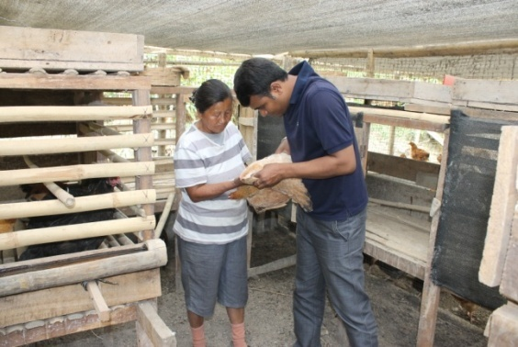
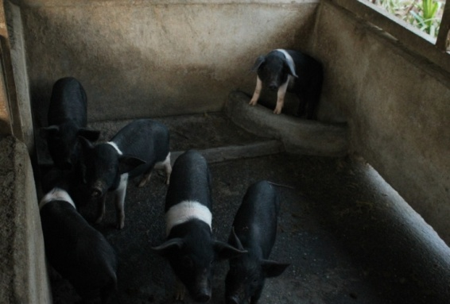
Inspiteof poor connectivity to the town she is in regular contact with Krishi Vigyan Kendra for the scientific techniques of livestock farming. Krishi Vigyan Kendra, Kalimpong always use to provide her scientific knowledge which enhanced the production performance of her livestock. She is deworming in her livestock on regular basis. She always supplements iron to her piglet to check mortality due to piglet anaemia. She vaccinate her pig against swine fever; poultry against Ranikhet disease and Gumboro and cattle against foot and mouth disease, haemorrhagic septicaemia and black quarter by which she reduces the disease incidence in her livestock and check morbidity and mortality. Thereby reduces the economic losses due to livestock diseases.
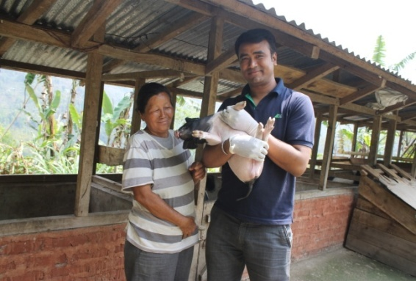
She had a significant income from different livestock species. She sells piglet as well as pig for meat purpose. She sells poultry egg and live chicken for meat purpose. Egg and meat of Vanaraja, Australop, cross breed of Vanaraja and Autralop and desi poultry birds always have a high demand in the market. Selling of milk is also a significant source of income to her total income. Due to poor connectivity to the town she had to sell her product in comparatively low rate, even though she had an annual income of more than 3 lakhs from different livestock species.
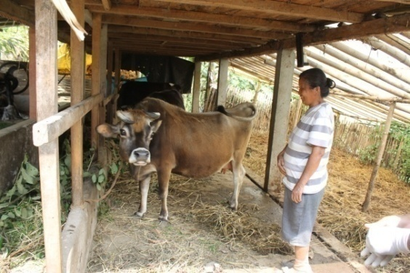
She use to inspire the youth in livestock farming by donating piglets to those who are in need of employment and use migrate to big cities of their livelihood. Now, she is a role model for many and a source of inspiration of young generation. She used to tell if at the age of more than 60 years she can earn from livestock farming then why youth couldn’t earn from it. She always used to tell that nobody should lose hope and never give up.

16. List of 5000 farmers with mobile number and Aadhar card number (only soft copy to be enclosed)

Collection of data is going on.

17. Number of commodity based organizations/ farmers’ cooperative society formed during last one year
(Details of the group/society may be indicated)

NIL

18. Any other programme organized by KVK not covered above
Organized Training programme under ASCI as Training partner for NSDC on Broiler Poultry Farm Worker and Bee Keeping.

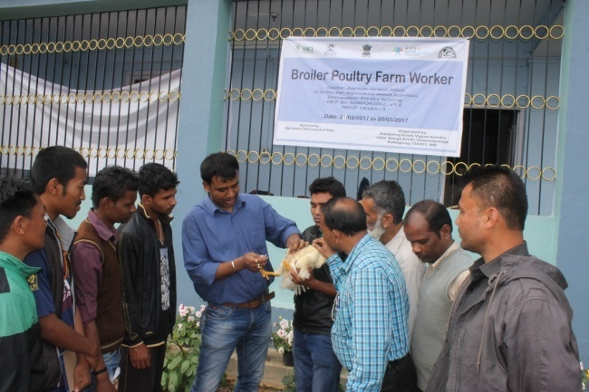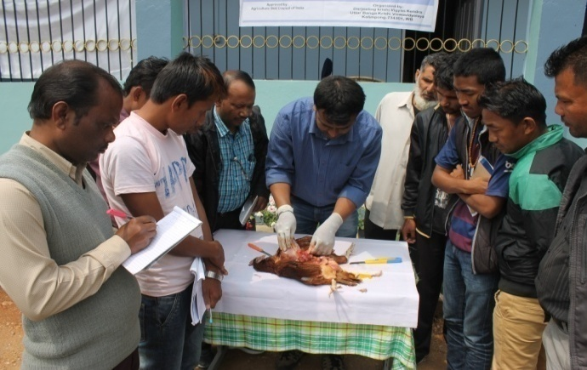

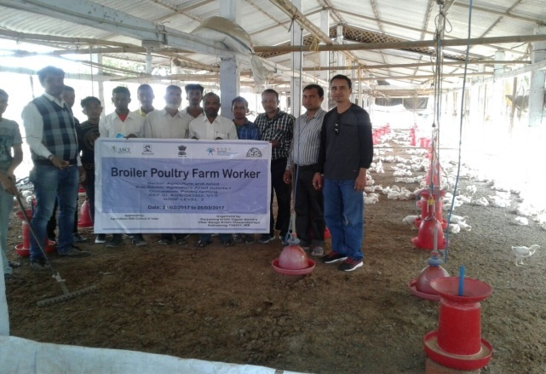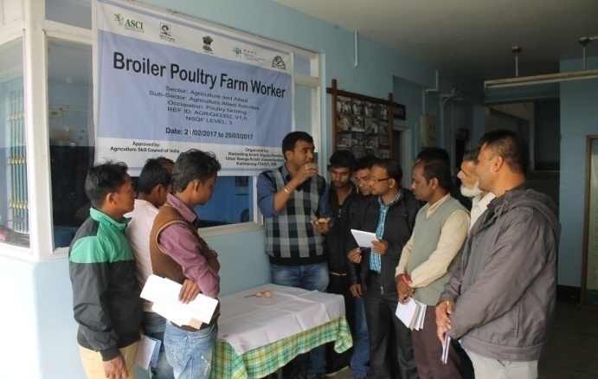
Training on Broiler Poultry Farm Worker

Making of Video film on Integrated farming system for hill region and Clean milk production and its processing by Doordarshan, Jalpaiguri on our progressive farmer.

