Edited by: Dr. M. W. Moktan

Contributed by : Mrs. Akriti Pradhan
: Dr. Pranab Barma
: Mrs. Snehalata Lama
: Dr. Ranajit Panda
: Dr. Subrata Manna
: Dr. Basu Deo Kharga
: Mr. Akash Deep Thapa
: Mr. Dinesh Kumar Diyali

Compiled by : Dr. Subrata Manna
Dr. Basu Deo Kharga

PROFORMA FOR ANNUAL REPORT 2020 (January 2020 to December 2020)

1. GENERAL INFORMATION ABOUT THE KVK

1.1. Name and address of KVK with phone, fax and e-mail

Address | Telephone |  | E mail
 | Office | FAX
Darjeeling KVK  Uttar Banga Krishi Viswavidyalaya  Kalimpong, Darjeeling, West Bengal - 734301 | 03552 256283 | 03552 256283 | djkvk@yahoo.com  djkvk93@gmail.com

1.2 .Name and address of host organization with phone, fax and e-mail

Address | Telephone |  | E mail
 | Office | FAX
Dr. Prabhat Pal  Uttar Banga Krishi Viswavidyalaya  P.O Pundibari, Cooch Behar | 03582-270141/986 | 03582-270249/986 | dee_ubkv@gmail.com

1.3. Name of Senior Scientist and Head with phone & mobile No.

Name | Telephone / Contact
 | Residence | Mobile | Email
Dr. Mendel Wangchuk Moktan | 10½ Mile, Kalimpong  9434407412 | 9434407412 | mendelmw@gmail.com

1.4. Year of sanction of KVK: 1993

1.5. Staff Position (as on 1st Jan, 2021)

Sl.  No. | Sanctioned post | Name of the incumbent | Designation | Discipline/ | Pay  Scale with present basic | Date of joining | Permanent/  Temporary | Category (SC/ST/  OBC/  Others)
1 | Senior Scientist& Head | Dr. Mendel Wangchuk Moktan | Senior Scientist- cum- Head | Agril. Extension | PB-4 | 10.12.2001 | Permanent | ST
2 | Subject Matter Specialist | Mrs Akriti Pradhan | SMS | Home Science | PB – 3 | 14/07/2014 | Permanent | OBC
3 | Subject Matter Specialist | Dr. Pranab Barma | SMS | Plant Protection | PB – 3 | 21/07/2014 | Permanent | SC
4 | Subject Matter Specialist | Mrs. Snehlata Lama | SMS | Horticulture | PB – 3 | 25/11/2014 | Permanent | ST
5 | Subject Matter Specialist | Dr. Ranajit Panda | SMS | Soil Science | PB-3 | 02/11/2018 | Permanent | General
6 | Subject Matter Specialist | Dr. M Hasan Khan | SMS | Animal Science | PB-3 |  | Permanent | OBC
7 | Subject Matter Specialist | Vacant | SMS | Agril Extension
8 | Programme Assistant | Dr. Basu Deo Kharga | Programme Assistant (Training) | Agril. Extension | PB – 3 | 20.06.2007 | Permanent | General
9 | Computer Programmer | Dr. Subrata Manna | Programme Assistant | Computer Science | PB – 3 | 30.01.2006 | Permanent | OBC
10 | Farm Manager | Akash Deep Thapa | Farm Manager | Agril. Extension | PB – 3 | 02.07.2007 | Permanent | OBC
11 | Accountant / Superintendent | Dinesh Kr.Diyali | Assistant | M.com. | PB – 2 | 30.01.2006 | Permanent | SC
12 | Stenographer | Mr. Bhaskar Roy | Stenographer Gr III | B.A | PB-1 | 31/05/2019 | Permanent | SC
13. | Driver | Ashok Tamang | Driver | HS | PB – 1 | 12.09.2007 | Permanent | ST
14. | Driver | Harish Kr.Chhetri | Driver | HS | PB – 1 | 13.09.2007 | Permanent | General
15. | Supporting staff | Mrs. Mingma Lhamu Lama | Supporting staff | HS | PB-1 | 31/10/2014 | Permanent | ST
16. | Supporting staff | Sri Sandeep Thapa | Supporting staff | B.A. | PB-1 | 03/11/2014 | Permanent | OBC

1.6. Total land with KVK (in ha) :

S. No. | Item | Area (ha)
1 | Under Buildings
2. | Under Demonstration Units | 1.00
3. | Under Crops | 2.50
4. | Orchard/Agro-forestry | 1.88
5. | Others with details | 16.77
 | Total | 22.4
Total area should be matched with breakup

1.7. Infrastructure Development:

- Buildings and others

S. No. | Name of infrastructure | Not yet started | Completed up to plinth level | Completed up to lintel level | Completed up to roof level | Totally completed | Plinth area (sq.m) | Under use or not* | Source of funding
1. | Administrative  Building |  |  |  |  | 2004 | 293 | Yes | ICAR
2. | Farmers Hostel |  |  |  |  | 2006 | 293 | Yes | ICAR
3. | Staff Quarters (6) |  |  |  |  | 2009 | 400 | 4 out of 6 | ICAR
4. | Piggery unit |  |  |  |  | 2012 | 14 | Yes | RKVY Project
5 | Fencing |  |  |  |  | 2018
6 | Rain Water harvesting |  |  |  |  | 2009 | 75000 L | Yes | ICAR
7 | Threshing floor |  |  |  |  | 2012 | 400 sq ft | Yes | RKVY Project
8 | Farm godown |  |  |  |  | 2010 | 800 Sq ft | Yes | ICAR
9. | Dairy unit |  |  |  |  | 2018
10. | Poultry unit |  |  |  |  | 2012 | 450 Sq ft | Yes | RKVY Project
11. | Goatary unit |  |  |  |  | /2012 | 120 Sq ft | Yes | RKVY Project
12. | Mushroom Lab |  |  |  |  | 2018
13. | Mushroom production unit |  |  |  |  | 2012 | 800 Sq ft | No | RKVY Project
14. | Shade house |  |  |  |  | 2012 | 180 Sq ft | Yes | University
15. | Soil test Lab |  |  |  |  | 2012 | 300 sq ft | No | RKVY Project
16 | Others,Please Specify |  |  |  |  | 2018 | 293 | Yes | ICAR
17 | Vermi Compost Unit |  |  |  |  | 2004 | 293 | Yes | ICAR

* If not in use then since when and reason for non-use

B) Vehicles

Type of vehicle | Year of purchase | Cost (Rs.) | Total km. Run | Present status
Mahindra Max (4 wheel drive) | 2006 | 5.0 lacks | More than 2 Lakh | Condemned by MVI
Honda Unicon Bike | 2016 | 0.75 Lakh | 4856 | Good
Mahindra Gusto Scooty | 2016 | 0.60 Lakh | 6879 | Good

C) Equipment & AV aids

Name of equipment | Year of purchase | Cost (Rs.) | Present status | Source of fund
a. Lab equipment
Spectrophotometer |  | 0.60 |  | ICAR
Flame Photometer |  | 0.50 |  | ICAR
PH Meter |  | 0.10 |  | ICAR
Conductivity bridge |  | 0.10 |  | ICAR
Physical balance |  | 0.10 |  | ICAR
Chemical balance |  | 1.00 |  | ICAR
Digestion unit |  |  |  | ICAR
Kjeldhal Distillation set |  | 0.60 |  | ICAR
Mechanical shaker |  | 0.50 |  | ICAR
Refrigerator |  | 0.20 |  | ICAR
Hot air oven |  | 0.15 |  | ICAR
Hot plate |  | 0.25 |  | ICAR
Grinder |  | 0.30 |  | ICAR
Water distillation unit (double) |  | 1.00 |  | ICAR
Chemical and Glass wares |  | 2.50 |  | ICAR
Soxlet Apparatus (Big &Small) |  | 0.50 |  | ICAR
Laboratory set up |  | 3.30 |  | ICAR
Soil and plant sample processing and storage facility |  | 0.50 |  | ICAR
b. Farm machinery
Power tiller | (2 nos) one from RRS, Hill Zone & another from Khoribari | One is in working condition another working but need some repairing
Mini Power tiller | 2019 | 1,00,000 | Working
Rotary power tiller | 2011 | 68500 | working | RKVY
Weed cutter | 2011 | 32800 | Working | RKVY
Mobile sprayer | 2011 | 32600 | Working | RKVY
Rocker sprayer | 2011 | 4800 | Working | RKVY
Branch cutter | 2011 | 61000 (2nos) | Working | RKVY
Paddy cutter | 2011 | 36000 | working | RKVY
Weigh machine | 2011 | 16640(2nos) | Working | RKVY
P.A. System | 2011 | 2860 | working | RKVY
C. AV Aids
Over Head Projector | 1995 | 9042 | Not good
Television | 2004 | 13500 | Good
DVD | 2006 | 4050 | Good
Camera | 1994 | 2350 | Not good
Digital Camera Sony F217 | 2004 | 64990 | Not good
LCD Projector | 2008 | 78000 | Not Working
LCD Projector | 2009 | 56000 | Not Good
Nikon SLR Camera | 2009 | 30000 | Not Good
Handy Cam | 2009 | 25000 | Not Good
Laptop | 2009 | 30000 | outdated
Laptop | 2011 | 30000 | Not Good
Netbook | 2011 | 25000 | Not Good
Ahuja Sound system for Conference Hall |  |  | Not Good
Canon Photo copier |  |  | Good
FAX Machine |  |  | Good
Laptop | 2011 | 44780 | Working
Desktop | 2011 | 40980 | Not Working
LCD Projector | 2011 | 54000 | Working
Printer | 2011 | 10900 | Not Working
UPS | 2011 | 1750 | Not working
LCD Projector | 2021 |  |  | SCSP

D) Farm implements

Name of equipment | Year of purchase | Cost (Rs.) | Present status | Source of fund
Maize Sheller | 2011 | 1500 (10 pcs) | Working | ICAR
Secateurs | 2011 | 2100 (6pcs) | Working | RKVY
Tree pruner | 2011 | 1645 (1pc) | Working | RKVY
Hedge shear | 2011 | 1000 (1pc) | Working | RKVY
Pruning saw | 2011 | 400 (2pcs) | Working | RKVY
Garden tools | 2011 | 1200 (3 pcs) | Working | RKVY
Spade | 2011 | 3750 (12 pcs) | Working | RKVY
Rake | 2011 | 1344 (6 pcs) | Working | RKVY
Khurpa | 2011 | 900 (8 pcs) | Working | RKVY
Datri | 2011 | 375 (3pcs) | Working | RKVY
Knapsack sprayer | 2011 | 5100 (2 pcs) | Working | RKVY
Turmeric cutter machine | 2016 | 14000 ( 1 Pcs) | Working | TSP
Honey Extractor | 2016 | 6600 (2 pcs) | Working | TSP
Bee Hives | 2016 | 5400 ( 3 Pcs) | Working | TSP
Drier with 2 trays |  |  | Working | ICAR
Refrigerator LG |  |  | Not working | ICAR
Electronic weighing scale | 2018 | 5000 | Working | ICAR
Mixer grinder  (Morphy Richards) | 2018 | 4500 | Working | ICAR
Electric Kettel (Scarlet) | 2018 | 1500 | Working | ICAR
Hand Sealing Machine | 2018 | 2500 | Working | ICAR
Gas Stove | 2018 | 5500 | Working | ICAR
Kitchen Utensils (37 nos.) | 2018 | 16,500 | Working | ICAR
Cardamom harvesting knife (5 No.s) | 2017 | 600 | Working | ICAR
Spade and Fork (5 piece each) | 2018 | 9000 | Working | ICAR

1.8. Details of SAC meeting* conducted in the year

Sl.  No. | Date | Number of Participants | Salient Recommendations | Action taken | If not conducted, state reason
* Salient recommendation of SAC in bullet form
Attach a copy of SAC proceedings along with list of participants

Proceedings of
20th Scientific Advisory Committee
Krishi Vigyan Kendra, UBKV, Kalimpong
Date: 22.03.2021

20th SAC Meeting of Darjeeling Krishi Vigyan Kendra, Uttar Banga Krishi Viswavidyalaya, Kalimpong (virtual Mode) was held on 22nd March, 2021. The meeting was chaired by honorable Vice Chancellor Dr Swarup Kumar Chakrabarti Uttar Banga Krishi Viswavidalaya ,Pundibari Coochbehar. Director of Extension Education Dr Prabhat Kumar Pal, Uttar Banga Krishi Viswavidalaya ,Pundibari Coochbehar. DDEE Dr Saikat Mukarjee Dr Abhijit Haldar Principal Scientist ATARI ,Kolkata , Prof.Tulsi Saran Ghimiray RRS Hill Zone Kalimpong Prof. Binay Raj Sharma RRS Hill Zone Kalimpong, Dr. Rakesh Roy, SS & Head. Malda KVK, UBKV .Mr. Nirmal Chandra Barma, DDA, Kalimpiong, Dr Navin Kumar Pradhan, A.D.O, Kalimpong. Farmers` Representative- Usha Tamang, Kumar Pakhrin, Arun Chhetri, Yohan Lepcha, Shailesh Darnal and Rajen Bhetwal.The Action taken report 2020-21 and the Action plan 2021-22 were presented by Dr M.W Moktan (S.S & Head, DJKVK).The recommendations suggested during the meeting were as follows:
- As suggested by the honorable Vice Chancellor Dr. Swarup Kumar Chakrabarti, UBKV, Pundibari, COOch Behar that an orientation training programme for the newly appointed SMS to be organized at U.B.K.V main campus.
- OFT on Horticulture, Dr A. Halder, PS, ATARI, Kolkata suggested that considering the negative result of the third technology option the said technology option should be dropped.
- OFT 4 on
- Dr A. Halder PS, ATARI, Kolkata suggested that the successful OFT conducted in the previous years may be converted to FLD.
- Dr Halder, PS, ATARI, Kolkata, suggested that while considering the training programme the content should be specific he further added that SMS (Soil Science) must encourage the farmers more on Hands on Training programme on vermicompost production.
- Dr Halder PS, ATARI, Kolkata suggested that as rainfall is very high in Kalimpong Hills we must emphasize more on conservation of rain water through propagation of Jalkund Technology.
- OFTs on Animal Science should be re-casted. Dr Halder suggested considering the availability of Rani variety of pig, the said variety may be propagated at KVK farm and then the OFT programme may be conducted at the farmers level. He further added that the OFTs of Animal Science on Nutrition of Pig and Backyard poultry may be taken up.
- As suggested by Dr Tulsi S Ghimiray, RRS (Hill Zone), UBKV, Kalimpong, and DDEE Dr Saikat Mukarjee, UBKV, Majhian, Short duration rice variety should be incorporated as for example Annada ,parijat etc in the OFT of Soil Science.
- OST trial on capsicum to be conducted on Dalapchand Farm.
- OFTs on Home Science should be re-casted.
- As per the queries on failure of technology by DDEE Dr Saikat Mukherjee, Dr Pranav Barma, SMS, PP, KVK, Kalimpong reported that use of methyl eugenol in Poison Bait to control fruit fly of Mandarin was a failure.
- Mr Kumar Pakhrin, representative-KOFPC reported that apple cultivation under ATMA Scheme of Agriculture dept. is found successful in Sakyong village and suggested for supply of apple sapling for cultivation from KVK if possible..
- Mr Arun Chettri and Mrs Usha Tamang progressive farmers engaged in floricultural activity shared their experiences expressing that the cultivation of Orchid, ornamental flowers and succulents have been found economically viable.
- Dr Haldar PS, ATARI, Kolkata, suggested that the considering the decline in yield of Manadarin, Ginger and other spices crop, more programmes should be taken up simultaneously. Hort.SMS should work in collaboration with RRS, SAUs and UBKV.
- Dr Haldar PS, ATARI, Kolkata, further suggested that more programmers on Pig farming, Backyard poultry farming and Animal Nutrition should be taken up. He also suggested that Considering Soil erosion in hill areas, fodder crop cultivation having soil conservation capacity should be grown.
- Dr P.K.Pal, DEE, UBKV, Pundibari, Cooch Behar suggested that OFT and FLD should be framed with the consultation of RRS, Hill Zone, UBKV, Kalimpong and further emphasized on dissemination of Field need based technology. He also suggested that the technology developed by the institution should be presented to such type of scientific meeting and forwarded to the university authority.
- Honorable Vice Chancellor, UBKV, Pundibari, Cooch Behar stressed upon the offseason vegetable and fruits cultivation, floriculture and good quality mushroom cultivation as well as entrepreneurship development. Honorable sir also suggested that there should be communication between University Authority as well other Research and Extension wings.
- Honorable Vice Chancellor UBKV, Pundibari, Cooch Behar and the chairman of the meeting declared the meeting was over.

2.a. District level data on agriculture, livestock and farming situation (2020)

Sl. no. | Item | Information
1 | Major Farming system/enterprise | Hill and mountain farming system with horticulture base crop enterprise
2 | Agro-climatic Zone
 | Hill Zone | - Sloppy land – high soil erosion, shallow depth  - Acidity problem  - Low soil fertility – due to NPK and micro nutrient  - Low Nitrogen release from organic matter due to soil acidity and low temperature
 | Tarai Zone | - High leaching loss of nutrient due to light texture soil  - Low availability of P due to soil acidity  - Bo and Mo deficiency
3 | Agro ecological situation | - Due to sub-humid climate organic matter content moderate to high (2%) but decrease with depth  - The eastern Himalayan region acidic to neutral range pH found
4 | Soil type
 | Brown forest soil | - Slow release nutrients from organic matter due to acidity and low temperature  - Micro nutrient deficiency  - Leaching loss of nutrients due to high rainfall
5 | Productivity of major 2-3 crops under cereals, pulses, oilseeds, vegetables, fruits and others | Crop | Productivity (q/ha)
 |  | Rice | 16.98
 |  | Wheat | 13.18
 |  | Maize | 20.42
 |  | Gram | 10.65
 |  | Other Pulses | 6.19
 |  | Mustard | 3.01
 |  | Linseed | 2.05
 |  | Potato | 164.40
 |  | Tea | 18.89
 |  | Chilli (dry) | 7.5
 |  | Ginger | 35
 |  | Mandarin Orange | 92
 |  | Tomato | 160.79
 |  | Cabbage | 340.21
 |  | Cauliflower | 343.55
 |  | Radish | 135.04
 |  | Gladiolus | 146733 spikes
7 | Production of major livestock products like milk, egg, meat etc. | Category |  | Population
 |  | Cattle
 |  | Crossbred |  | 277057
 |  | Indigenous
 |  | Buffalo |  | 5520
 |  | Sheep
 |  | Crossbred |  | 2649
 |  | Indigenous
 |  | Goats |  | 187975
 |  | Pigs |  | 53875
 |  | Crossbred
 |  | Indigenous
 |  | Rabbits
 |  | Poultry |  | 673026
 |  | Hen
 |  | Desi
 |  | Improved
 |  | Duck
 |  | others |  | 71593

Note: Please give recent data only

2.b. Details of operational area / villages (2020-21)

Sl.  No. | Name of Taluk | Name of the block | Name of the villages | Major crops  & enterprises | Major problems identified (crop-wise) | Identified Thrust Areas
Horticulture
01 | Kalimpong | Kalimpong -I | Tirwa Gaon, Chibbo | Vegetables, Maize, | Low productivity of vegetables | Labour intensive and Improper management practices.
 |  |  | Bong Busty, Darnal Gaon | Ginger  Paddy, Vegetables, Maize, | Ginger Rhizome rot, low productivity of paddy and vegetables | Rhizome rot disease of ginger
 |  |  | Sindebong | Paddy, Maize, Potato Vegetables | Blight in potato, less production, Improper management practices. | Soil Health Management
 |  | Kalimpong-II | Sangsay | Large Cardamom  Vegetables  Ginger  Potato | Blight in Large cardamom and potato, low market price for vegetables Rhizome rot in ginger. | Rhizome rot in ginger, Blight of large cardamom.
 |  |  | Kagey | Paddy, Vegetables, maize ,potato, Ginger | low productivity of paddy and vegetables | Rhizome rot in ginger, high acidity of soil
 |  |  | Sakyong | Large Cardamom, Potato, Maize, Zinger, Round chilli | Low productivity of Potato, Mandarin orange. | Citrus dieback, disease pest infestation, high acidity of soil.
 |  |  | Lingsey | Paddy, Mandarin orange, Large Cardamom, Vegetables | Low productivity of Paddy & Mandarin orange. | Citrus dieback, disease pest infestation, high acidity of soil.
 |  | Gorubathan | Jaldhaka | Black pepper, Paddy , areca-nut and vegetables | low productivity of paddy and vegetables. | Labour intensive and Improper management practices.
 | Kurseong | Mirik | Duptin no 10  Zimba Gaon  Sadhu gaon  Rangamohan  Panighatta | Mandarin  Large cardamom  Vegetables  Ginger  Paddy ,Mustard , maize, | Decline in yield of Mandarin, Rhizome rot in ginger, Low production of vegetables ,Blight of large cardamom | Blight of large cardamom, fruit drop of mandarin , rhizome rot of ginger .  Labour intensive and Improper management practices of paddy .

2. c. Details of village adoption programme:

Name of the villages adopted by PC and SMS (2020) for its development and action plan

Name of village | Block | Action taken for development
Lower Ecchey | Block I | Income and enterprise generating activities on Value addition, Mushroom cultivation, Kitchen gardening for nutrition security, Observation of important events like National Nutrition week, International Breast feeding week, Swach Bharat abhiyan
Sangsay | Block II | Income generation through Off season cultivation of vegetables in low cost polyhouse, Nutritional management of Darjeeling Mandarin, media preparation for the Commercial cultivation of Alstromeria flower. Strawberry cultivation,
Sindebong | Kpg-I | Cultivation of Potato with application of vermi-compost for better production and soil health management.
Sakyong | Kpg-II | Application of Bio-products and vermi-compost for cultivation of Potato check the acidity of soil and improve the nutritional status of soil.
Tirwa Gaon | Kpg – I | FLD on Vermi-compost production for income and enterprise generation.
Darnal Gaon | Kpg-I | Vermi-compost production in polybag method for improving organic cultivation.
Lower Dungra | Kpg-I | Eco-friendly management of diamond back moth in cauliflower grown in Darjeeling Hills
Tare Gaon | Kpg-I | Integrated disease management strategy of rice blast disease (Pyriculariaoryzae)
Duptin Busty | Mirik | Management of Trunk borer in Mandarin orange
Bong Busty  Kagey  Sakyong | Kpg- I | FLD on Azolla feeding in backyard poultry for reduction of feed cost.
Sakyong  Kagey  Sangsay | Kpg-II | Training on Livestock and Poultry for sustainable development
Today-Tangta | Gorubathan | Training on Livestock and Poultry for sustainable development
Kagey | Kpg – II | Training on low cost food preparation and nutri-gardening
Dungra | Kpg-I | Training and FLD on Value Addition of local fruits and vegetables
Sakyong | Kpg – II | Training on entrepreneur development for farm women
Tirwa Gaon | Kpg – I | OFT on preparation of Soymilk for entrepreneur development

2.1 Priority thrust areas

S. No | Discipline wise Thrust area
Soil Science
1. | Soil fertility management
2. | Soil Acidity management
3. | Integrated Nutrient Management
4. | Production and use of organic inputs
5. | Management of Problematic soils
6. | Micro nutrient deficiency in crops
7. | Nutrient Use Efficiency
Plant Protection
8 | Integrated Pest Management
9 | Integrated Disease Management
10 | Bee Keeping
11 | Mushroom Cultivation
12 | Bio-control of pests and diseases
13 | Production of bio control agents and bio pesticides
Animal Science
14 | Low productive breed
15 | Feeding with poor quality feed
16 | Improper Bio-security and vaccination.
17 | Irregular deworming of animals.
18 | Improper management especially in winter season.
Home Science
19 | Food insecurity and under-nutrition (kitchen gardening)
20 | Food storage and shelf-life enhancement
21 | Income generating activity for women
22 | Processing and value addition
23 | Location specific drudgery reduction technologies
Horticulture
23 | Crop Production
24 | Integrated nutrient management
25 | Off-season vegetables
26 | Production of low volume and high value crops
27 | Cultivation of Fruit
28 | Nursery Management
29 | Spices crop management
30 | Post-harvest technology

Achievements on technologies assessed and refined

OFT-1 (Horticulture)

1. | Title of On farm Trial | Assessment of Turmeric Varieties (Curcuma longa) in Kalimpong Hills
2. | Problem diagnosed | Local variety gives very low yield.
3. | Details of technologies selected for assessment/refinement | Farmers’ practice - use of local variety with FYM 20 t/ha.  Tech. option I: use of with Uttar Rangini (TCP-129) FYM 15 t/ha and N:P:K 60:60:90 kg/ha  Tech. option II: use of Suranjana (TCP-2)variety with FYM 15 t/ha and N:P:K 60:60:90 kg/ha  Tech. option III: use of Uttar Rupanjana (TCP-64) variety) with FYM 15 t/ha and N:P:K 60:60:90 kg/ha
4. | Source of Technology (ICAR/ AICRP/SAU/other, please specify) | U.B.K.V
5. | Production system and thematic area | Vegetable based production system
6. | Performance of the Technology with performance indicators | Based on the rhizome yield, Average weight of rhizome and comparative economics of different varieties compared to locally available variety
7. | Final recommendation for micro level situation | Among the different Varieties , the Technology option III was recommended but further trial on commercial production against the local variety.
8. | Constraints identified and feedback for research | Non-availability of quality materials and lack of awareness about the proper production technology. That’s why further research and training programmes have to be conducted to standardize the variety.
9. | Process of farmers participation and their reaction | Farmers participated actively through phone calls, personal contacts, field days, etc. Farmers participated in this programme were highly interested in raising crops from the different variety and demanded a larger quantity and a regular supply of the different varieties for turmeric production.
Results
Technology option | No. of trials | Yield component  Average weight of rhizome  (g) | Yield  (t/ha) | Gross return  (Rs/ha) | Gross cost (Rs/ha) | Net return  (Rs./ha) | BC ratio
Farmers Practice : - use of local variety with FYM 20 t/ha– | 6 | 103.385 | 12.77 | 3,83,100/- | 1,93,400/- | 1,89,700/- | 1.98:1
Tech. option I: use of with Uttar Rangini (TCP-129) FYM 15 t/ha and N:P:K 60:60:90 kg/ha |  | 184.43 | 19.19 | 5,75,700/- | 1,97,200/- | 3,78,500/- | 2.9:1
Tech. option II: use of Suranjana (TCP-2)variety with FYM 15 t/ha and N:P:K 60:60:90 kg/ha |  | 164.49 | 17.95 | 5,38,500/- | 1,97,200/- | 3,41,300/- | 2.7:1
Tech. option III: use of Uttar Rupanjana (TCP-64) variety) with FYM 15 t/ha and N:P:K 60:60:90 kg/ha |  | 236.15 | 21.08 | 6,32,400/- | 1,97,200/- | 4,35,200/- | 3.2:1

OFT-2 (Plant Protection)

1. | Title of On farm Trial | Eco-friendly management of diamond back moth in cauliflower grown in Darjeeling Hills
2. | Problem diagnosed | Cauliflower crop are suffering from low yield due to the severe attack of diamond back moth and no proper management practices were followed
3. | Details of technologies selected for assessment/refinement  (Mention either Assessed or Refined) | Tech. option I: Sow Indian mustard as a trap crop  Tech option II: T.O. I + Spray neem formulation Azadirachtin 1% @ 3ml/l of water  Tech. option III: T.O. I + Install light trap
4. | Source of Technology (ICAR/ AICRP/SAU/other, please specify) | IPM schedule for vegetables, NHM, Ministry of Agriculture
5. | Production system and thematic area | Vegetable based cropping system and Integrated pest management
6. | Performance of the Technology with performance indicators | Pest incidence, Yield and BC ratio
7. | Final recommendation for micro level situation | Technology option III i.e. sowing of Indian mustard as a trap crop + installation of light trap @ 4/ha, resulted to produce highest yield (189q ha⁻¹) as well as reduces the significant numbers of larval population (1.5 larvae plant⁻¹), was effectively control the DBM population in cauliflower.
8. | Constraints identified and feedback for research | -
9. | Process of farmers participation and their reaction | For selection of farmers a group meeting was organized from where a few farmers was selected considering the production system and farming situation as per action plan. Ultimately 8 no. of farmers were selected from primary list after in situ visit of the farmers’ field.

Thematic area: Integrated Pest Management
Table:
Technology option | No. of trials | Yield component |  |  | Mean no. of larvae /plant | Yield  (q/ha) | Cost of cultivation  (Rs./ha) | Gross return (Rs/ha) | Net return  (Rs./ha) | BC ratio
 |  | No. of effective tillers/hill | No. of spikelet per panicle | Test wt. (100 grain wt.)
Farmers Practice | 3 | - | - | - | 6.3 (2.50) | 178 | 233350 | 326120 | 92770 | 1.39
T1 | 3 | - | - | - | 2.3 (1.50) | 183 | 238750 | 366110 | 127360 | 1.53
T2 | 3 | - | - | - | 2.8 (1.65) | 187 | 238950 | 374025 | 135075 | 1.56
T3 | 3 | - | - | - | 1.5 (1.21) | 189 | 239150 | 378030 | 138880 | 1.58
CD (p=0.05) |  |  |  |  | 0.39 | 5.99

Interpretation:All the selected technologies performed significantly better over farmers’ practice of which technology option₃i.e. sowing of Indian mustard as a trap crop + installation of light trap @ 4/ha, resulted to produce highest yield (189q ha⁻¹) as well as reduces the significant numbers of larval population (1.5 larvae plant⁻¹) followed by technology option₂ and technology option₁.

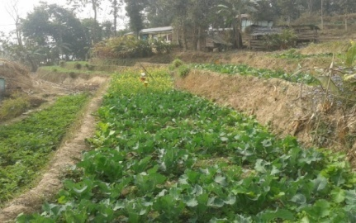

Plate: OFT - Eco-friendly management of diamond back moth in cauliflower grown in Darjeeling Hills

FT-3 (Plant Protection)

1. | Title of On farm Trial | Integrated disease management strategy of rice blast disease (Pyriculariaoryzae)
2. | Problem diagnosed | Poor yield due to high incidence of blast disease in rice
3. | Details of technologies selected for assessment/refinement  (Mention either Assessed or Refined) | Technology option-I (TO-I): Seed treatment with Pseudomonas fluorescence liquid formulation @ 10 ml/kg of seed + Seedling root dipping with Pseudomonas fluorescence liquid (500 ml for one hectare) + Foliar spray with Pseudomonas fluorescence @ 5ml/l  Technology option-II (TO-II): Split application of N₂ (Basal + 25 DAP + 45 DAP) + Application of Tricyclazole (15 DAP and 30 DAP)
4. | Source of Technology (ICAR/ AICRP/SAU/other, please specify) | NIPHM
5. | Production system and thematic area | Rice based cropping system and Integrated disease management
6. | Performance of the Technology with performance indicators | Disease incidence, Yield and BC ratio
7. | Final recommendation for micro level situation | The technology option _{II}i.e. Split application of N₂ (Basal + 25 DAP + 45 DAP) + Application of Tricyclazole (15 DAP and 30 DAP), resulted to produce highest yield (24.67q ha⁻¹) as well as reduces the significant numbers of disease intensity (15.6%), was effectively control the blast disease incidence in rice.
8. | Constraints identified and feedback for research | -
9. | Process of farmers participation and their reaction | For selection of farmers a group meeting was organized from where a few farmers was selected considering the production system and farming situation as per action plan. Ultimately 8 no. of farmers were selected from primary list after in situ visit of the farmers’ field.

Results

Technology option | Per cent disease intensity (PDI) | Yield  (q/ha) | Yield % increase over Farmer’s practice | Net return  (Rs./ha) | BC ratio
Farmers Practice: No management practices was followed | 59.2 | 18.31 | - | 616 | 1.02:1
TO1: Seed treatment with Pseudomonas fluorescens liquid formulation @ 10 ml/kg of seed + Seedling root dipping with Pseudomonas fluorescens liquid (500 ml for one hectare) + Foliar spray with Pseudomonas fluorescens @ 5ml/l | 33.6 | 19.18 | 4.75 | 1485 | 1.06:1
TO2: Split application of N2 (Basal + 25 DAP + 45 DAP) + Application of Tricyclazole (15 DAP and 30 DAP) | 15.6 | 24.67 | 34.75 | 8875 | 1.35:1
CD (p=0.05) | 3.19 | 2.78

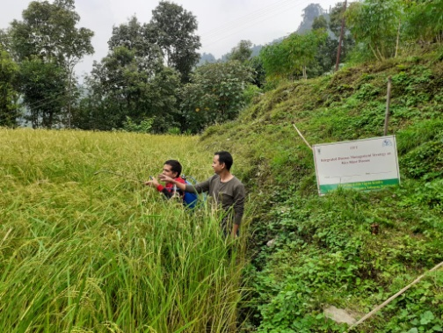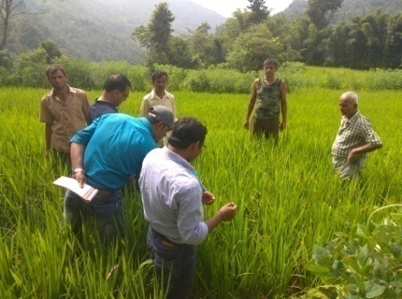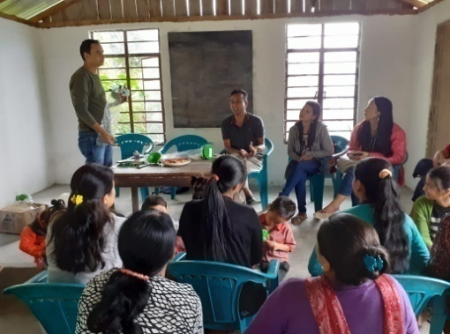
Plate: OFT - Integrated disease management strategy of rice blast disease

OFT-4 (Soil Science)

1. | Title of On farm Trial | Efficacy of Organic manure, Vermi-compost & bio-product (Trichoderma viride) to increase the productivity of Potato & Soil pH in hilly region of West Bengal
2. | Problem diagnosed | Due to high acidity & low nutrient status cause less productivity
3. | Details of technologies selected for assessment/refinement  (Mention either Assessed or Refined) | Farmers Practice: Application of FYM @ 15 t/ha  T1:Seed treatment with Trichoderma viride @ 5 gm/kg of seed + 675kg FYM/bigha (i.e. 5t/ha) + 335 kg Vermicompost /bigha (i.e 2.5t/ha) in the main field 10 days before sowing of seeds  T2:Seed treatment with Trichoderma viride @ 5 gm/kg of seed + 675kg FYM/bigha (i.e. 5t/ha) + 675kg vermicompost/ bigha (i.e.5t/ha) 10 days before sowing of seeds
4. | Source of Technology (ICAR/ AICRP/SAU/other, please specify) | RVKSVV, Gwalior
5. | Production system and thematic area | Vegetable based cropping system  Soil health management
6. | Performance of the Technology with performance indicators | Application of bio-products and vermi-compost increases the pH status of soil and as well as increases the production of potato.
7. | Final recommendation for micro level situation | Technology option₂ i.e. Seed treatment with Trichoderma viride @ 5 gm/kg of seed + 675kg FYM/bigha (i.e. 5t/ha) + 675kg vermicompost/ bigha (i.e.5t/ha) 10 days before sowing of seeds, resulted to produce highest yield 21.44 t/ha as well as the pH range was rises to 6.21.
8. | Constraints identified and feedback for research | Production of potato was hampered to some extent due to scarcity of water.
9. | Process of farmers participation and their reaction | Progressive farmers of selected village were identified and conducted the oft programme. They have appreciated the work after getting result and accepted the technology.

Results
Technology option | Yield  (t/ha) | Yield % increase over Farmer’s practice | Net return  (Rs./ha) | BC ratio | Initial Soil pH Status | After Harvest Soil pH Status
Farmers Practice: Application of FYM @ 15 t/ha | 17.05 | - | 71651/- | 2.1 | 5.62  to  5.74 | 5.87
T1:Seed treatment with Trichoderma viride @ 5 gm/kg of seed + 675kg FYM/bigha (i.e. 5t/ha) + 335 kg Vermicompost /bigha (i.e 2.5t/ha) in the main field 10 days before sowing of seeds | 18.85 | 10.80% | 86350/- | 2.3 |  | 6.04
T2:Seed treatment with Trichoderma viride @ 5 gm/kg of seed + 675kg FYM/bigha (i.e. 5t/ha) + 675kg vermicompost/ bigha (i.e.5t/ha) 10 days before sowing of seeds | 21.44 | 26.07% | 106440/- | 2.6 |  | 6.21
CD (p=0.05) | 0.57
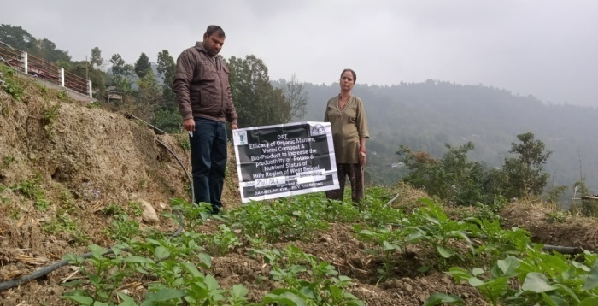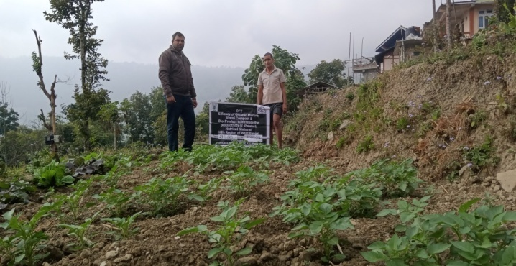

OFT-5 (Home Science)

1. | Title of On farm Trial | Assessment on storage and shelf life of Soy milk
2. | Problem diagnosed | Traditional method of storage of soy milk
3. | Details of technologies selected for assessment/refinement | Farmers Practice (FP): Boiling process for storage  Technology option-I (TO-I): Boiling and refrigeration  Technology option-II (TO-II): Boiling and addition of preservatives (Sodium benzoate @ 350mg/kg)  Technology option- III (TO- III): Boiling with addition of preservatives (Sodium benzoate @350mg/kg) and refrigeration
4. | Source of Technology (ICAR/ AICRP/SAU/other, please specify) | IFTM University, Moradabad, Uttar Pradesh, India
5. | Production system and thematic area | Value addition
6. | Performance of the Technology with performance indicators | Among the three technology options Tech Option III showed a good result in terms of keeping quality and improved the shelf life of the soy milk. However, spoilage and curdling started after 10 days duration for this option too. Therefore, further more trails are necessary.
7. | Final recommendation for micro level situation | After the SAC meeting this OFT has been recommended to be discontinued
8. | Constraints identified and feedback for research | Irregular current supply and absence of refrigerator
9. | Process of farmers participation and their reaction | Training and demonstration
Thematic area: Value addition
Problem definition: Traditional method of storage of soy milk
Technology assessed: Use of preservative (Sodium benzoate @ 350mg/kg) to enhance the shelf life of soy milk

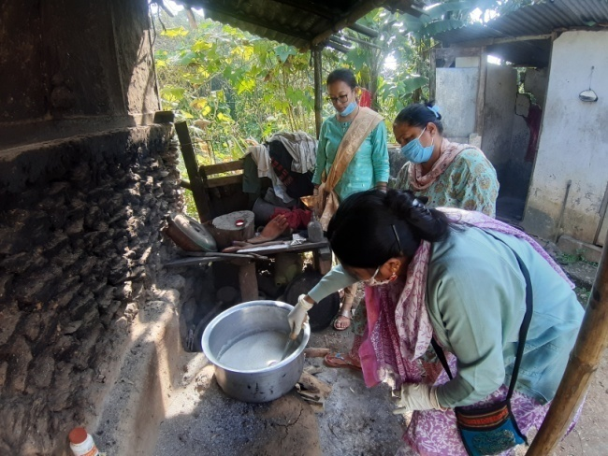
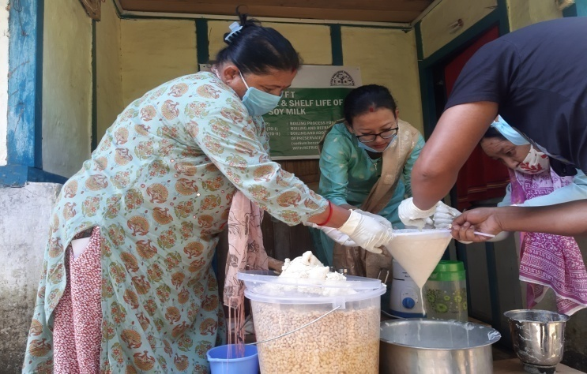

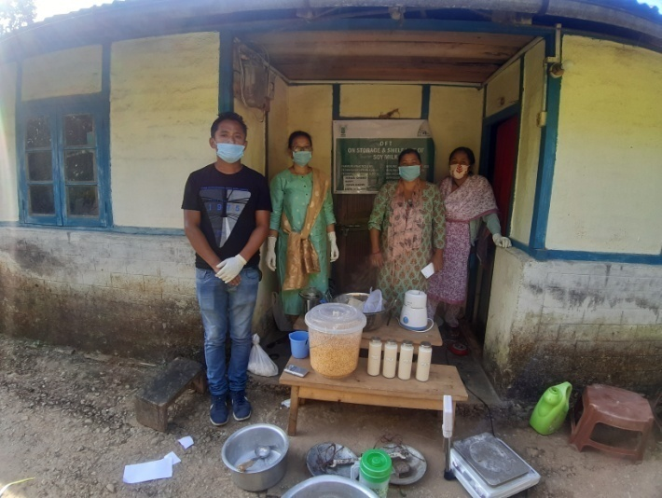

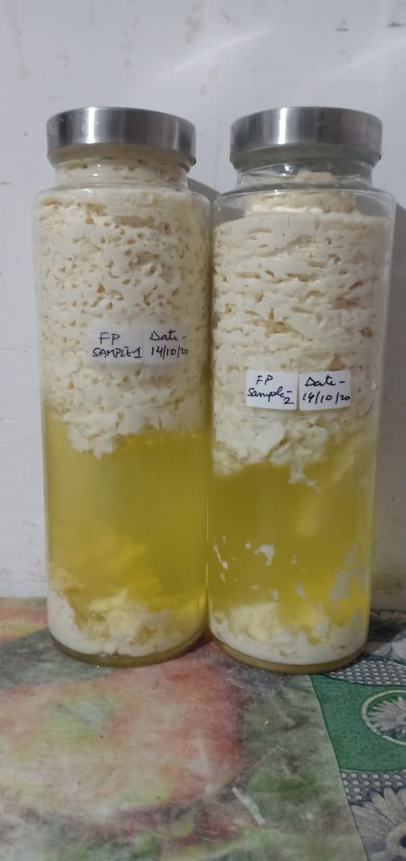
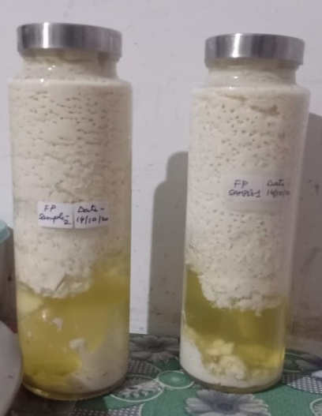
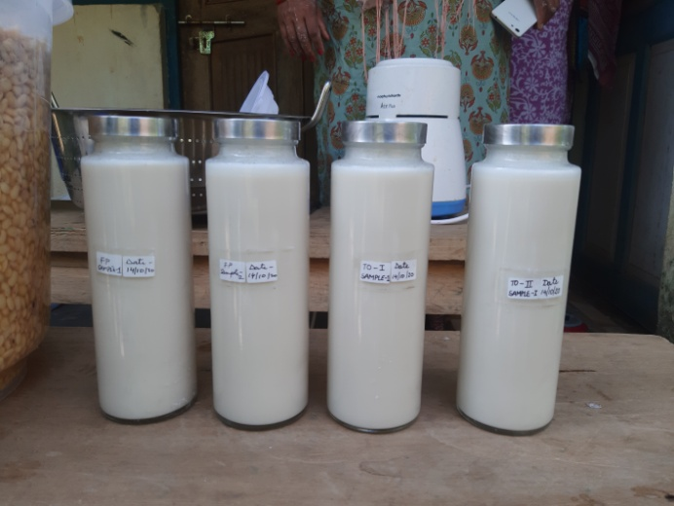
Results: No positive results found in all the samples due to many unavoidable circumstances and constrains

3.2 Achievements of Frontline Demonstrations

- Details of FLDs conducted during the year (Cereals)
Sl.  No. | Crop | Thematic area | Technology Demonstrated with detailed treatments | Area (ha) |  | No. of farmers/  demonstration |  |  |  |  |  |  |  |  | Reasons for shortfall in achievement
 |  |  |  | Proposed | Actual | SC |  | ST |  | Others |  | Total
 |  |  |  |  |  | M | F | M | F | M | F | M | F | T
1. | Paddy  (PP) | Integrated pest management | Pheromone trap @10/ha | 0.5 | 0.5 | 3 | 0 | 4 | 3 | 12 | 3 | 19 | 6 | 25

Details of farming situation

Crop | Season | Farming situation (RF/Irrigated) | Soil type | Status of soil  (Kg/ha) |  |  | Previous crop | Sowing date | Harvest date | Seasonal rainfall (mm) | No. of rainy days
 |  |  |  | N | P₂O₅ | K₂O
Paddy  (PP) | Kharif 2020 | Rainfed | Acidic | 152-235 | 51-78 | 127-174 | Summer vegetable | 26-30.06.20 | 18-24.09.20 | - | -

Performance of FLD

Crop | Thematic Area | Name of the technology demonstrated | No. of Farmers | Area  (ha) | Yield (q/ha) |  | % Increase | *Economics of demonstration (Rs./ha) |  |  |  | *Economics of check  (Rs./ha)
 |  |  |  |  | Demo | Check |  | Gross  Cost | Gross  Return | Net Return | **  BCR | Gross  Cost | Gross  Return | Net Return | **  BCR
Paddy  (PP) | Integrated pest management | Pheromone trap @10/ha | 25 | 0.5 | 16.4 | 12.8 | 28.12 | 25334 | 49200 | 23866 | 1.94 | 25012 | 38400 | 13388 | 1.53
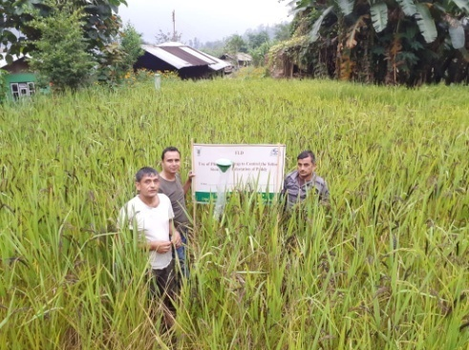
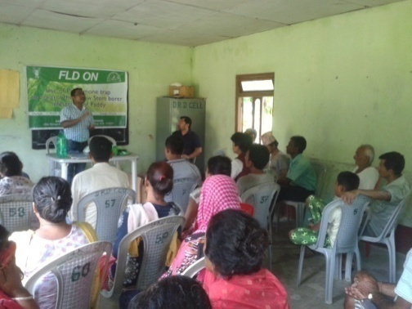

Demonstration
Training
Plate: Management of YSB with Pheromone trap

Crop category: Fruit Crop
Sl.  No. | Crop | Thematic area | Technology Demonstrated with detailed treatments | Area (ha) |  | No. of farmers/  demonstration |  |  |  |  |  |  |  |  | Reasons for shortfall in achievement
 |  |  |  | Proposed | Actual | SC |  | ST |  | Others |  | Total
 |  |  |  |  |  | M | F | M | F | M | F | M | F | T
1 | Mandarin | Integrated Pest Management | *Drenching the tree basin with 10 liters of 0.5% Monocrotophos 36 SL | 5 nos. per unit | 5 nos. per unit | 5 | 2 | 0 | 1 | 3 | 4 | 8 | 7 | 15
Details of farming situation
Crop | Season | Farming situation (RF/Irrigated) | Soil type | Status of soil  (Kg/ha) |  |  | Previous crop | Sowing date | Harvest date | Seasonal rainfall (mm) | No. of rainy days
 |  |  |  | N | P₂O₅ | K₂O
Mandarin | Perennial | Rainfed | Acidic | 132-184 | 65-75 | 105-120 | - | 28/02/2020 | 30.12.2020 | - | -
Performance of FLD

Crop | Thematic area | Name of the technology demonstrated | No. of Farmer | Area  (ha) | Yield |  | % change in yield | *Economics of demonstration (Rs./ha) |  |  |  | *Economics of check  (Rs./ha)
 |  |  |  |  | Demons  ration | Check |  | Gross  Cost | Gross  Return | Net Return | **  BCR | Gross  Cost | Gross  Return | Net Return | **  BCR
Mandarin | IPM | * | 15 | 5 nos. per unit | 35 fruits/tree | 28 fruits/tree | 25 | 328 | 700 | 372 | 2.13 | 294 | 560 | 266 | 1.90
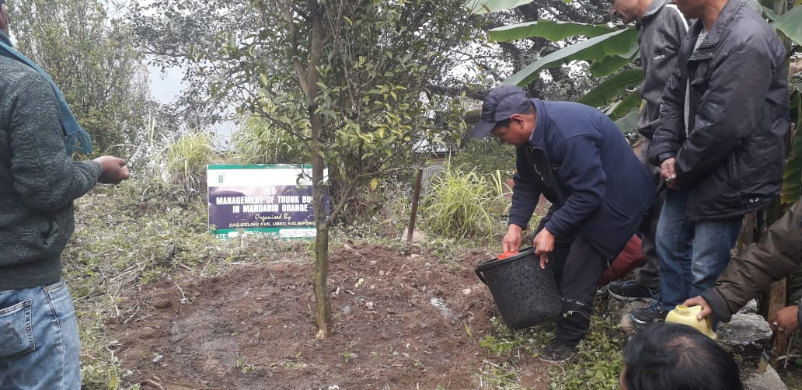
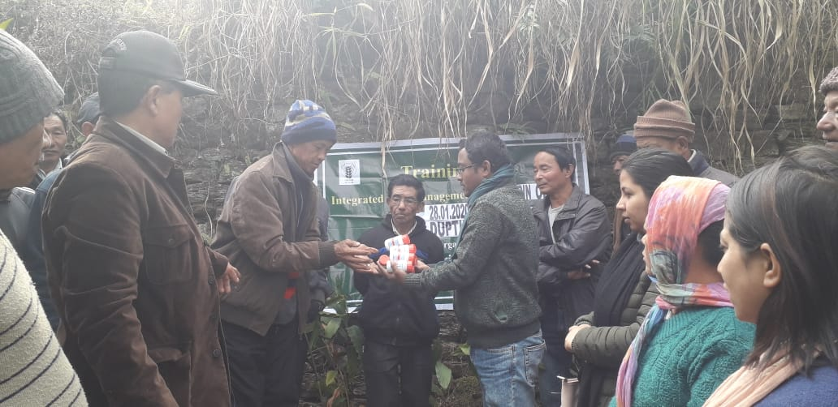

Input Distribution
Demonstration

Plate: Management of trunk borer of Mandarin orange
Fruit Crop : Mandarin Orange
Details of farming situation

Sl.  No. | Crop | Thematic area | Technology Demonstrated with detailed treatments | Area (ha) |  | No. of farmers/  demonstration |  |  |  |  |  |  |  |  | Reasons for shortfall in achievement
 |  |  |  | Proposed | Actual | SC |  | ST |  | Others |  | Total
 |  |  |  |  |  | M | F | M | F | M | F | M | F | T
1 | Mandarin | Crop Production | N:P:K@300:250:300 g, B 50 g, Z 250g, Vermicompost 12.5kg,Pig Manure 6.25kg and FYM 25 kg/tree | 0.1 | 0.1 | 0 | 0 | 2 | 0 | 3 | 1 | 5 | 1 | 6

Crop | Season | Farming situation (RF/Irrigated) | Soil type | Status of soil  (Kg/ha) |  |  | Previous crop | Sowing date | Harvest date | Seasonal rainfall (mm) | No. of rainy days
 |  |  |  | N | P2O5 | K2O
Mandarin | Perennial | Rainfed | Acidic | 284.0 | 94.1 | 123.5 | ---- | 07/11/2020 | 25/02/2021
Crop | Thematic area | Name of the technology demonstrated | No. of Farmer | Area  (ha) | Yield (q/ha) |  | % change in yield | *Economics of demonstration (Rs./ha) |  |  |  | *Economics of check  (Rs./ha)
 |  |  |  |  | Demons  ration | Check |  | Gross  Cost | Gross  Return | Net Return | **  BCR | Gross  Cost | Gross  Return | Net Return | **  BCR
Mandarin | Crop production | N:P:K@300:250:300 g, B 50 g, Z 250g, Vermicompost 12.5kg,Pig Manure 6.25kg and FYM 25 kg/tree | 6 | 0.10 | 559 | 275 fruits/tree) | 50.8 | 2,33,500/- | 5,53,410/- | 3,19,910/- | 2.3:1 | 1,55,600/- | 2,72,250/- | 1,16,650/- | 1.7:1

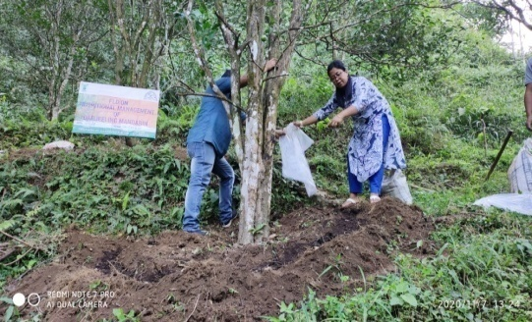
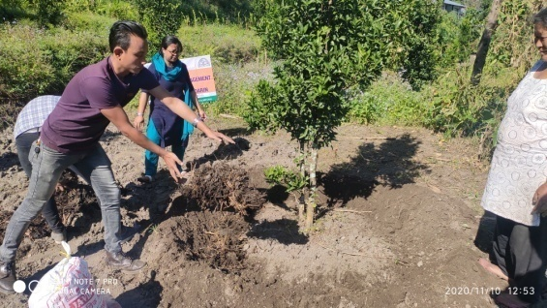

Flower : Gladiolus
Details of farming situation

Sl.  No. | Crop | Thematic area | Technology Demonstrated with detailed treatments | Area (ha) |  | No. of farmers/  demonstration |  |  |  |  |  |  |  |  | Reasons for shortfall in achievement
 |  |  |  | Proposed | Actual | SC |  | ST |  | Others |  | Total
 |  |  |  |  |  | M | F | M | F | M | F | M | F | T
1 | Gladiolus | Crop Production | Variety –American Beauty with N:P:K @120:150:150 FYM 10t/ha | 0.1 | 0.1 | 0 | 0 | 0 | 0 | 3 | 3 | 3 | 3 | 6

Crop | Season | Farming situation (RF/Irrigated) | Soil type | Status of soil  (Kg/ha) |  |  | Previous crop | Sowing date | Harvest date | Seasonal rainfall (mm) | No. of rainy days
 |  |  |  | N | P2O5 | K2O
Gladiolus | Rabi | Rainfed | Acidic | 271.4 | 38.4 | 158.6 | Paddy | 17/01/2020 | 11/05/2021
Crop | Thematic area | Name of the technology demonstrated | No. of Farmer | Area  (ha) | Yield (q/ha) |  | % change in yield | *Economics of demonstration (Rs./ha) |  |  |  | *Economics of check  (Rs./ha)
 |  |  |  |  | Demons  ration | Check |  | Gross  Cost | Gross  Return | Net Return | **  BCR | Gross  Cost | Gross  Return | Net Return | **  BCR
Gladiolus | Crop production | Variety –American Beauty with N:P:K @120:150:150 FYM 10t/ha | 5 | 0.10 | 1,75,167 | 1,15,650  (sticks) | 33 | 2,30,562/- | 5,25,501 | 2,94,939/- | 2.2:1 | 2,10,300/- | 3,46,950/- | 1,36,650/- | 1.6:1

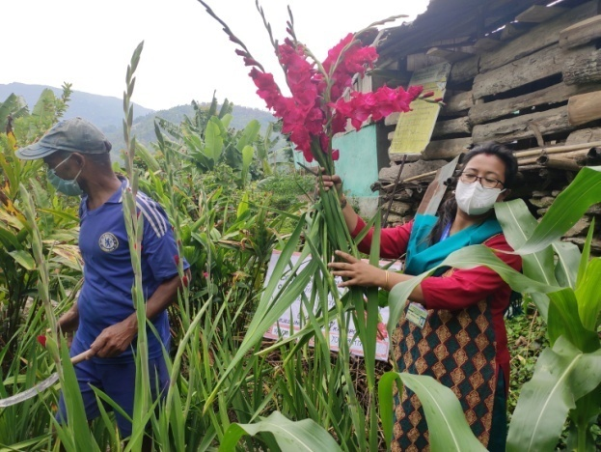

Vegetable: Off-season Cauliflower
Details of farming situation

Sl.  No. | Crop | Thematic area | Technology Demonstrated with detailed treatments | Area (ha) |  | No. of farmers/  demonstration |  |  |  |  |  |  |  |  | Reasons for shortfall in achievement
 |  |  |  | Proposed | Actual | SC |  | ST |  | Others |  | Total
 |  |  |  |  |  | M | F | M | F | M | F | M | F | T
1 | Cauliflower | Crop Production | Seedlings on raised bedunder transparent polythene . | 0.1 | 0.1 | 1 | 4 | 0 | 0 | 1 | 0 | 2 | 4 | 6

Crop | Season | Farming situation (RF/Irrigated) | Soil type | Status of soil  (Kg/ha) |  |  | Previous crop | Sowing date | Harvest date | Seasonal rainfall (mm) | No. of rainy days
 |  |  |  | N | P2O5 | K2O
Off season cauliflower | Kharif | Irrigated | Acidic | 381.2 | 28.4 | 121.4 | Round Chillies | 01/9/2020 | 11/11/2020
Crop | Thematic area | Name of the technology demonstrated | No. of Farmer | Area  (ha) | Yield (q/ha) |  | % change in yield | *Economics of demonstration (Rs./ha) |  |  |  | *Economics of check  (Rs./ha)
 |  |  |  |  | Demons  ration | Check |  | Gross  Cost | Gross  Return | Net Return | **  BCR | Gross  Cost | Gross  Return | Net Return | **  BCR
Off season cauliflower | Crop production | Seedlings on raised bedunder transparent polythene . | 6 | 0.10 | 155.20 | 110.23 |  | 72,500/- | 1,55,200/- | 82,700/- | 2.1:1 | 60,500/- | 1,10,230 | 497301/- | 1.8:1

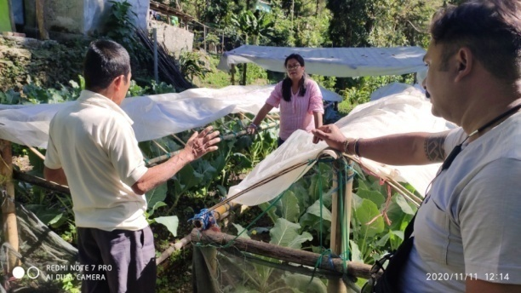
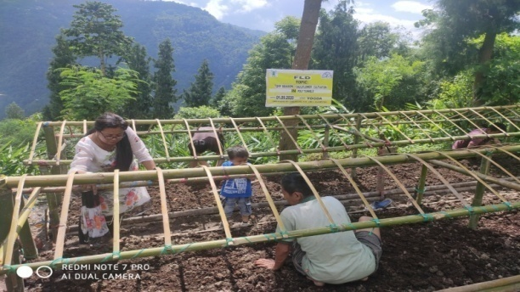
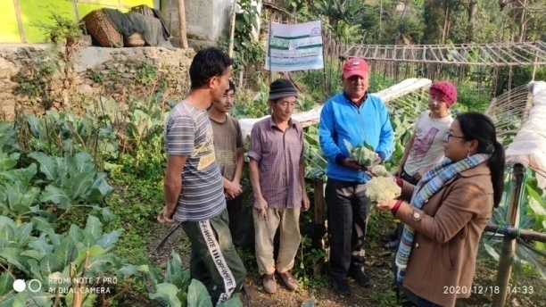

Information of same crop should be provided. For example, if in Table 3.2A crops are mentioned as a,b,c,d etc., in the table for Details of farming situation, the same crop should be mentioned in the identical sequence.

Performance of FLD

Oilseeds:

Frontline demonstrations on oilseed crops

Crop | Thematic Area | Name of the technology demonstrated | No. of Farmers | Area  (ha) | Yield (q/ha) |  | % Increase | *Economics of demonstration (Rs./ha) |  |  |  | *Economics of check  (Rs./ha)
 |  |  |  |  | Demo | Check |  | Gross  Cost | Gross  Return | Net Return | **  BCR | Gross  Cost | Gross  Return | Net Return | **  BCR
Total

* Economics to be worked out based on total cost of production per unit area and not on critical inputs alone.
** BCR= GROSS RETURN/GROSS COST

Pulses
Frontline demonstration on pulse crops
Crop | Thematic Area | Name of the technology demonstrated | No. of Farmers | Area  (ha) | Yield (q/ha) |  | % Increase | *Economics of demonstration (Rs./ha) |  |  |  | *Economics of check  (Rs./ha)
 |  |  |  |  | Demo | Check |  | Gross  Cost | Gross  Return | Net Return | **  BCR | Gross  Cost | Gross  Return | Net Return | **  BCR
 | Total

* Economics to be worked out based on total cost of production per unit area and not on critical inputs alone.
** BCR= GROSS RETURN/GROSS COST
Livestock
Category | Thematic  area | Name of the technology demonstrated | No. of Farmer | No. of units | Major parameters |  | % change in major parameter | Other parameter |  | *Economics of demonstration (Rs.) |  |  |  | *Economics of check  (Rs.)
 |  |  |  |  | Demons  ration | Check |  | Demons  ration | Check | Gross  Cost | Gross  Return | Net Return | **  BCR | Gross  Cost | Gross  Return | Net Return | **  BCR
Dairy
Cow
Buffalo
Poultry | Nutritional Management | Azolla feeding as low cost protein supplement | 25 | 25 | -- | -- | -- | -- | -- | -- | -- | -- | -- | -- | -- | -- | --
Rabbitry
Pigerry
Sheep and goat
Duckery
Others (pl.specify)
Total
* Economics to be worked out based on total cost of production per unit area and not on critical inputs alone.
** BCR= GROSS RETURN/GROSS COST

Fisheries
Category | Thematic area | Name of the technology demonstrated | No. of Farmer | No. of units | Major parameters |  | % change in major parameter | Other parameter |  | *Economics of demonstration (Rs.) |  |  |  | *Economics of check  (Rs.)
 |  |  |  |  | Demons  ration | Check |  | Demons  ration | Check | Gross  Cost | Gross  Return | Net Return | **  BCR | Gross  Cost | Gross  Return | Net Return | **  BCR
Common carps
Mussels
Ornamental fishes
Others (pl.specify)
Total
* Economics to be worked out based on total cost of production per unit area and not on critical inputs alone.
** BCR= GROSS RETURN/GROSS COST

Other enterprises

Category | Name of the technology demonstrated | No. of Farmer | No. of units | Major parameters |  | % change in major parameter | Other parameter |  | *Economics of demonstration (Rs.) or Rs./unit |  |  |  | *Economics of check  (Rs.) or Rs./unit
 |  |  |  | Demons  ration | Check |  | Demons  ration | Check | Gross  Cost | Gross  Return | Net Return | **  BCR | Gross  Cost | Gross  Return | Net Return | **  BCR
Oyster mushroom | Enterprise development
Button mushroom
Vermicompost
Sericulture
Apiculture
Value addition | Preservation techniques along with usage of natural preservatives | 10 | 1 | Value added products | Value added products |  |  |  | 10000 | 16000 | 6000 | 0.6:1 | 10000 | 25000 | 15000 | 1.5:1
Total
* Economics to be worked out based on total cost of production per unit area and not on critical inputs alone.
** BCR= GROSS RETURN/GROSS COST

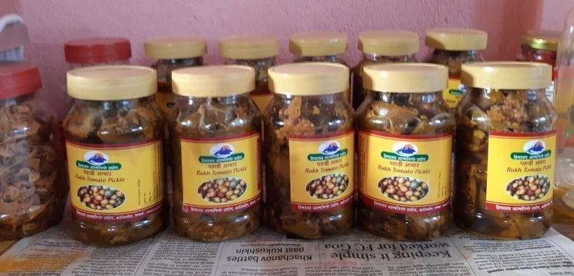
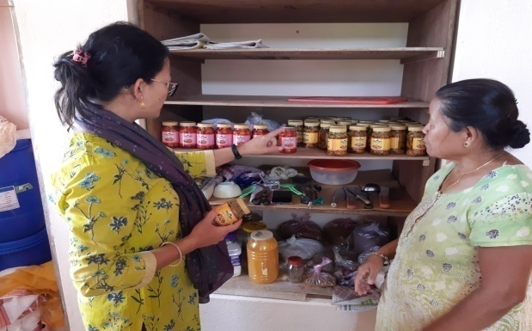
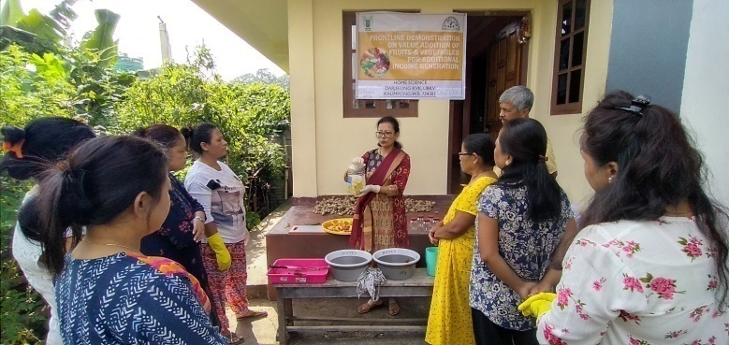

Women empowerment
Category | Name of technology | No. of demonstrations | Observations |  | Remarks
 |  |  | Demonstration | Check
Farm Women | Value addition | 2 | Self employment  Income generation | Unemployed and dependent, inactive SHG | Skill development
Pregnant women
Adolescent Girl
Other women | Nutri gardening | 4 | Improvement of knowledge | Lack of knowledge | Knowledge level enhanced
Children
Neonatal
Infants
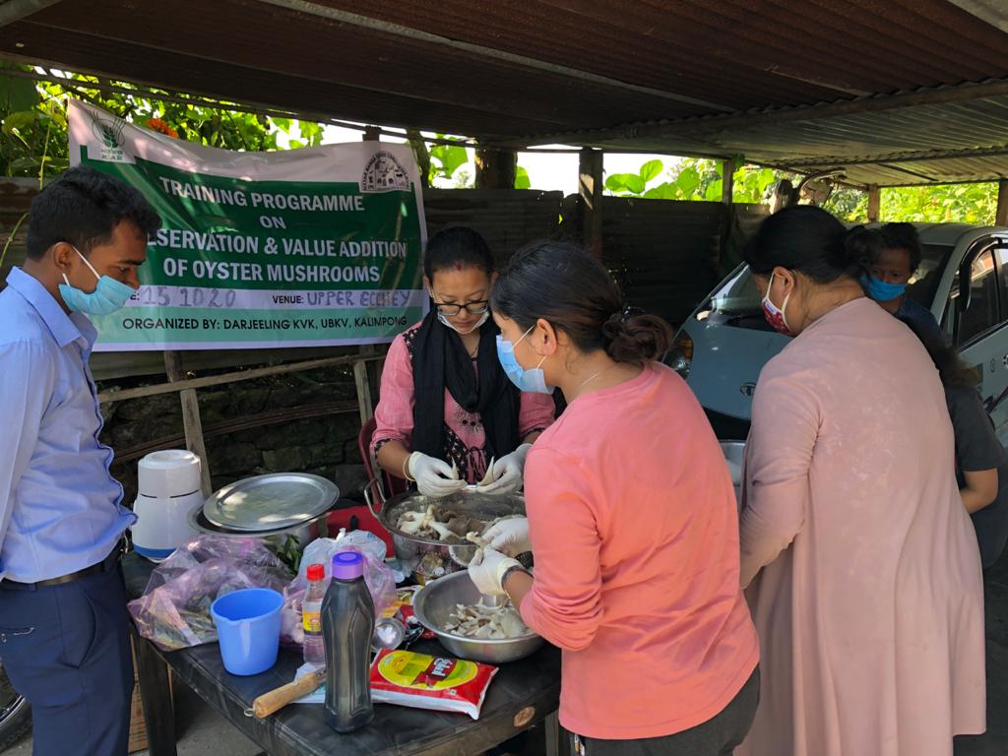
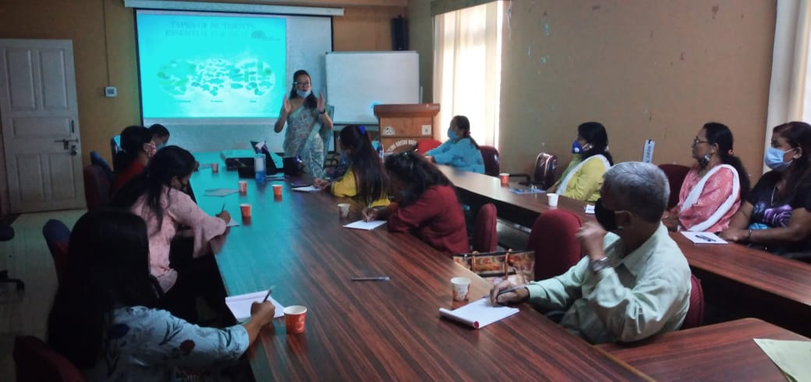

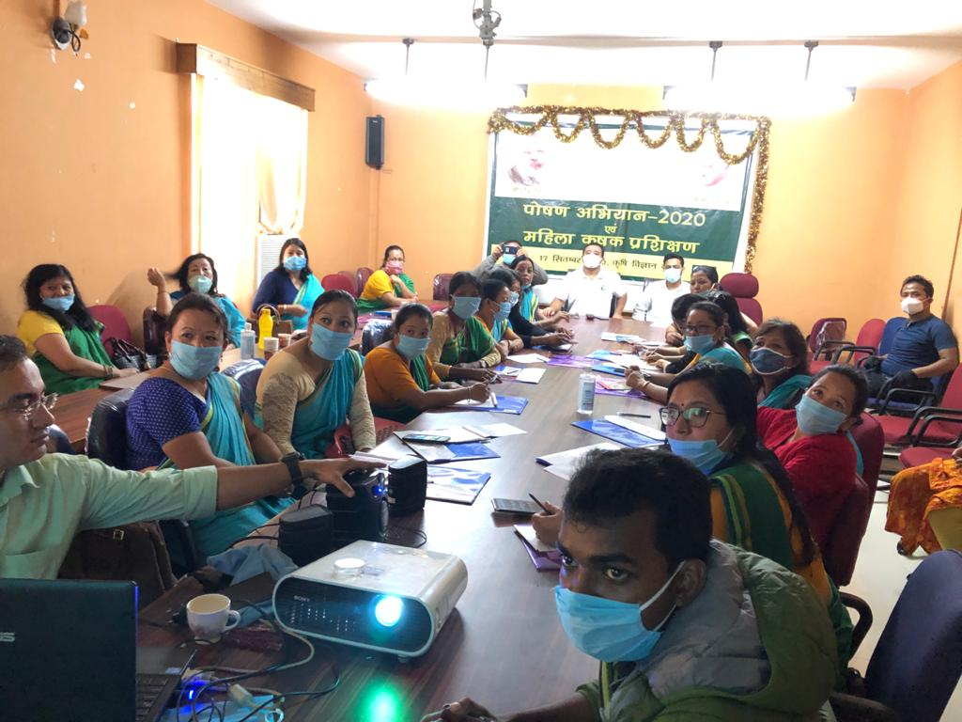
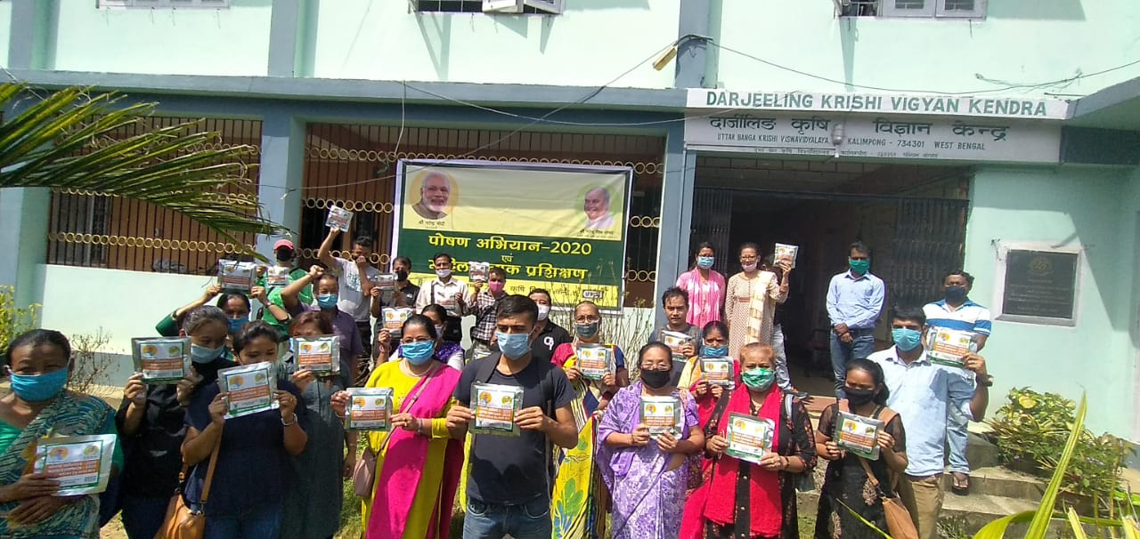

Category | Name of the technology demonstrated | No. of Farmer | No. of units | Major parameters |  | % change in major parameter | Other parameter |  | *Economics of demonstration (Rs.) or Rs./unit |  |  |  | *Economics of check  (Rs.) or Rs./unit
 |  |  |  | Demons  ration | Check |  | Demons  ration | Check | Gross  Cost | Gross  Return | Net Return | **  BCR | Gross  Cost | Gross  Return | Net Return | **  BCR
Oyster mushroom | Enterprise  development
Button mushroom
Vermicompost
Sericulture
Apiculture
Others (pl.specify)
Total
* Economics to be worked out based on total cost of production per unit area and not on critical inputs alone.
** BCR= GROSS RETURN/GROSS COST

Women empowerment
Category | Name of technology | No. of demonstrations | Observations |  | Remarks
 |  |  | Demonstration | Check
Farm Women
Pregnant women
Adolescent Girl
Other women
Children
Neonatal
Infants

Farm implements and machinery

Name of the implement | Crop | Name of the technology demonstrated | No. of Farmer | Area (ha) | Filed observation (output/man hour) |  | % change in major parameter | Labor reduction (man days) | Cost reduction (Rs./ha or Rs./Unit)
 |  |  |  |  | Demons  ration | Check
* Economics to be worked out based on total cost of production per unit area and not on critical inputs alone.
** BCR= GROSS RETURN/GROSS COST

Demonstration details on crop hybrids
Crop | Name of the Hybrid | No. of  farmers | Area  (ha) | Yield (kg/ha) / major parameter |  |  | Economics (Rs./ha)
Cereals |  |  |  | Demo | Local check | % change | Gross  Cost | Gross  Return | Net  Return | BCR
Bajra
Maize
Paddy
Sorghum
Wheat
Others (Pl. specify)

Total
Oilseeds
Castor
Mustard
Safflower
Sesame
Sunflower
Groundnut
Soybean
Others (Pl. specify)
Total
Pulses
Greengram
Blackgram
Bengalgram
Redgram
Others (Pl. specify)

Total
Vegetable crops
Bottle gourd
Capsicum
Cucumber
Tomato
Brinjal
Okra
Onion
Potato
Field bean
Others (Pl. specify)

Total
Commercial crops
Cotton
Coconut
Others (Pl. specify)

Total
Fodder crops
Napier (Fodder)
Maize (Fodder)
Sorghum (Fodder)
Others (Pl. specify)

Total

Technical Feedback on the demonstrated technologies

Sl. No | Crop | Feed Back
1 | Paddy | The technology may reduce the YSB population by trapping the adult moth and can increase the yield up to 28.12% with BC ratio of 1.94 over traditional practice.
2 | Mustard | Variety B-9 with the use of Bio-fertilizer PSB gave higher yield by 49% over the local variety and BC ratio of 1.62 .
3 | Mandarin | Application of Balanced nutrition in Darjeeling Mandarin increased the number of fruits per tree which ultimately increase the crop production per unit area.
4 | Mandarin | The trunk borer population may reduced with the application of Monocrotophos 36SL and may increased the 30-35% yield performance.
5 | Black Pepper | Serpentine method of propagation increases the survival rate of cuttings than the traditional method.
6 | Season based vegetables | Kitchen gardening is very necessary to sensitize women on importance of nutrition and intake of fresh vegetables for good health. Simultaneously it can also serve as an additional source of income.
7 | Low cost cereals and pulses, GLV’s | The various techniques and recipes to prepare low cost nutrient rich supplements were adopted and accepted well by the farmers. It was cost effective compared to the supplements readily available in the market.

Extension and Training activities under FLD

Sl.No. | Activity | Date | No. of activities organized | Number of participants | Remarks
1. | Field days | 28.09.20 (Paddy) | 1 | 15
2. | Farmers Training | 26.06.20 (Paddy)  28.02.20 (Mandarin) | 1  1 | 25  15
3. | Media coverage
4. | Training for extension functionaries

Performance of the demonstration under CFLD on Pulse and Oilseed Crops during Kharif 2020 and Rabi 2020-21:

- Technical Parameters:
Sl.  No. | Crop demonstrated | Existing (Farmer's) variety name | Existing yield  (q/ha) | Yield gap (q/ha)  w.r.to |  |  | Name of Variety + Technology  demonstrated | Number of farmers | Area in ha | Yield obtained (q/ha) |  |  | Yield gap minimized  (%)
 |  |  |  | District  yield (D) | State  yield (S) | Potential  yield (P)
 |  |  |  |  |  |  |  |  |  | Max. | Min. | Av. | D | S | P
1 | Field Pea | Local | 9.82 | ----- | 11.9 | 22 | Variety –Vikash Seed treatment Rhizobium @25g/kg seed N:P:K @20:40:40 and Soil application of Boron @ 2 kg/ha . | 50 | 10 | 13.15 | 11.03 | 12.52 |  | 4.95

- Economic parameters:

Sl.  No. | Variety demonstrated & Technology demonstrated | Farmer’s Existing plot |  |  |  | Demonstration plot
 |  | Gross Cost  (Rs/ha) | Gross return  (Rs/ha) | Net Return  (Rs/ha) | B:C  ratio | Gross Cost  (Rs/ha) | Gross return  (Rs/ha) | Net Return  (Rs/ha) | B:C  ratio
1 | Variety Vikash  Seed treatment Rhizobium @25g/kg seed. N:P:K @20:40:40 and Soil application of Boron @ 2 kg/ha . | 31,630/- | 49,200/- | 17,570/- | 1.55 | 33,430/- | 62,600/- | 29,170/- | 1.87

- Socio-economic impact parameters:

Sl.  No. | Crop and variety  Demonstrated | Total Produce  Obtained (kg) | Produce sold  (Kg/household) | Selling  Rate  (Rs/Kg) | Produce used for own sowing (Kg) | Produce distributed to other farmers (Kg) | Purpose for which income gained was utilized | Employment Generated (Mandays/house hold)
1 | Variety Vikash .Seed treatment Rhizobium @25g/kg seed . N:P:K @20:40:40 and Soil application of Boron @ 2 kg/ha . | 12520 | 250.40 | 50 | 30 | 60 | Household activity and Children education | 12

- Pulse Farmers’ perception of the intervention demonstrated :

Sl.  No. | Technologies demonstrated  (with name) | Farmers’ Perception parameters
 |  | Suitability to their farming system | Likings  (Preference) | Affordability | Any negative effect | Is Technology acceptable to all in the group/village | Suggestions, for change/improvement, if any
1 | Variety Vikash Seed treatment Rhizobium @25g/kg seed . N:P:K @20:40:40 and Soil application of Boron @ 2 kg/ha . | Yes | Good | Affordable | No | Yes | Availability of these type of seeds are required for better production

- Specific Characteristics of Technology and Performance :

Specific Characteristic | Performance | Performance of Technology vis-a vis Local Check | Farmers Feedback
Variety Vikash | Pod formation and seed per pod is higher. Dwarf Variety and Resistant to powdery mildew | Seed treatment Rhizobium @25g/kg seed . N:P:K @20:40:40 and Soil application of Boron @ 2 kg/ha . | Produce higher yield than the local one.

- Extension activities under FLD conducted till dates:

Extension Activities organized | Date and place of activity | Number of farmer attended
Training | 18/12/2020 Yogda Village | 25
 | 29/12/2020Yok villge | 25
Demonstration | 18/12/2020 Yogda Village | 25
 | 29/12/2020Yok villge | 25
Field Visit | 18/02/2021 Yok Busty | 5
 | 22/02/2021 Yogda Busty | 5
Field Day | 23/03/2021 Yogda Village | 10

- Sequential good quality photographs (as per crop stages i.e. growth & development) and field visit

- Farmers' training photographs
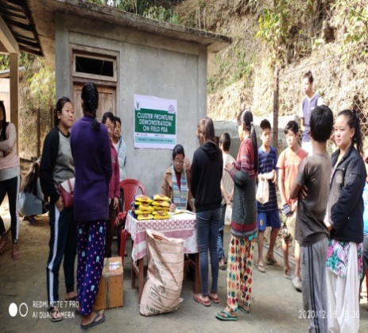
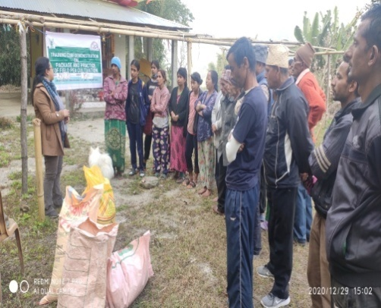

- Quality Action Photographs of field visits/field days and technology demonstrated.

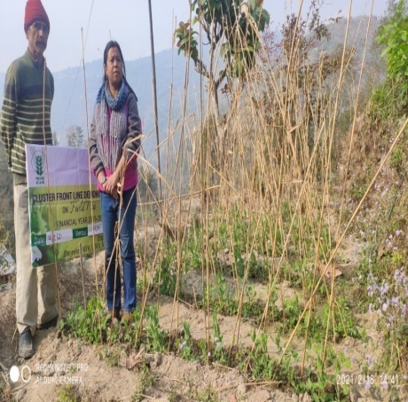
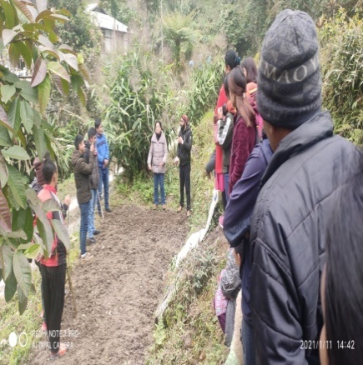

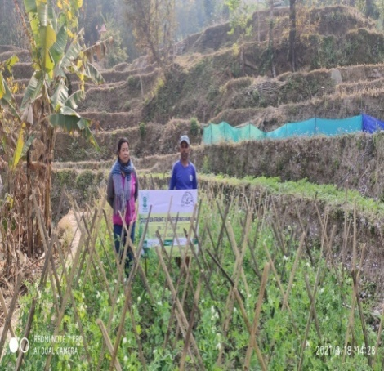

J. Details of budget utilization

Crop  (provide crop wise information ) | Items |  | Budget  Received  (Rs.) | Budget  Utilization  (Rs.) | Balance  (Rs.)
 | i) Critical input |  | 54,000 | 54,000 | 0
 |  | ii) TA/DA/POL etc. for monitoring | 13,500 | 13500 | 0
 |  | iii) Extension Activities (Field day) | 13,500 | 13500 | 0
 |  | iv)Publication of literature | 9,000 | 8678 | 322
 | Total |  | 90,000/- | 89678 | 322

List of Farmers

l. No. | Name of cluster FLD farmer | Category (Gen/OBC/  SC/ST) | Village | Block | Variety
1 | Marsang Rai | Gen | Yogda | Kpg II | Vikash
2 | Sujata Rai | Gen | Yogda | -do- | do
3 | Sabita Rai | Gen | Yogda | -do- | -do-
4 | Evena Lepcha | ST | -do- | -do- | -do-
5 | Rebika Rai | Gen | -do- | -do- | -do-
6 | Bibi Lepcha | ST | -do- | -do- | -do-
7 | Pemlal Lepcha | ST | -do- | -do- | -do-
8 | Buddha maya Rai | Gen | -do- | -do- | -do-
9 | Munna Rai | Gen | -do- | -do- | -do-
10 | Chhimit Lepcha | ST | -do- | -do- | -do-
11 | Ongmit Lepcha | ST | -do- | -do- | -do-
12 | Sailesh Rai | Gen | -do- | -do- | -do-
13 | Suku Tshering Lepcha | ST | -do- | -do- | -do-
14 | Sarathi Chettri | Gen | -do- | -do- | -do-
15 | Sundari Rai | -do- | -do- | -do- | -do-
16 | Ongdup Lepcha | ST | -do- | -do- | -do-
17 | Ganga Devi Rai | Gen | -do- | -do- | -do-
18 | Sunita Rai | -do- | -do- | -do- | -do-
19 | Mutan Rai | -do | -do- | -do- | -do-
20 | Rajani Rai | -do- | -do- | -do- | -do-

l. No. | Name of cluster FLD farmer | Category (Gen/OBC/  SC/ST) | Village | Block | Variety
21 | Meena Rai | -do- | -do- | -do- | -do-
22 | Rupa Rai | -do- | -do- | -do- | -do-
23 | Sarita Rai | -do- | -do- | -do- | -do-
24 | Renuka Rai | -do- | -do- | -do- | -do-
25 | Laxmi Rai | -do- | -do- | -do- | -do-
26 | Anya Prasad Acharya | -do- | Yok Busty | -do- | -do-
27 | Kasananda Acharya | -do- | -do- | -do- | -do-
28 | Bhakti Prasad Acharya | -do- | -do- | -do- | -do-
29 | Bishnu Prasad Acharya | -do- | -do- | -do- | -do-
30 | Nandi Kishore Luitel | -do- | -do- | -do- | -do-
31 | Diliram Kahtel | -do- | -do- | -do- | -do-
32 | Devi Bhakta Acharya | -do- | -do- | -do- | -do-
33 | Tikaram Acharya | -do- | -do- | -do- | -do-
34 | Diliram Dhulal | -do- | -do- | -do- | -do-
35 | Dhan Bdr Subba | ST | -do- | -do- | -do-
36 | Dhan Bdr Subba | ST | -do- | -do- | -do-
37 | Ramlal Acharya | -do- | -do- | -do- | -do-
38 | Kharananda Acharya | -do- | -do- | -do- | -do-
39 | Yug Bahadur Subba | ST | -do- | -do- | -do-
40 | Basant Kumar Subba | ST | -do- | -do- | -do-
41 | Kedarnath Parajuli | -do- | -do- | -do- | -do-
42 | Bhumi Sankar Ghimiray | -do- | -do- | -do- | -do-
43 | Dhanabati Acharya | -do- | -do- | -do- | -do-
44 | Phuna Prasad Luitel | -do- | -do- | -do- | -do-
45 | Phip Raj Subba | ST | -do- | -do- | -do-
46 | Laxnath Dulal | -do- | -do- | -do- | -do-
47 | Biraspati Bajgai | -do- | -do- | -do- | -do-
48 | Goma Devi Sharma | -do- | -do- | -do- | -do-
49 | Bhawani Shankar Ghimiray | -do- | -do- | -do- | -do-
50 | Laxmi Kantha Dulal | -do- | -do- | -do- | -do-

  - Achievements on Training (Including the sponsored and FLD training programmes):

- Farmers and farm women (on campus)

Thematic Area | No. of Courses | No. of Participants |  |  |  |  |  |  |  |  |  | Grand Total
 |  | Other |  |  | SC |  |  |  | ST
 |  | M | F | T | M | F |  | T | M | F | T | M | F | T
I. Crop Production
Weed Management
Resource Conservation Technologies
Cropping Systems
Crop Diversification
Integrated Farming
Water management
Seed production
Nursery management
Integrated Crop Management
Fodder production
Production of organic inputs
Others, (cultivation of crops )
II. Horticulture
a) Vegetable Crops
Integrated nutrient management
Water management
Enterprise development
Skill development
Yield increment
Production of low volume and high value crops
Off-season vegetables
Nursery raising
Export potential vegetables
Grading and standardization
Protective cultivation (Green Houses, Shade Net etc.)
Others, if any (Cultivation of Vegetable)
Training and Pruning
b) Fruits
Layout and Management of Orchards
Cultivation of Fruit
Management of young plants/orchards
Rejuvenation of old orchards
Export potential fruits
Micro irrigation systems of orchards
Plant propagation techniques
Others, if any(INM)
c) Ornamental Plants
Nursery Management
Management of potted plants
Export potential of ornamental plants
Propagation techniques of Ornamental Plants
Others, if any
d) Plantation crops
Production and Management technology
Processing and value addition
Others, if any
e) Tuber crops
Production and Management technology
Processing and value addition
Others, if any
f) Spices
Production and Management technology | 1 | 10 | 4 | 14 | 0 | 0 |  | 0 | 9 | 2 | 11 | 19 | 6 | 25
Processing and value addition
Others, if any
g) Medicinal and Aromatic Plants
Nursery management
Production and management technology
Post harvest technology and value addition
Others, if any
III. Soil Health and Fertility Management
Soil fertility management
Soil and Water Conservation
Integrated Nutrient Management
Production and use of organic inputs | 1 | 0 | 8 | 8 | 1 | 1 |  | 2 | 8 | 7 | 15 | 9 | 16 | 25
Management of Problematic soils
Micro nutrient deficiency in crops
Nutrient Use Efficiency
Soil and Water Testing
Others, if any
IV. Livestock Production and Management
Dairy Management
Poultry Management | 1 | 0 | 13 | 13 | 0 | 0 |  | 0 | 0 | 13 | 13 | 0 | 26 | 26
Piggery Management | 1 | 23 | 30 | 53 | 8 | 11 |  | 19 | 5 | 7 | 12 | 36 | 48 | 84
Rabbit Management
Disease Management
Feed management
Production of quality animal products
Others, if any Goat farming
V. Home Science/Women empowerment
Household food security by kitchen gardening and nutrition gardening
Design and development of low/minimum cost diet
Designing and development for high nutrient efficiency diet
Minimization of nutrient loss in processing
Gender mainstreaming through SHGs
Storage loss minimization techniques
Enterprise development
Value addition | 1 | 0 | 7 | 7 | 0 | 1 |  | 1 | 0 | 2 | 2 | 0 | 10 | 10
Income generation activities for empowerment of rural Women
Location specific drudgery reduction technologies
Rural Crafts
Capacity building
Women and child care
Others, if any
VI.Agril. Engineering
Installation and maintenance of micro irrigation systems
Use of Plastics in farming practices
Production of small tools and implements
Repair and maintenance of farm machinery and implements
Small scale processing and value addition
Post Harvest Technology
Others, if any
VII. Plant Protection
Integrated Pest Management | 1 | 20 | 2 | 22 | 10 | 1 |  | 11 | 0 | 0 | 0 | 30 | 3 | 33
Integrated Disease Management | 1 | 0 | 13 | 13 | 0 | 0 |  | 0 | 0 | 13 | 13 | 0 | 26 | 26
Bio-control of pests and diseases
Production of bio control agents and bio pesticides
Others, if any
VIII. Fisheries
Integrated fish farming
Carp breeding and hatchery management
Carp fry and fingerling rearing
Composite fish culture & fish disease
Fish feed preparation & its application to fish pond, like nursery, rearing & stocking pond
Hatchery management and culture of freshwater prawn
Breeding and culture of ornamental fishes
Portable plastic carp hatchery
Pen culture of fish and prawn
Shrimp farming
Edible oyster farming
Pearl culture
Fish processing and value addition
Others, if any
IX. Production of Inputs at site
Seed Production
Planting material production
Bio-agents production
Bio-pesticides production
Bio-fertilizer production
Vermi-compost production
Organic manures production
Production of fry and fingerlings
Production of Bee-colonies and wax sheets
Small tools and implements
Production of livestock feed and fodder
Production of Fish feed
Others, if any
X. Capacity Building and Group Dynamics
Leadership development
Group dynamics
Formation and Management of SHGs
Mobilization of social capital
Entrepreneurial development of farmers/youths
WTO and IPR issues
Others, if any
XI Agro-forestry
Production technologies
Nursery management
Integrated Farming Systems
XII. Others (Pl. Specify)
TOTAL | 7 | 53 | 77 | 130 | 19 |  | 14 | 33 | 22 | 44 | 66 | 94 | 135 | 229

B) Rural Youth (on campus)

Thematic Area | No. of Courses | No. of Participants |  |  |  |  |  |  |  |  |  | Grand Total
 |  | Other |  |  | SC |  |  |  | ST
 |  | M | F | T | M | F |  | T | M | F | T | M | F | T
Mushroom Production | 1 | 0 | 2 | 2 | 4 |  | 7 | 11 | 2 | 6 | 8 | 6 | 15 | 21
Bee-keeping | 1 | 7 | 1 | 8 | 0 |  | 0 | 0 | 5 | 2 | 7 | 12 | 3 | 15
Integrated farming
Seed production
Production of organic inputs
Integrated Farming
Planting material production
Vermi-culture | 1 | 4 | 9 | 13 | 1 |  | 0 | 1 | 11 | 4 | 15 | 21 | 5 | 26
Sericulture
Protected cultivation of vegetable crops
Commercial fruit production
Repair and maintenance of farm machinery and implements
Nursery Management of Horticulture crops
Training and pruning of orchards
Value addition
Production of quality animal products
Dairying
Sheep and goat rearing
Quail farming
Piggery
Rabbit farming
Poultry production
Ornamental fisheries
Enterprise development
Para vets
Para extension workers
Composite fish culture
Freshwater prawn culture
Shrimp farming
Pearl culture
Cold water fisheries
Fish harvest and processing technology
Fry and fingerling rearing
Small scale processing
Post Harvest Technology
Tailoring and Stitching
Rural Crafts
TOTAL | 3 | 11 | 12 | 23 | 5 |  | 7 | 12 | 18 | 12 | 30 | 39 | 23 | 62

C) Extension Personnel (on campus)

Thematic Area | No. of Courses | No. of Participants |  |  |  |  |  |  |  |  |  | Grand Total
 |  | Other |  |  | SC |  |  |  | ST
 |  | M | F | T | M | F |  | T | M | F | T | M | F | T
Productivity enhancement in field crops
Value addition
Integrated Pest Management
Integrated Nutrient management
Rejuvenation of old orchards
Protected cultivation technology
Formation and Management of SHGs
Group Dynamics and farmers organization
Information networking among farmers
Capacity building for ICT application
Care and maintenance of farm machinery and implements
WTO and IPR issues
Management in farm animals
Livestock feed and fodder production
Household food security
Women and Child care
Low cost and nutrient efficient diet designing
Production and use of organic inputs
Gender mainstreaming through SHGs
TOTAL

D) Farmers and farm women (off campus)
Thematic Area | No. of Courses | No. of Participants |  |  |  |  |  |  |  |  |  | Grand Total
 |  | Other |  |  | SC |  |  |  | ST
 |  | M | F | T | M | F |  | T | M | F | T | M | F | T
I. Crop Production
Weed Management
Resource Conservation Technologies
Cropping Systems
Crop Diversification
Integrated Farming
Water management
Seed production
Nursery management
Integrated Crop Management
Fodder production
Production of organic inputs
Others, (cultivation of crops )
II. Horticulture
a) Vegetable Crops
Integrated nutrient management | 1 | 2 | 19 | 21 | 0 | 0 |  | 0 | 4 | 4 | 8 | 6 | 23 | 29
Water management | 1 | 2 | 1 | 3 | 3 | 19 |  | 22 | 0 | 1 | 1 | 5 | 21 | 26
Enterprise development
Skill development
Yield increment
Production of low volume and high value crops
Off-season vegetables | 1 | 0 | 0 | 0 | 0 | 20 |  | 20 | 0 | 0 | 0 | 0 | 20 | 20
Nursery raising
Export potential vegetables
Grading and standardization
Protective cultivation (Green Houses, Shade Net etc.)
Others, if any (Cultivation of Vegetable)
Training and Pruning
b) Fruits
Layout and Management of Orchards | 1 | 10 | 5 | 15 | 0 | 1 |  | 1 | 5 | 6 | 11 | 15 | 12 | 27
Cultivation of Fruit | 1 | 4 | 4 | 8 | 4 | 9 |  | 13 | 0 | 0 | 0 | 8 | 13 | 21
Management of young plants/orchards | 1 | 4 | 5 | 9 | 3 | 14 |  | 17 | 0 | 0 | 0 | 7 | 19 | 26
Rejuvenation of old orchards
Export potential fruits
Micro irrigation systems of orchards
Plant propagation techniques
Others, if any(INM)
c) Ornamental Plants
Nursery Management
Management of potted plants
Export potential of ornamental plants
Propagation techniques of Ornamental Plants
Others, if any
d) Plantation crops
Production and Management technology
Processing and value addition
Others, if any
e) Tuber crops
Production and Management technology
Processing and value addition
Others, if any
f) Spices
Production and Management technology | 4 | 1 | 7 | 12 | 25 | 47 |  | 37 | 2 | 8 | 16 | 28 | 61 | 49
Processing and value addition
Others, if any
g) Medicinal and Aromatic Plants
Nursery management
Production and management technology
Post harvest technology and value addition
Others, if any
III. Soil Health and Fertility Management
Soil fertility management | 1 | 7 | 8 | 15 | 1 | 1 |  | 2 | 2 | 7 | 9 | 10 | 16 | 26
Soil and Water Conservation
Integrated Nutrient Management
Production and use of organic inputs | 1 | 2 | 2 | 4 | 12 | 16 |  | 28 | 0 | 0 | 0 | 14 | 18 | 32
Management of Problematic soils
Micro nutrient deficiency in crops
Nutrient Use Efficiency
Soil and Water Testing | 1 | 11 | 10 | 21 | 0 | 0 |  | 0 | 3 | 2 | 5 | 14 | 12 | 26
Others, if any
IV. Livestock Production and Management
Dairy Management
Poultry Management | 4 | 11 | 16 | 26 | 17 | 40 |  | 15 | 4 | 3 | 20 | 32 | 59 | 33
Piggery Management
Rabbit Management
Disease Management
Feed management
Production of quality animal products
Others, if any Goat farming
V. Home Science/Women empowerment
Household food security by kitchen gardening and nutrition gardening
Design and development of low/minimum cost diet | 1 | 7 | 7 | 14 | 2 | 11 |  | 13 | 2 | 2 | 4 | 11 | 20 | 31
Designing and development for high nutrient efficiency diet | 1 | 0 | 6 | 6 | 0 | 9 |  | 9 | 0 | 4 | 4 | 0 | 19 | 19
Minimization of nutrient loss in processing
Gender mainstreaming through SHGs
Storage loss minimization techniques
Enterprise development
Value addition | 1 | 3 | 5 | 8 | 0 | 0 |  | 0 | 0 | 1 | 1 | 3 | 6 | 9
Income generation activities for empowerment of rural Women
Location specific drudgery reduction technologies
Rural Crafts
Capacity building
Women and child care
Others, if any
VI.Agril. Engineering
Installation and maintenance of micro irrigation systems
Use of Plastics in farming practices
Production of small tools and implements
Repair and maintenance of farm machinery and implements
Small scale processing and value addition
Post Harvest Technology
Others, if any
VII. Plant Protection
Integrated Pest Management | 1 | 12 | 3 | 15 | 1 | 0 |  | 1 | 18 | 2 | 20 | 31 | 5 | 36
Integrated Disease Management
Bio-control of pests and diseases
Production of bio control agents and bio pesticides | 1 | 1 | 12 | 13 | 0 |  | 1 | 1 | 0 | 27 | 27 | 1 | 40 | 41
Others, if any
VIII. Fisheries
Integrated fish farming
Carp breeding and hatchery management
Carp fry and fingerling rearing
Composite fish culture & fish disease
Fish feed preparation & its application to fish pond, like nursery, rearing & stocking pond
Hatchery management and culture of freshwater prawn
Breeding and culture of ornamental fishes
Portable plastic carp hatchery
Pen culture of fish and prawn
Shrimp farming
Edible oyster farming
Pearl culture
Fish processing and value addition
Others, if any
IX. Production of Inputs at site
Seed Production
Planting material production
Bio-agents production
Bio-pesticides production
Bio-fertilizer production
Vermi-compost production
Organic manures production
Production of fry and fingerlings
Production of Bee-colonies and wax sheets
Small tools and implements
Production of livestock feed and fodder
Production of Fish feed
Others, if any
X. Capacity Building and Group Dynamics
Leadership development
Group dynamics
Formation and Management of SHGs
Mobilization of social capital
Entrepreneurial development of farmers/youths
WTO and IPR issues
Others, if any
XI Agro-forestry
Production technologies
Nursery management
Integrated Farming Systems
XII. Others (Pl. Specify)
TOTAL | 22 | 77 | 110 | 190 | 68 |  | 188 | 179 | 40 | 67 | 126 | 185 | 364 | 451

E) RURAL YOUTH (Off Campus)
Thematic Area | No. of Courses | No. of Participants |  |  |  |  |  |  |  |  | Grand Total
 |  | Other |  |  | SC |  |  | ST
 |  | M | F | T | M | F | T | M | F | T | M | F | T
Mushroom Production | 1 | 10 | 6 | 16 | 0 | 0 | 0 | 3 | 1 | 4 | 13 | 7 | 20
Bee-keeping | 1 | 8 | 0 | 8 | 5 | 0 | 5 | 12 | 0 | 12 | 25 | 0 | 25
Integrated farming
Seed production
Production of organic inputs
Integrated Farming
Planting material production
Vermi-culture
Sericulture
Protected cultivation of vegetable crops
Commercial fruit production
Repair and maintenance of farm machinery and implements
Nursery Management of Horticulture crops
Training and pruning of orchards
Value addition | 1 | 0 | 0 | 0 | 6 | 15 | 21 | 0 | 0 | 0 | 6 | 15 | 21
Production of quality animal products
Dairying
Sheep and goat rearing
Quail farming
Piggery
Rabbit farming
Poultry production
Ornamental fisheries
Para vets
Para extension workers
Composite fish culture
Freshwater prawn culture
Shrimp farming
Pearl culture
Cold water fisheries
Fish harvest and processing technology
Fry and fingerling rearing
Small scale processing
Post Harvest Technology
Tailoring and Stitching
Rural Crafts
Others, if any
TOTAL | 3 | 18 | 6 | 24 | 11 | 15 | 26 | 15 | 1 | 16 | 44 | 22 | 66

F) Extension Personnel (Off Campus)
Thematic Area | No. of Courses | No. of Participants |  |  |  |  |  |  |  |  | Grand Total
 |  | Other |  |  | SC |  |  | ST
 |  | M | F | T | M | F | T | M | F | T | M | F | T
Productivity enhancement in field crops
Integrated Pest Management
Integrated Nutrient management
Rejuvenation of old orchards
Protected cultivation technology
Formation and Management of SHGs
Group Dynamics and farmers organization
Information networking among farmers
Capacity building for ICT application
Care and maintenance of farm machinery and implements
WTO and IPR issues
Management in farm animals
Livestock feed and fodder production
Household food security
Women and Child care
Low cost and nutrient efficient diet designing
Production and use of organic inputs
Gender mainstreaming through SHGs
Crop intensification
TOTAL
G) Consolidated table (ON and OFF Campus)
i. Farmers & Farm Women
Thematic Area | No. of Courses | No. of Participants |  |  |  |  |  |  |  |  |  | Grand Total
 |  | Other |  |  | SC |  |  |  | ST
 |  | M | F | T | M | F |  | T | M | F | T | M | F | T
I. Crop Production
Weed Management
Resource Conservation Technologies
Cropping Systems
Crop Diversification
Integrated Farming
Water management
Seed production
Nursery management
Integrated Crop Management
Fodder production
Production of organic inputs
Others, (cultivation of crops )
II. Horticulture
a) Vegetable Crops
Integrated nutrient management | 1 | 2 | 19 | 21 | 0 | 0 |  | 0 | 4 | 4 | 8 | 6 | 23 | 29
Water management | 1 | 2 | 1 | 3 | 3 | 19 |  | 22 | 0 | 1 | 1 | 5 | 21 | 26
Enterprise development
Skill development
Yield increment
Production of low volume and high value crops
Off-season vegetables | 1 | 0 | 0 | 0 | 0 | 20 |  | 20 | 0 | 0 | 0 | 0 | 20 | 20
Nursery raising
Export potential vegetables
Grading and standardization
Protective cultivation (Green Houses, Shade Net etc.)
Others, if any (Cultivation of Vegetable)
Training and Pruning
b) Fruits
Layout and Management of Orchards | 1 | 10 | 5 | 15 | 0 | 1 |  | 1 | 5 | 6 | 11 | 15 | 12 | 27
Cultivation of Fruit | 1 | 4 | 4 | 8 | 4 | 9 |  | 13 | 0 | 0 | 0 | 8 | 13 | 21
Management of young plants/orchards | 1 | 4 | 5 | 9 | 3 | 14 |  | 17 | 0 | 0 | 0 | 7 | 19 | 26
Rejuvenation of old orchards
Export potential fruits
Micro irrigation systems of orchards
Plant propagation techniques
Others, if any(INM)
c) Ornamental Plants
Nursery Management
Management of potted plants
Export potential of ornamental plants
Propagation techniques of Ornamental Plants
Others, if any
d) Plantation crops
Production and Management technology
Processing and value addition
Others, if any
e) Tuber crops
Production and Management technology
Processing and value addition
Others, if any
f) Spices
Production and Management technology | 5 | 11 | 11 | 26 | 25 | 47 |  | 37 | 11 | 10 | 27 | 47 | 67 | 74
Processing and value addition
Others, if any
g) Medicinal and Aromatic Plants
Nursery management
Production and management technology
Post harvest technology and value addition
Others, if any
III. Soil Health and Fertility Management
Soil fertility management | 1 | 7 | 8 | 15 | 1 | 1 |  | 2 | 2 | 7 | 9 | 10 | 16 | 26
Soil and Water Conservation
Integrated Nutrient Management
Production and use of organic inputs | 2 | 2 | 10 | 12 | 13 | 17 |  | 30 | 8 | 7 | 15 | 23 | 34 | 57
Management of Problematic soils
Micro nutrient deficiency in crops
Nutrient Use Efficiency
Soil and Water Testing | 1 | 11 | 10 | 21 | 0 | 0 |  | 0 | 3 | 2 | 5 | 14 | 12 | 26
Others, if any
IV. Livestock Production and Management
Dairy Management
Poultry Management | 5 | 11 | 29 | 39 | 17 | 40 |  | 15 | 4 | 16 | 33 | 32 | 85 | 59
Piggery Management | 1 | 23 | 30 | 53 | 8 | 11 |  | 19 | 5 | 7 | 12 | 36 | 48 | 84
Rabbit Management
Disease Management
Feed management
Production of quality animal products
Others, if any Goat farming
V. Home Science/Women empowerment
Household food security by kitchen gardening and nutrition gardening
Design and development of low/minimum cost diet | 1 | 7 | 7 | 14 | 2 | 11 |  | 13 | 2 | 2 | 4 | 11 | 20 | 31
Designing and development for high nutrient efficiency diet | 1 | 0 | 6 | 6 | 0 | 9 |  | 9 | 0 | 4 | 4 | 0 | 19 | 19
Minimization of nutrient loss in processing
Gender mainstreaming through SHGs
Storage loss minimization techniques
Enterprise development
Value addition | 2 | 3 | 12 | 15 | 0 | 1 |  | 1 | 0 | 3 | 3 | 3 | 16 | 19
Income generation activities for empowerment of rural Women
Location specific drudgery reduction technologies
Rural Crafts
Capacity building
Women and child care
Others, if any
VI.Agril. Engineering
Installation and maintenance of micro irrigation systems
Use of Plastics in farming practices
Production of small tools and implements
Repair and maintenance of farm machinery and implements
Small scale processing and value addition
Post Harvest Technology
Others, if any
VII. Plant Protection
Integrated Pest Management | 2 | 32 | 5 | 37 | 11 | 1 |  | 12 | 18 | 2 | 20 | 61 | 8 | 69
Integrated Disease Management | 1 | 0 | 13 | 13 | 0 | 0 |  | 0 | 0 | 13 | 13 | 0 | 26 | 26
Bio-control of pests and diseases
Production of bio control agents and bio pesticides | 1 | 1 | 12 | 13 | 0 |  | 1 | 1 | 0 | 27 | 27 | 1 | 40 | 41
Others, if any
VIII. Fisheries
Integrated fish farming
Carp breeding and hatchery management
Carp fry and fingerling rearing
Composite fish culture & fish disease
Fish feed preparation & its application to fish pond, like nursery, rearing & stocking pond
Hatchery management and culture of freshwater prawn
Breeding and culture of ornamental fishes
Portable plastic carp hatchery
Pen culture of fish and prawn
Shrimp farming
Edible oyster farming
Pearl culture
Fish processing and value addition
Others, if any
IX. Production of Inputs at site
Seed Production
Planting material production
Bio-agents production
Bio-pesticides production
Bio-fertilizer production
Vermi-compost production
Organic manures production
Production of fry and fingerlings
Production of Bee-colonies and wax sheets
Small tools and implements
Production of livestock feed and fodder
Production of Fish feed
Others, if any
X. Capacity Building and Group Dynamics
Leadership development
Group dynamics
Formation and Management of SHGs
Mobilization of social capital
Entrepreneurial development of farmers/youths
WTO and IPR issues
Others, if any
XI Agro-forestry
Production technologies
Nursery management
Integrated Farming Systems
XII. Others (Pl. Specify)
TOTAL | 29 | 130 | 187 | 320 | 87 |  | 202 | 212 | 62 | 111 | 192 | 279 | 499 | 680

ii. RURAL YOUTH (On and Off Campus)
Thematic Area | No. of Courses | No. of Participants |  |  |  |  |  |  |  |  | Grand Total
 |  | Other |  |  | SC |  |  | ST
 |  | M | F | T | M | F | T | M | F | T | M | F | T
Mushroom Production | 2 | 10 | 8 | 18 | 4 | 7 | 11 | 5 | 7 | 12 | 19 | 22 | 41
Bee-keeping | 2 | 15 | 1 | 16 | 5 | 0 | 5 | 17 | 2 | 19 | 37 | 3 | 40
Integrated farming
Seed production
Production of organic inputs
Integrated Farming
Planting material production
Vermi-culture | 1 | 4 | 9 | 13 | 1 | 0 | 1 | 11 | 4 | 15 | 21 | 5 | 26
Sericulture
Protected cultivation of vegetable crops
Commercial fruit production
Repair and maintenance of farm machinery and implements
Nursery Management of Horticulture crops
Training and pruning of orchards
Value addition | 1 | 0 | 0 | 0 | 6 | 15 | 21 | 0 | 0 | 0 | 6 | 15 | 21
Production of quality animal products
Dairying
Sheep and goat rearing
Quail farming
Piggery
Rabbit farming
Poultry production
Ornamental fisheries
Para vets
Para extension workers
Composite fish culture
Freshwater prawn culture
Shrimp farming
Pearl culture
Cold water fisheries
Fish harvest and processing technology
Fry and fingerling rearing
Small scale processing
Post Harvest Technology
Tailoring and Stitching
Rural Crafts
Others, if any
TOTAL | 6 | 29 | 18 | 47 | 16 | 22 | 38 | 33 | 13 | 46 | 83 | 45 | 128

iii. Extension Personnel (On and Off Campus)

Thematic Area | No. of Courses | No. of Participants |  |  |  |  |  |  |  |  | Grand Total
 |  | Other |  |  | SC |  |  | ST
 |  | M | F | T | M | F | T | M | F | T | M | F | T
Productivity enhancement in field crops
Integrated Pest Management
Integrated Nutrient management
Rejuvenation of old orchards
Value addition
Protected cultivation technology
Formation and Management of SHGs
Group Dynamics and farmers organization
Information networking among farmers
Capacity building for ICT application
Care and maintenance of farm machinery and implements
WTO and IPR issues
Management in farm animals
Livestock feed and fodder production
Household food security
Women and Child care
Low cost and nutrient efficient diet designing
Production and use of organic inputs
Gender mainstreaming through SHGs
Crop intensification
Others if any
TOTAL

Please furnish the details of training programmes as Annexure in the proforma given below
Discipline | Clientele | Title of the training programme | Duration in days | Venue (Off / On Campus) | Number of participants |  |  | Number of SC/ST
 |  |  |  |  | Male | Female | Total | Male | Female | Total
Plant Protection | RY | Scientific Mushroom cultivation | 1 | OFF | 10 | 6 | 16 | 3 | 1 | 4
Plant Protection | RY | Scientific Oester Mushroom Cultivation | 1 | ON | 0 | 2 | 2 | 6 | 13 | 19
Horticulture | PF | Package and practices of vegetable cultivation under polutunnel | 1 | off | 0 | 0 | 0 | 0 | 20 | 20
Horticulture | RY | Round the year cultivation of Round Chillies in low cost polyhouse | 1 | 0ff | 0 | 1 | 1 | 2 | 18 | 20
Plant Protection | PF | Training on preservation and value addition of Oyster Mushroom | 1 | OFF | 3 | 5 | 8 | 0 | 1 | 1
Plant Protection | RY | Awereness programme on formation of FPO & training on organic pest and disease management | 1 | OFF | 1 | 12 | 13 | 0 | 28 | 28
Plant Protection | PF | Plant protection as an integral part of Integrated Farming system | 1 | OFF | 12 | 3 | 15 | 19 | 2 | 21
Horticulture |  | Processing of Large Cardamom in Improved Bhatti | 1 | off | 0 | 0 | 0 | 6 | 15 | 21
Animal Science | PF | Scientific Poultry Farming | 1 | off | 6 | 8 | 14 | 4 | 12 | 16
Home Science | PF | Training program on formulation of weaning foods for rural infants | 1 | Kagay busty | 7 | 7 | 14 | 4 | 13 | 17
Plant Protection | PF | IPM & IDM on Winter vegetables | 1 | ON | 20 | 2 | 22 | 10 | 1 | 11
Horticulture | PF | Package and Practices of Darjeeling Mandarin cultivation | 1 | OFF | 10 | 5 | 15 | 5 | 7 | 12
Horticulture | PF | Integrated Nutrient Managemant of Solanaceous Crop | 1 | OFF | 2 | 19 | 21 | 4 | 4 | 8
Horticulture | PF | Package and Practices of Darjeeling Mandarin cultivation | 1 | OFF | 4 | 5 | 9 | 3 | 14 | 17
Horticulture | PF | Package and Practices of Mandarin cultivation | 1 | OFF | 4 | 4 | 8 | 4 | 9 | 13
Soil Science |  | Scientific Methods of Vermicompost Production | 1 | On campus | 4 | 9 |  | 12 | 4 | 16
Soil Science |  | Importance of Organic matter and Bio-fertilizer to increase the Soil fertility and crop production | 1 | On campus | 0 | 8 |  | 9 | 8 | 0
Animal Science | PF | Scientific Pig Farming | 2 | ON | 23 | 30 | 53 | 13 | 18 | 31
Home Science | PF | Training on preservation and value addition of local foods | 1 | ON | 0 | 7 | 7 | 0 | 3 | 3
Home Science | EF | Training on Preparation of low cost balanced diet for expectant and nursing mothers | 1 | OFF | 0 | 6 | 6 | 0 | 13 | 13
Plant Protection | PF | Disease and pest management of vegetable crops | 1 | ON | 0 | 13 | 13 | 0 | 13 | 13
Horticulture | PF | Package and Practices of Round chillies cultivation | 1 | off | 0 | 3 | 3 | 10 | 13 | 23
Soil Science | PF | Importance of Soil Testing and Soil Sample Collection Technique (practical on field) | 1 | OFF | 11 | 10 | 21 | 3 | 2 | 5
Soil Science | PF | Training on vermi-compost production under SCSP | 1 | OFF | 2 | 2 | 4 | 12 | 16 | 28
Animal Science | PF | Winter management of livestock and poultry under SCSP | 1 | OFF | 3 | 5 | 8 | 14 | 17 | 31
Animal Science | PF | Scientific Poultry Farming | 1 | ON | 0 | 13 | 13 | 0 | 13 | 13
Plant Protection | RY | Promotion of bee keeping in hill agriculture | 1 | OFF | 8 | 0 | 8 | 17 | 0 | 17
Plant Protection | RY | Promotion of bee keeping in hill agriculture | 2 | ON | 7 | 1 | 8 | 5 | 2 | 7
Horticulture | PF | Package and Practice of Ginger Cultivation | 1 | ON | 10 | 4 | 14 | 9 | 2 | 11
Horticulture | PF | Package and Practice of Cole crops Cultivation -Cabbage,Cauliflower and BROCOLLI | 1 | OFF | 2 | 1 | 3 | 3 | 20 | 23
Horticulture | PF | Package and Practice of Round Chillies cultivation | 1 | OFF | 2 | 1 | 3 | 8 | 15 | 24
Soil Science | PF | Collection technique of Soil Sample for Soil testing | 1 | OFF | 7 | 8 | 15 | 3 | 8 | 11
Total |  |  | 34 |  | 158 | 200 | 337 | 188 | 325 | 497

H) Vocational training programmes for Rural Youth

Details of training programmes for Rural Youth
Crop / Enterprise | Identified Thrust Area | Training title* | Duration (days) | No. of Participants |  |  | Self-employed after training |  |  | Number of persons employed else where
 |  |  |  | Male | Female | Total | Type of units | Number  of units | Number of persons employed
Sponsored Training Programmes
Sl. No | Title | Thematic area | Month | Duration (days) | Client | No. of courses | No. of Participants |  |  |  |  |  |  |  |  |  | Sponsoring Agency
 |  |  |  |  | PF/RY/EF |  | Male |  |  | Female |  |  | Total
 |  |  |  |  |  |  | Others | SC | ST | Others | SC | ST | Others | SC | ST | Total
1 | Feeding of pigs |  | 13-01-2012 | 1 | PF | 1 | 0 | 0 | 0 | 14 | 0 | 12 | 14 | 0 | 12 | 26 | WORLD VISION
2 | Scientific poultry farming |  | 08-01-2021 | 1 | PF | 1 | 6 | 0 | 5 | 7 | 1 | 7 | 13 | 1 | 12 | 26 | ATMA
3 | Scientific poultry farming |  | 20-01-2021 | 1 | PF | 1 | 4 | 0 | 1 | 8 | 0 | 3 | 12 | 0 | 4 | 16 | ATMA
4 | DAESI Programme |  |  | 1 | EF | 1 | 27 | 10 | 0 | 2 | 1 | 0 | 29 | 11 | 0 | 40 | MANAGE
5 | Scientific Mushroom cultivation |  | 07-01-2021 | 1 | RY | 1 | 6 | 0 | 5 | 7 | 1 | 7 | 13 | 1 | 12 | 26 | ATMA
6 | Promotion of Bee keeping in hill agriculture |  | 19-01-2021 | 1 | RY | 1 | 4 | 0 | 1 | 8 | 0 | 3 | 12 | 0 | 4 | 16 | WORLD VISION
7 | Scientific Mushroom cultivation |  | 07-01-2021 | 1 | RY | 1 | 7 | 6 | 5 | 0 | 1 | 7 | 7 | 7 | 12 | 26 | ATMA
8 | Scientific Poultry Production |  | 03.02.2021 | 1 | PF | 1 | 14 | 0 | 2 | 12 | 0 | 4 | 26 | 0 | 6 | 32 | ATMA
9 | Integrated Farming System |  | 04.02.2021 | 1 | PF | 1 | 14 | 0 | 2 | 12 | 0 | 4 | 26 | 0 | 6 | 32 | WORLD VISION

3.4. A. Extension Activities (including activities of FLD programmes)
Nature of Extension Activity | No. of activities | Farmers |  |  |  | Extension Officials |  |  | Total
 |  | M | F | T | SC/ ST  (% of total) | Male | Female | Total | Male | Female | Total
Field Day | 3 | 18 | 12 | 30 | 60 | 2 | 2 | 4 | 20 | 14 | 34
KisanMela | 0 | 0 | 0 | 0 | 0 | 0 | 0 | 0 | 0 | 0 | 0
KisanGhosthi | 0 | 0 | 0 | 0 | 0 | 0 | 0 | 0 | 0 | 0 | 0
Exhibition | 0 | 0 | 0 | 0 | 0 | 0 | 0 | 0 | 0 | 0 | 0
Film Show | 4 | 35 | 67 | 102 | 42 | 3 | 1 | 4 | 38 | 68 | 106
Method Demonstrations | 0 | 0 | 0 | 0 | 0 | 0 | 0 | 0 | 0 | 0 | 0
Farmers Seminar | 2 | 31 | 14 | 45 | 52 | 3 | 0 | 3 | 34 | 14 | 48
Workshop | 0 | 0 | 0 | 0 | 0 | 0 | 0 | 0 | 0 | 0 | 0
Group meetings | 1 | 8 | 17 | 25 | 48 | 2 | 2 | 4 | 10 | 19 | 29
Lectures delivered as resource persons | 8 | 62 | 178 | 240 | 43 | 8 | 4 | 12 | 70 | 182 | 252
Advisory Services | 0 | 0 | 0 | 0 | 0 | 0 | 0 | 0 | 0 | 0 | 0
Scientific visit to farmers field | 18 | 17 | 13 | 30 | 57 | 3 | 2 | 5 | 20 | 15 | 35
Farmers visit to KVK | 48 | 26 | 22 | 48 | 42 | 3 | 2 | 5 | 29 | 24 | 53
Diagnostic visits | 0 | 0 | 0 | 0 | 0 | 0 | 0 | 0 | 0 | 0 | 0
Exposure visits | 0 | 0 | 0 | 0 | 0 | 0 | 0 | 0 | 0 | 0 | 0
Ex-trainees Sammelan | 0 | 0 | 0 | 0 | 0 | 0 | 0 | 0 | 0 | 0 | 0
Soil health Camp | 0 | 0 | 0 | 0 | 0 | 0 | 0 | 0 | 0 | 0 | 0
Animal Health Camp | 1 | 28 | 14 | 42 | 37 | 4 | 1 | 5 | 32 | 15 | 47
Agri mobile clinic | 0 | 0 | 0 | 0 | 0 | 0 | 0 | 0 | 0 | 0 | 0
Soil test campaigns | 0 | 0 | 0 | 0 | 0 | 0 | 0 | 0 | 0 | 0 | 0
Farm Science Club Conveners meet | 0 | 0 | 0 | 0 | 0 | 0 | 0 | 0 | 0 | 0 | 0
Self Help Group Conveners meetings | 0 | 0 | 0 | 0 | 0 | 0 | 0 | 0 | 0 | 0 | 0
Mahila Mandals Conveners meetings | 0 | 0 | 0 | 0 | 0 | 0 | 0 | 0 | 0 | 0 | 0
Celebration of important days | 3 | 44 | 78 | 122 | 56 | 5 | 5 | 10 | 49 | 83 | 132
Sankalp Se Siddhi | 0 | 0 | 0 | 0 | 0 | 0 | 0 | 0 | 0 | 0 | 0
Swatchta Hi Sewa | 0 | 0 | 0 | 0 | 0 | 0 | 0 | 0 | 0 | 0 | 0
Any Other (Specify) | 0 | 0 | 0 | 0 | 0 | 0 | 0 | 0 | 0 | 0 | 0
Total | 88 | 269 | 415 | 684 | 437 | 33 | 19 | 52 | 302 | 434 | 736

B. Other Extension Activities

Nature of Extension Activity | No. of activities
Newspaper coverage | 3
Radio talks | 2
TV talks | 0
Popular articles | 6
Extension Literature | 5
Other, if any | 0

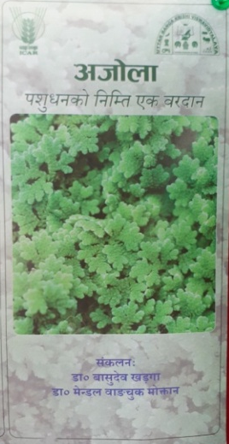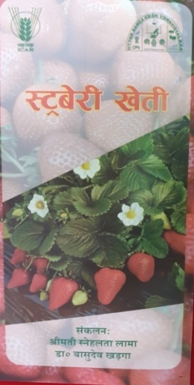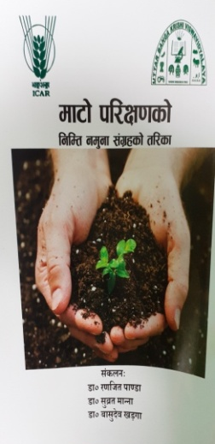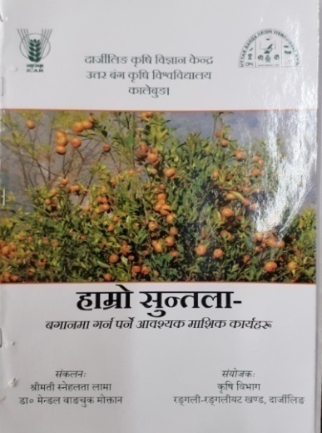

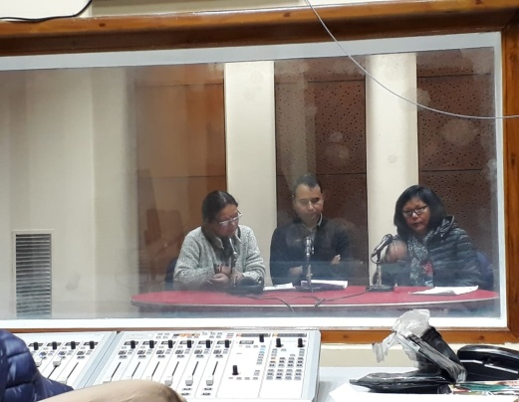

3.5 a. Production and supply of Technological products

Village seed
Crop | Variety | Quantity of seed  (q) | Value  (Rs) | No. of farmers involved in village seed production | Number of farmers  to whom seed provided
 |  |  |  |  | SC | ST | Other | Total
Total

KVK farm

Crop | Variety | Quantity of seed  (q) | Value  (Rs) | Number of farmers  to whom seed provided
 |  |  |  | SC | ST | Other | Total
Maize | Kaveri | 120 kg. | 1440/- | 3 | 5 | 4 | 12
Turmeric | Paheli local | 90 kg. | 4500/- | 3 | 3 | 3 | 9
Ginger | Gorubathaney | 75 kg. | 3750/- | 4 | 4 | 4 | 12
Potato | Kanchan & Jalandhar | 900 kg. | 22500/- | 8 | 9 | 6 | 25
Grand Total |  |  |  | 18 | 21 | 17 | 58

Production of planting materials by the KVKs
Crop | Variety | No. of planting materials | Value  (Rs) | Number of farmers  to whom planting material provided
 |  |  |  | SC | ST | Other | Total
Vegetable seedlings
Cauliflower | White Flash | 3200 | 3000 | 7 | 6 | 4 | 17
Cabbage
Tomato | Jessica | 3200 | 3200 | 6 | 9 | 7 | 22
Brinjal
Chilli
Onion
Others
Fruits
Mango
Guava
Lime
Papaya
Banana
Others (Strawberry) | Festival | 2200 | 4400 | 10 | 9 | 6 | 25
Ornamental plants
Medicinal and Aromatic
Plantation
Spices
Turmeric
Tuber
Elephant yams
Fodder crop saplings
Forest Species
Others, pl.specify (Broom Stick) | Local | 4000 | 12000 | 15 | 12 | 8 | 35
Total |  |  |  | 38 | 36 | 25 | 99

Production of Bio- product by KVKs

Bio -product | Name of the Bio -product | Quantity (no.) |  | Quantity (Kg.) |  | Value (Rs.) | Number of farmers | Quantity (no.) | Quantity (Kg.) | Value (Rs.) | Number of farmers | Quantity (no.) | Quantity (Kg.) | Value (Rs.) | Number of farmers | Quantity (no.) | Quantity (Kg.) | Value (Rs.) | Number of farmers
Bio- fertilisers |  | A&N Islands |  |  |  |  |  | Odisha |  |  |  | West bengal |  |  |  | Total
Non Symbiotic Azotobacter
Vermi compost |  |  |  |  |  |  |  |  |  |  |  | 2 | Started
Azolla |  |  |  |  |  |  |  |  |  |  |  | 1 | Started
Earth worms
Compost
Worms
Blue green algae
NADEP
Azatobactor
Azospirillum
PSB
Rhizobium
Azolla culture
Total
Bio- pestisides
Neem extract
Tobacco extract
Trichoder- maviride
Panchagavya
Trichoderma
Total
Worms
Eudriluseuniae
Total
Earth worm
Eiseniafoetida
Earth worm
Total
Bio- fungicides
Trichoder maviridae
Total
others
Vermiculture
Mushroom-spawn
Cuelure
Mineral mixture
Cow dung(dry)
Cow dung(wet)
Total
Grand Total

Production of livestock materials
Particulars of Live stock | Name of the breed | Number | Value (Rs.) | No. of Farmers benefitted
 |  |  |  | SC | ST | Other | Total
Dairy animals
Cows
Buffaloes
Calves
Others (Pl. specify)
Small ruminants
Sheep
Goat
Other, please specify
Poultry
Broilers
Layers
Duals (broiler and layer)
Japanese Quail
Turkey
Emu
Ducks
Others (Pl. specify)
Piggery
Piglet
Hog
Others (Pl. specify)
Fisheries
Indian carp
Exotic carp
Mixed carp
Fish fingerlings
Spawn
Others (Pl. specify)
Grand Total

3.5. b. Seed Hub Programme - “Creation of Seed Hubs for Increasing Indigenous Production of Pulses in India”
i) Name of Seed Hub Centre:

Name of Nodal Officer :
Address :
e-mail :
Phone No. :
Mobile :

ii) Details of Quality Seed Production
Season | Crop | Variety | Production (q)
 |  |  | Target | Area sown (ha) | Production | Category of Seed  (F/S, C/S)
Kharif 2020
Rabi 2020-21
Summer/Spring 2021

iii) Financial Progress
Fund received  (2016-17, 2017-18 2018-19 and2019-20) | Expenditure (Rs. in lakhs) |  | Unspent balance  (Rs. in lakhs) | Remarks
 | Infrastructure | Revolving fund
2016-17
2017-18
2018-19
2019-20

iv) Infrastructure Development

Item | Progress
Seed processing unit
Seed storage structure

3.6. (A) Literature Developed/ Published (with full title, author & reference)

Item | Title | Author’s name | Number | Circulation
Research paper
Seminar/conference/ symposia papers | Webinar |  | 16
Books
Bulletins
News letter | KVK Newsletter |  | 4
Popular Articles
Book Chapter
Extension Pamphlets/ literature | Smart Irrigation System  Smart Poultry Unit |  | 2 | 200
Technical reports | Monthly report, Newsletter, Annual Report etc |  | 15
Electronic Publication (CD/DVD etc)
TOTAL

N.B.: Please enclose a copy of each. In case of literature prepared in local language please indicate the title in English

(B) Details of HRD programmes undergone by KVK personnel:

Sl. No. | Name of programme | Name of course | Name of KVK personnel and designation | Date and Duration | Organized by

3.7. Success stories/Case studies, if any (two or three pages write-up on 1-2 best case(s) with suitable action photographs)

Name of farmer
Address
Contact details (Phone, mobile, email Id)
Landholding (in ha.)
Name and description of the farm/ enterprise
Economic impact
Social impact
Environmental impact
Horizontal/ Vertical spread

3.8. Give details of innovative methodology or innovative technology of Transfer of Technology developed and used during the year

Sl. No. | Name/ Title of the technology | Name/ Details of the Innovator(s) | Brief details of the Innovative Technology

3.9. a. Give details of indigenous technology practiced by the farmers in the KVK operational area which can be considered for technology development (in detail with suitable photographs)

Sl. No. | Crop / Enterprise | ITK Practiced | Purpose of ITK

b. Give details of organic farming practiced by the farmer

Sl. No. | Crop / Enterprise | Area (ha)/ No. covered | Production | No. of farmers involved | Market available (Y/N)

3.10. Indicate the specific training need analysis tools/methodology followed by KVKs

Sl. No. | Brief details of the tool/ methodology followed | Purpose for which the tool was followed

3.11. a. Details of equipment available in Soil and Water Testing Laboratory

Sl. No | Name of the Equipment | Qty.
1. | Spectrophotometer | 1
2. | Flame Photometer | 1
3. | PH Meter | 1
4. | Conductivity bridge | 1
5. | Physical balance | 1
6. | Chemical balance | 1
7. | Digestion unit | 1
8. | Kjeldhal Distillation set | 2
9. | Mechanical shaker | 1
10. | Refrigerator | 1
11. | Hot air oven | 1
12. | Hot plate | 1
13. | Grinder | 1
14. | Water distillation unit (double) | 1
15. | Chemical and Glass wares | 50
16. | Soxlet Apparatus (Big &Small) | 2
17. | Laboratory set up | 1
18. | Soil and plant sample processing and storage facility | 2
Total |  | 17

3.11.b. Details of samples analyzed so far :
Number of soil samples analyzed |  |  | No. of Farmers | No. of Villages | Amount realized  (in Rs.)
Through mini soil testing kit/labs | Through soil testing laboratory | Total
48 | 0 | 48 | 48 | 4 | 2880

3.11.c. Details on World Soil Day

Sl. No. | Activity | No. of Participants | No. of VIPs | Name (s) of VIP(s) | Number of Soil Health Cards distributed | No. of farmers benefitted
01 | World Soil Day | 25 | -- | -- | 25 | 25

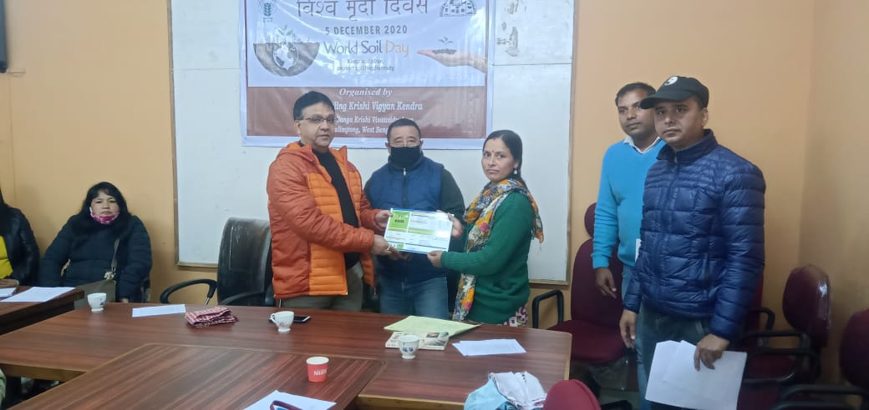
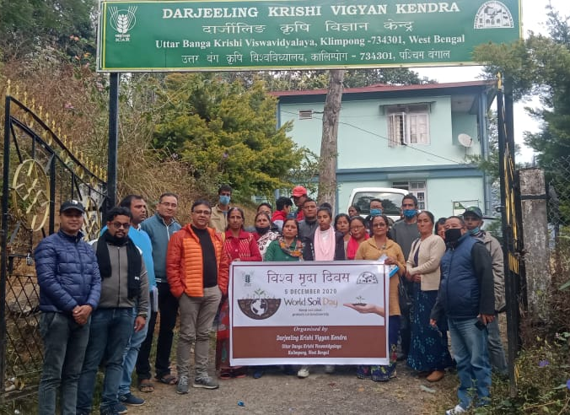

3.12. Activities of rain water harvesting structure and micro irrigation system

No of training programme | No of demonstrations | No of plant material produced | Visit by the farmers | Visit by the officials
-- | -- | -- | -- | --

3.13. Technology week celebration

Type of activities | No. of activities | Number of participants | Related crop/livestock technology
-- | -- | -- | --

3.14. RAWE/ FET programme - is KVK involved? (Y/N)

No of student trained | No of days stayed

ARS trainees trained | No of days stayed

3.15. List of VIP visitors (Minister/ MP/MLA/DM/VC/Zila Sabhadipati/Other Head of Organization/Foreigners)

Date | Name of the person | Purpose of visit

- IMPACT

  - Impact of KVK activities (Not to be restricted for reporting period).

Name of specific technology/skill transferred | No. of participants | % of adoption | Change in income (Rs.)
 |  |  | Before (Rs./Unit) | After (Rs./Unit)
NB: Should be based on actual study, questionnaire/group discussion etc. with ex-participants

4.2. Cases of large scale adoption
(Please furnish detailed information for each case)
Horizontal spread of technologies
Technology | Horizontal spread

Give information in the same format as in case studies

4.3. Details of impact analysis of KVK activities carried out during the reporting period

Sl. No. | Brief details of technology | Impact of the technology in subjective terms | Impact of the technology in objective terms

4.4. Details of innovations recorded by the KVK

Thematic area
Name of the Innovation
Details of Innovator
Back ground of innovation
Technology details
Practical utility of innovation

4.5. Details of entrepreneurship development

Entrepreneurship development
Name of the enterprise | Himalay Atma Nirbhar Udyog, Kalimpong
Name & complete address of the entrepreneur | Mrs. Asha Thapa, (Devi Dhara SHG)  Ramitay, Lower Dungra Busty,  Below Livestock Farm,  BPO Rousay, Kalimpong
Role of KVK with quantitative data support: | Training and packaging and processing materials (100 no.s) .  Assessment of product for quality checking
Timeline of the entrepreneurship development | 6 Months
Technical Components of the Enterprise | Food preservation and value addition
Status of entrepreneur before and after the enterprise | It was started with Rs. 2000/- per month turnover. Presently its monthly turnover has reached in Rs. 10,000/- per month
Present working condition of enterprise in terms of raw materials availability, labour availability, consumer preference, marketing the product etc. ( Economic viability of the enterprise): | Since the raw materials are seasonal, activity is in moderate working condition.
Horizontal spread of enterprise | 4 female worker
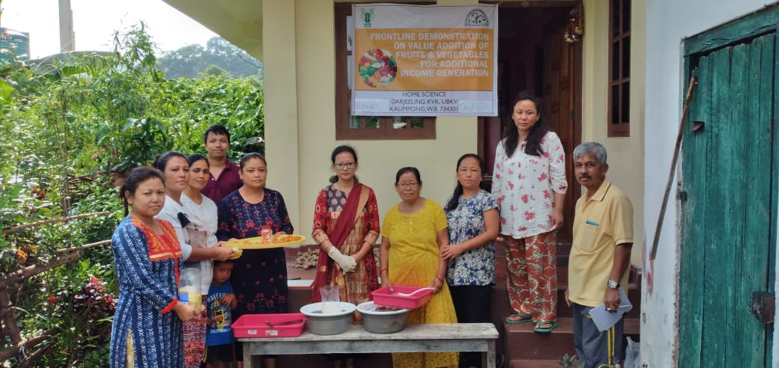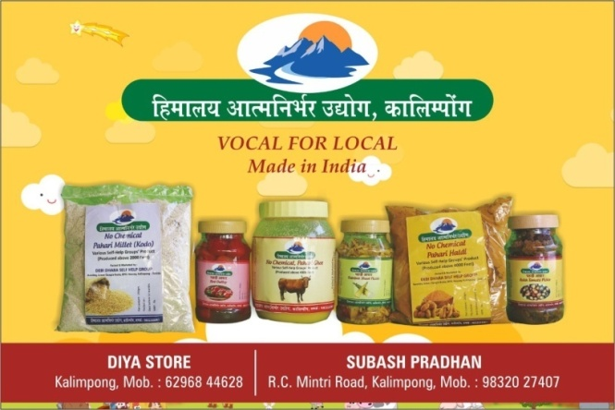

4.6. Any other initiative taken by the KVK

5. LINKAGES

5.1. Functional linkage with different organizations

Name of organization | Nature of linkage
State Agriculture Dept., Govt. of West Bengal | Training
Regional Research Station (Hill Zone), Uttar Banga Krishi Viswavidyalaya, Kalimpong
Dept. of Animal Recourses Development, Govt. of West Bengal
Sasastra Seema Bal (SSB), Siliguri Frontier
Regional Station, Indian Agricultural Research Institute, Kalimpong
Regional Research Station (Hill Zone), Uttar Banga Krishi Viswavidyalaya, Kalimpong | Demonstration
State Agriculture Dept., Govt. of West Bengal
Regional Research Station (Hill Zone), Uttar Banga Krishi Viswavidyalaya, Kalimpong | Joint Survey
State Agriculture Dept., Govt. of West Bengal
State Agriculture Dept., Govt. of West Bengal | Technical Support
Regional Research Station (Hill Zone), Uttar Banga Krishi Viswavidyalaya, Kalimpong
Dept. of Animal Recourses Development, Govt. of West Bengal
Spices Board, Kalimpong, Govt. of India
Regional Station, Indian Agricultural Research Institute, Kalimpong
5.2. List of special programmes undertaken during 2020-21 by the KVK, which have been financed by ATMA/ Central Govt/ State Govt./NABARD/NHM/NFDB/Other Agencies (information of previous years should not be provided)

a) Programmes for infrastructure development : NIL

Name of the programme/ scheme | Purpose of programme | Date/ Month of initiation | Funding agency | Amount (Rs.)

(b) Programme for other activities (training, FLD,OFT, Mela, Exhibition etc.)

Name of the programme/ scheme | Purpose of programme | Date/ Month of initiation | Funding agency | Amount (Rs.)
Mulberry based sericulture programme | Research based | 2020-21 | ATMA | 1.5
Varietal assessment Dragon Fruit | Research based | 2020-21 | ATMA | 2.0
Varietal assessment of apple | Research based | 2020-21 | ATMA | 1.5
Smart Poultry Unit | Research & Demonstration | 2020-21 | NABARD | 3.5
Smart Irrigation System | Research & Demonstration | 2020-21 | NABARD | 3.0
DAESI | Diploma Course | 2020-21 | MANAGE | 4.0

- PERFORMANCE OF INFRASTRUCTURE IN KVK

6.1. Performance of demonstration units (other than instructional farm)

Sl. No. | Name of demo Unit | Year of estt. | Area(Sq.mt) | Details of production |  |  | Amount (Rs.) |  | Remarks
 |  |  |  | Variety/breed | Produce | Qty. | Cost of inputs | Gross income
1 | Mushroom Unit | 2020-21 | 20 | Oyster | Fruit | 40 Kg | 1200 | 4000
2 | Azolla Unit | 2020-21 | 2 | Azolla | Fodder | 200 Kg | 1250 | 2000
3 | Bee Keeping | 2020-21 | 5 No.s | Indian bee | Honey | --
4 | Poultry | 2020-21 | 4 | Kadaknath | Meat | --
Total

6.2. Performance of Instructional Farm (Crops)
Name  Of the crop | Date of sowing | Date of harvest | Area (ha) | Details of production |  |  | Amount (Rs.) |  | Remarks
 |  |  |  | Variety | Type of Produce | Qty.(q) | Cost of inputs | Gross income
Seeds
Maize | May 2020 | Aug-Sep 2020 | 900 sq m | Kaveri | Seed | 120 kg. | 1050 | 1440/-
Turmeric | Mar-Apr 2020 | Jan-Feb 21 |  | Paheli local | Seed | 90 kg. | 3600 | 4500/-
Ginger | Mar-Apr 2020 | Jan-Feb 21 |  | Gorubathaney | Seed | 75 kg. | 2200 | 3750/-
Potato | Oct-Nov 2020 | Mar-Apr 21 |  | Kanchan & Jalandhar | Seed | 900 kg. | 16000 | 22500/-
Seedlings
Tomato | Jan-Feb 2020 |  | 900 sq ft | Jessica | Seedling | 3200 | 2050 | 3200
Cauliflower | Sept –Oct 2020 |  |  | White Flash | Seedling | 3000 | 1900 | 3000
Strawberry |  | June-Jul 20 |  | Festival | Seedling | 2200 | 3150 | 4400
Broomstick |  | June-Jul 20 |  | Local | Seedling | 4000 | 9300 | 12000

Seeds Poduction : Maize (Kaveri) Seedling Production : Tomato (Jessica)
Turmeric (Paheli) Cauliflower (white flash)
Potato (Kanchan & Jalandhar) Strawberry (Festival)

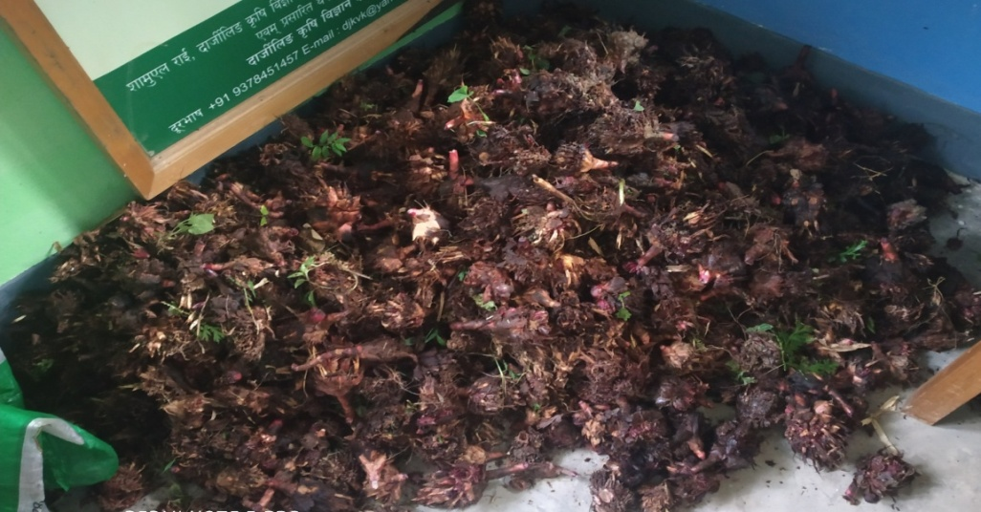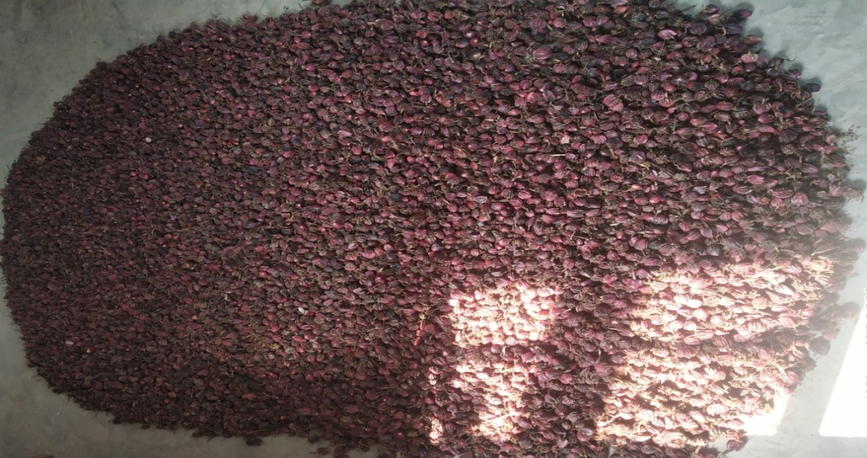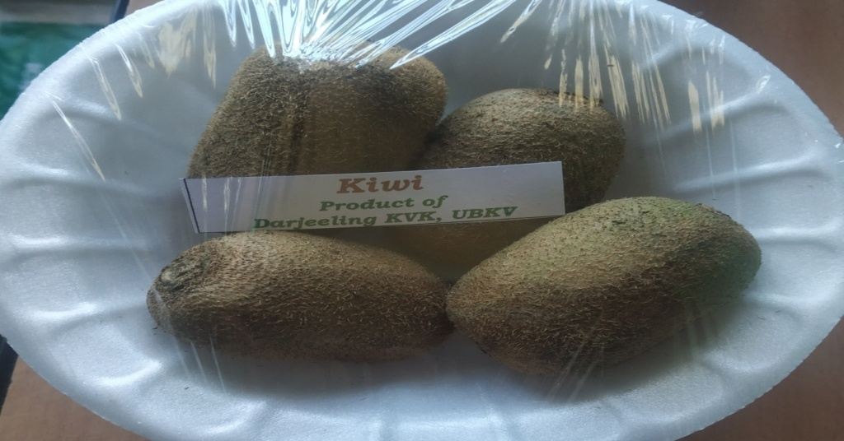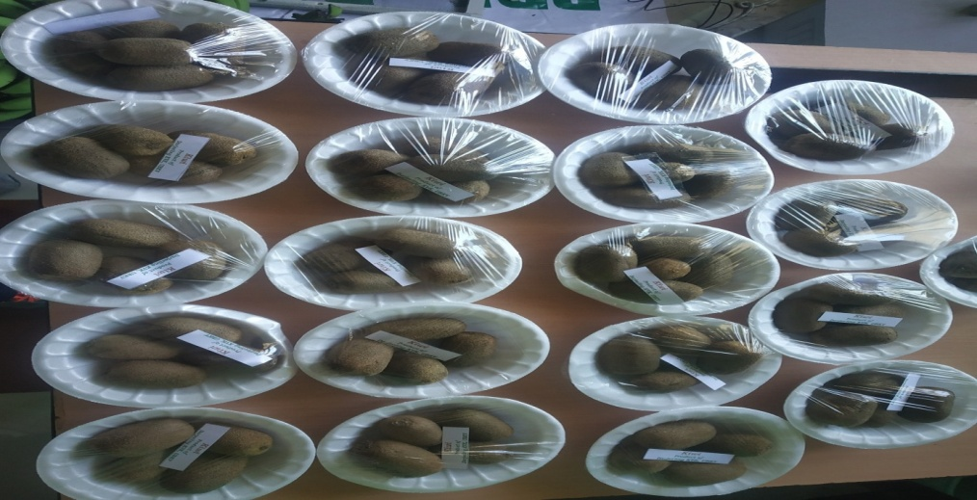

6.3 Performance of Production Units (bio-agents / bio pesticides/ bio fertilizers etc.,)

Sl. No. | Name of the Product | Qty. (Kg) | Amount (Rs.) |  | Remarks
 |  |  | Cost of inputs | Gross income
1. | Mushroom | 37.5 Kg | 1125 | 3750
2 | Vermi-compost | 150 Kg | 300 | 1500
3 | Azolla | 200 Kg | 1250 | 2000

  - Performance of instructional farm (livestock and fisheries production)

Sl.  No | Name  of the animal / bird / aquatics | Details of production |  |  | Amount (Rs.) |  | Remarks
 |  | Breed | Type of Produce | Qty. | Cost of inputs | Gross income
1.
2.
3.

6.5 Utilization of hostel facilities

Accommodation available (No. of beds)

Months | No. of trainees stayed | Trainee days  (days stayed) | Reason for short fall (if any)
Total :
(For whole of the year)

  - Utilization of staff quarters

Whether staff quarters has been completed:
No. of staff quarters: 6
Date of completion: 2008
Occupancy details: 2 vacant

Months | Q I | QII | Q III | QIV | Q V | QVI

- FINANCIAL PERFORMANCE

7.1. Details of KVK Bank accounts

Bank account | Name of the bank | Location | Account Number
Darjeeling KVK | SBI | Kalimpong | 11283931150
Darjeeling KVK | Bank of India | Kalimpong | 429310110000033

  - Utilization of funds under CFLD on Oilseed (Rs. In Lakhs)

Item | Released by ICAR |  | Expenditure |  | Unspent balance as on -
 | Kharif | Rabi | Kharif | Rabi
-- | -- | --- | -- | -- | --

7.3. Utilization of funds under CFLD on Pulses (Rs. In Lakhs)
Item | Released by ICAR |  | Expenditure |  | Unspent balance as on 1st January 2021
 | Kharif | Rabi | Kharif | Rabi
Field Pea |  | 90,000/- |  | 89,678/- | 322/-

  - Utilization of KVK funds during the year 2020-21 (Not audited)

Sl. No. | Particulars |  | Sanctioned | Released | Expenditure
A. Recurring Contingencies
1 | Pay & Allowances |  | 1,23,00,000 | 1,23,00,000 | 1,22,90,836
2 | Traveling allowances |  | 1,30,000 | 1,30,000 | 1,29,323
3 | Contingencies
A | Stationary, telephone, postage and other expenditure on office running, publication of newsletter |  | 1,40,000 | 1,40,000 | 1,39,452
B | Training of farmer | 1,05,000 |  | 1,05,000 | 1,04,574
C | SCSP |  | 12,00,000 | 12,00,000 | 5,97,452
D | Front line demonstration | 53,000 |  | 53,000 | 51,336
E | On farm testing (On need based, location specific and newly generated information in the major production system of the area) |  | 52,000 | 52,000 | 51,885
F | HRD |  | 30,000 | 30,000 | 29,966
G | Swachhta Expenditure
H
I
J
TOTAL (A) |  |  | 1,40,10,000 | 1,40,10,000 | 1,33,94,824
B. Non-Recurring Contingencies
1 | Library |  | 10,000 | 10,000 | --
2
3
4
TOTAL (B) |  |  | 10,000 | 10,000 | --
C. REVOLVING FUND |  |  | -- | -- | --
GRAND TOTAL (A+B+C) |  |  | 1,40,20,000 | 1,40,20,000 | 1,33,94,824

7.5. Status of revolving fund (Rs. in lakh) for last three years

Year | Opening balance as on 1st April | Income during the year | Expenditure during the year | Net balance in hand as on 1st April of each year (Kind + cash)
2015-16 | 4,16,841 | 17,24,056 | 16,37,151 | 5,03,745
2016-17 | 5,03,745 | 2,11,967 | 2,78,520 | 4,37,192
2017-18 | 4,37,192 | 11,96,326 | 10,65,400 | 5,68,118
2018-19 | 5,68,118 | 19,53,452 | 19,44,552 | 5,77,018
2019-20 | 5,77,018 | 2,21,440/- | 6,21,788 | 1,76,670

  - (i) Number of SHGs formed by KVKs : NIL

(ii) Association of KVKs with SHGs formed by other organizations indicating the area of SHG activities : NIL

(iii) Details of marketing channels created for the SHGs : NIL

  - Joint activity carried out with line departments and ATMA : NIL

Name of activity | Number of activity | Season | With line department | With ATMA | With both

8. Other information

8.1. Prevalent diseases in Crops : NIL

Name of the disease | Crop | Date of outbreak | Area affected (in ha) | % Commodity loss | Preventive measures taken for area (in ha)

8.2. Prevalent diseases in Livestock/Fishery : NIL

Name of the disease | Species affected | Date of outbreak | Number of death/ Morbidity rate (%) | Number of animals vaccinated | Preventive measures taken in pond (in ha)

9.1. Nehru Yuva Kendra (NYK) Training : NIL

Title of the training programme | Period |  | No. of the participant |  | Amount of Fund Received (Rs)
 | From | To | M | F

9.2. mKisan Portal (National Farmers’ Portal/ SMS Portal) : NIL

Type of message | No. of messages | No. of farmers covered
Crop
Livestock
Fishery
Weather
Marketing
Awareness
Training information
Other
Total

9.3. KVK Portal and Mobile App

Sl. No. | Particulars | Description
1. | No. of visitors visited the portal | --
2. | No. of farmers registered in the portal | 406
3. | Mobile Apps developed by KVK | 1
4. | Name of the App | KVK online Agrimart
5. | Language of the App
6. | Meant for crop/ livestock/ fishery/ others | crop/ livestock
7. | No. of times downloaded | --

9.4. a. Observation of Swachh Bharat Programme

Date/ Duration of Observation | Activities undertaken

b. Details of Swachhta activities with expenditure

Activities | Number | Expenditure (in Rs.)
- Digitization of office records/ e-office
- Basic maintenance
- Sanitation and SBM
- Cleaning and beautification of surrounding areas
- Vermicomposting/
Composting of biodegradable waste management & other activities on generate of wealth for waste
- Used water for agriculture/ horticulture application
- Swachhta Awareness at local level
- Swachhta Workshops
- Swachhta Pledge
- Display and Banner
- Foster healthy competition
- Involvement of print and electronic media
- Involving the farmers, farm women and village youth in the adopted villages (no of adopted village)
- No of Staff members involved in the activities
- No of VIP/VVIPs involved in the activities
16. Any other specific activity (in details)
Total

9.5. Observation of National Science day

Date of Observation | Activities undertaken

9.6. Programme with Seema Suraksha Bal/ BSF
Title of Programme | Date | No. of participants

9.7. Agriculture Knowledge in rural school

Name and address of school | Date of visit to school | Areas covered | Teaching aids used
Give good quality 1-2 photograph(s)

9.8. Details of ‘Pre-Rabi Campaign’ Programme

Date of programme | No. of Union Ministers attended the programme | No. of Hon’ble MPs (Loksabha/ Rajyasabha) participated | No. of State Govt. Ministers | Participants (No.) |  |  |  |  |  |  | Coverage by Door Darshan (Yes/No) | Coverage by other channels (Number)
 |  |  |  | MLAs Attended the programme | Chairman ZilaPanchayat | Distt. Collector/ DM | Bank Officials | Farmers | Govt. Officials, PRI members etc. | Total

9.9. Details of Swachhta Hi Sewa programme organized

Sl.  No. | Activity | No. of villages Involved | No. of Participants | No. of VIPs | Name (s) of VIP(s)

9.10. Details of Mahila Kisan Divas programme organized

Sl.  No. | Activity | No. of villages Involved | No. of Participants | No. of VIPs | Name (s) of VIP(s)

9.11. No. of Progressive/ Innovative/ Lead farmer identified (category wise)

Sl.  No. | Name of Farmer | Address of the farmer with contact no. | Innovation/ Leading in enterprise

9.12. Revenue generation
Sl.No. | Name of Head | Income(Rs.) | Sponsoring agency
1.

9.13. Resource Generation:
Sl. No. | Name of the programme | Purpose of the programme | Sources of fund | Amount  (Rs. lakhs) | Infrastructure created

9.14. Performance of Automatic Weather Station in KVK

Date of establishment | Source of funding i.e. IMD/ICAR/Others (pl. specify) | Present status of functioning

9.15. Contingent crop planning

Name of the state | Name of district/KVK | Thematic area | Number of programmes organized | Number of Farmers contacted | A brief about contingent plan executed by the KVK

10. Report on Cereal Systems Initiative for South Asia (CSISA)

- Year:
- Introduction / General Information:

 | Title | Objective | Treatment details | Date of sowing | Replication | Result with photographs
Experiment 1
Experiment 2
Experiment 3
Others (If any)

11. Details of TSP

- Achievements of physical output under TSP during 2017-18

Programmes | Physical achievements
Asset creation (Number; Sprayer, ridge maker, pump set, weeder etc.)
On-farm trials (Number)
Frontline demonstrations (Number)
Farmers training (in lakh)
Extension personnel training (in lakh)
Participants in extension activities (in lakh)
Seed production (in tonnes)
Planting material production (in lakh)
Livestock strains and fingerlings production (in lakh)
Soil, water, plant, manures samples testing (in lakh)
Provision of mobile agro – advisory to farmers (in lakh)
No. of other programmes (Swachha Bharat Abhiyaan, Agriculture knowledge in rural school, Planting material distribution, Vaccination camp etc.)

- Fund received under TSP in 2020-21 (Rs. In lakh):

- (i) Achievements of physical outcome under TSP during 2020-21

Sl. No. | Description | Unit | Achievements
1 | Change in family income | %
2 | Change in family consumption level | %
3 | Change in availability of agricultural implements/ tools etc. | No. per household

(ii) Table:

Sl.  No. | Description | Unit | Achievements
1 | Number of Technologies Identified after Assessment | Number
2 | Upgraded Skills and Knowledge of farmers | Number
3 | Oriented extension personnel in frontier areas of agricultural technology | Number
4 | Increased availability of quality seed | Quintal
5 | Increased availability of quality Planting material | Number
6 | Increased availability of live-stock strains and fingerlings | Number
7 | Testing of Soil & water samples for balance fertilizer use | Number

2020-21
Name of KVK | Year since ARYA is initiated in the KVK (specify year) | No. of Training programs | No. of rural youth trained |  | No. of youth established units |  | No. of entrepreneurial units established
 |  |  | M | F | M | F

- Location and Beneficiary Details during 2020-21

District | Sub-district | No. of Village covered | Name of village(s)  covered | ST population benefitted  (No.)
 |  |  |  | M | F | T

12. Schedule caste Output & Outcome achievements

Sl.  No. | Indicator/Activities | Unit of Indicator | Achievements
1 | Farmers, farm women trained by KVKs | Number
2 | Extension personnel trained by KVKs | Number
3 | On-farm trials conducted by KVKs | Number
4 | Frontline demonstrations conducted by KVKs | Number
5 | Quantity of seeds produced | Quintal
6 | Planting materials Produced | Number
7 | Livestock strains and fingerlings produced | Number
8 | Soil & water samples tested | Number
13. Information pertaining to ARYA Project

14. Progress report of NICRA KVK (Technology Demonstration component) during the period
(Applicable for KVKs identified under NICRA)

Natural Resource Management
Name of intervention undertaken | Numbers under taken | No of units | Area (ha) | No of farmers covered / benefitted |  |  |  |  |  |  |  |  |  | Remarks
 |  |  |  | SC |  | ST |  |  | Other |  | Total
 |  |  |  | M | F |  | M | F | M | F | M | F | T

Crop Management

Name of intervention undertaken | Area (ha) | No of farmers covered / benefitted |  |  |  |  |  |  |  |  |  | Remarks
 |  | SC |  | ST |  |  | Other |  | Total
 |  | M | F |  | M | F | M | F | M | F | T
Livestock and fisheries

Name of intervention undertaken | Number of animals covered | No of units | Area (ha) | No of farmers covered / benefitted |  |  |  |  |  |  |  |  |  | Remarks
 |  |  |  | SC |  | ST |  |  | Other |  | Total
 |  |  |  | M | F |  | M | F | M | F | M | F | T

Institutional interventions

Name of intervention undertaken | No of units | Area (ha) | No of farmers covered / benefitted |  |  |  |  |  |  |  |  |  | Remarks
 |  |  | SC |  | ST |  |  | Other |  | Total
 |  |  | M | F |  | M | F | M | F | M | F | T

Capacity building
Thematic area | No of Courses | No of beneficiaries
 |  | SC | ST |  | Other |  |  | Total
 |  | M | F | M | F | M | F | M | F | T

Extension activities
Thematic area | No of activities | No of beneficiaries
 |  | SC | ST |  | Other |  |  | Total
 |  | M | F | M | F | M | F | M | F | T
Detailed report should be provided in the circulated Performa

15. Awards/Recognition received by the KVK

Sl. No. | Name of the Award | Year | Conferring Authority | Amount | Purpose

Award received by Farmers from the KVK district
Sl. No. | Name of the Award | Name of the Farmer | Year | Conferring Authority | Amount | Purpose

16. Any significant achievement of the KVK with facts and figures as well as quality photograph

17. Number of commodity based organizations/ farmers’ cooperative society/ FPO formed/ associated with during last one year (Details of the group/society may be indicated)

Sl. No. | Name of the organization/ Society | Trust Deed No.& date | Date of Trust Registration  Address | Proposed Activity | Commodity Identified | No. of Members | Financial position  (Rupees in lakh) | Success indicator

- Integrated Farming System (IFS)
Details of KVK Demo. Unit
Sl.  No. | Module details (Component-wise) | Area under IFS (ha) | Production (Commodity-wise) | Cost of production in Rs. (Component-wise) | Value realized in Rs. (Commodity-wise) | No. of farmer adopted practicing IFS | % Change in adoption during the year

19.Technologies for Doubling Farmers' Income

Sl. No. | Name of the Technology | Brief Details of Technology (3- 5 bullet points) | Net Return to the farmer (Rs.) per ha per year due to adoption of the technology | No. of farmers adopted the technology in the district | One high resolution ‘Photo’ in ‘jpg’ format for each technology
1
2

20.Report on Digital Farming Initiatives in Agriculture/ Digital Ag. Extension Service

 | Database prepared/ covered for |  | KVK level Committee |  | Various activity conducted for farmers
Phase | Total no. of villages | Total no. of farmers | Date of formation | Name of members
I (up-to 15.03.2018)
II (up-to 24.04.218)
Total

21.Information on Visit of VIPs to KVKs, if any : NIL

Date of Visit | Name of Hon’ble Minister | Name of Ministry | Salient points in his/ her observation  (2-3 bulleted points)

22.a) Information on ASCI Skill Development Training Programme, if undertaken during 2019-20 and 2020-21

Year | Name of the Job role | Name of the certified Trainer of KVK for the Job role | Date of start of training | Date of completion of training | No. of participants | Whether uploaded to SDMS Portal (Y/N) | Fund utilized for the training (Rs.)
2016-17
2017-18
2018-19
2019-20

b) Information on Skill Development Training Programme (Other than ASCI or less than 200 hrs., if any) if undertaken during 2020-21

Thematic area of training | Title of the training | Duration (in hrs.) | No. of participants |  |  |  |  |  |  |  |  | Fund utilized for the training (Rs.)
 |  |  | SC |  | ST |  | Other |  | Total
 |  |  | M | F | M | F | M | F | M | F | T

- Information on NARI Project (if applicable)

Name of Nodal Officer | No. of OFT on specified aspects | Title(s) of OFT | No. of FLD on specified aspects | No. of capacity development programme on specified aspects | Total no. of farm women/ girls involved in the project | Details of Issues related to gender mainstreaming addressed through the project

- Information on Krishi Kalyan Abhiyan Phase- I/ Phase-II/ Phase-III, if applicable

Krishi Kalyan Abhiyan- I and II
- Training

Name of programme | No. of programmes | No. of farmers benefitted |  |  |  |  |  |  |  |  | No. of officials attended the programme
 |  | SC |  | ST |  | Others |  | Total
 |  | M | F | M | F | M | F | M | F | T
KKA-I
KKA-II

- Distribution of seed/ planting materials/ input/ others

Name of programme | No. of Programme | Total quantity distributed |  |  |  | No. of farmers benefited |  |  |  |  |  |  |  |  |  | No. of other officials (except KVK)  attended the programme
 |  | Seed (q) | Planting material (lakh) | Input (kg) | Other (kg/ No.) | SC |  | ST |  | Others |  | Total
 |  |  |  |  |  | M | F | M | F | M | F | M | F | T
KKA-I
KKA-II

- Livestock and Fishery related activities

Name of programme | No. of Programme | Activities performed |  |  |  | No. of farmers benefited |  |  |  |  |  |  |  |  | No. of other officials (except KVK)  attended the programme
 |  | No. of animals vaccinated | No. of animals dewormed | Feed/ nutrient supplements provided (kg) | Any other (Distribution of animals/ birds/ fingerlings)  [No.] | SC |  | ST |  | Others |  | Total
 |  |  |  |  |  | M | F | M | F | M | F | M | F | T
KKA-I
KKA-II

- Other activities
Name of programme | Activities | No. of farmers benefited |  |  |  |  |  |  |  |  | No. of other officials (except KVK)  attended the programme
 |  | SC |  | ST |  | Others |  | Total
 |  | M | F | M | F | M | F | M | F | T
KKA-I | Soil Health Card Distributed
NADEP
Pit established
 | Farm implements distributed
 | Others, if any
KKA-II | Soil Health Card Distributed
NADEP
Pit established
 | Farm implements distributed
 | Others, if any

Krishi Kalyan Abhiyan- III
No. of villages covered | No. of animal inseminated | No. of farmers benefitted |  |  |  |  |  |  |  |  | Any other, if any  (pl. specify)
 |  | SC |  | ST |  | Others |  | Total
 |  | M | F | M | F | M | F | M | F | T

25. Nutri-garden
Sl.no. | Name of KVK | Established in KVK Campus | No. of nutria-garden established in the village | Major vegetables production

Please provide one or two good quality photographs

26. Any other programme organized by KVK, not covered above

Sl. No. | Name of the programme | Date of the programme | Venue | Purpose | No. of participants

27.Good quality action photographs of overall achievements of KVK during the year (best 10)

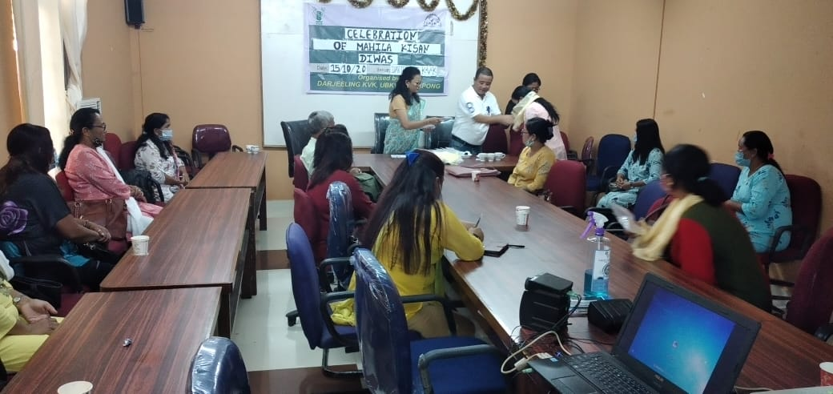

Celebration of Mahila Kisan Diwas 2021

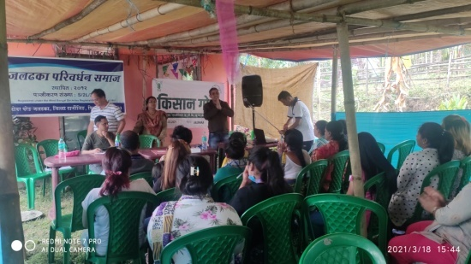
Kishan Gosthi Formation

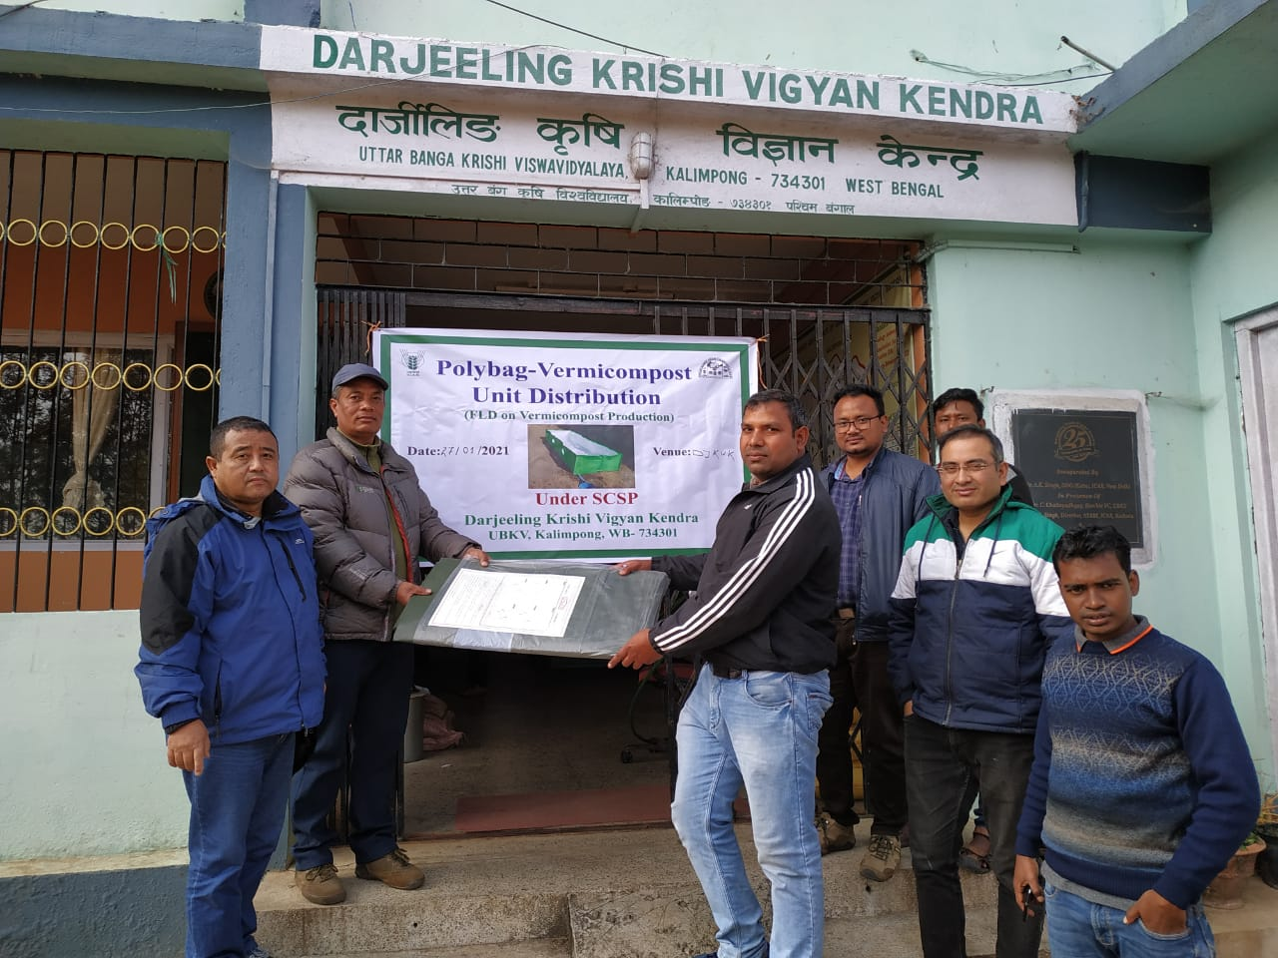
Distribution of Vermi Compost - Polybag

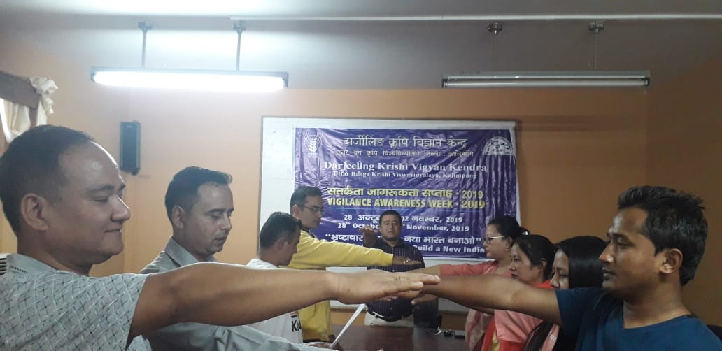
Constitution Day Celebration

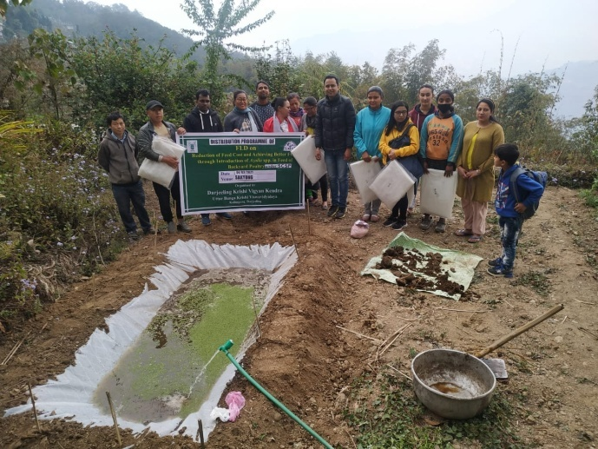
Establishment of Azolla Unit

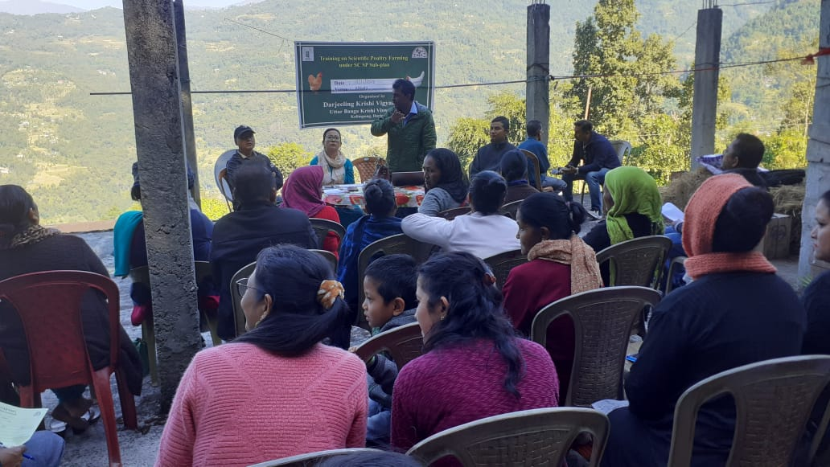

Off-campus Training Programme
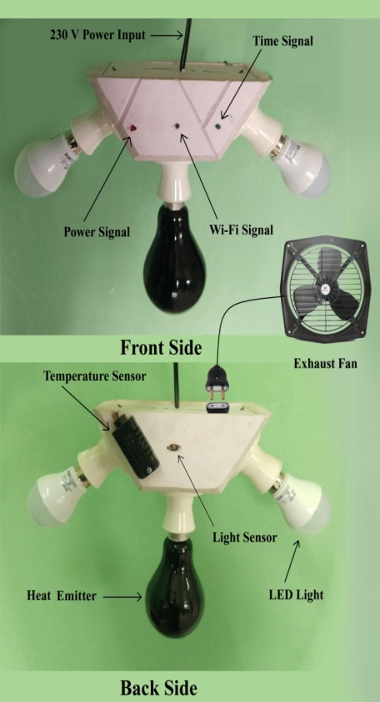

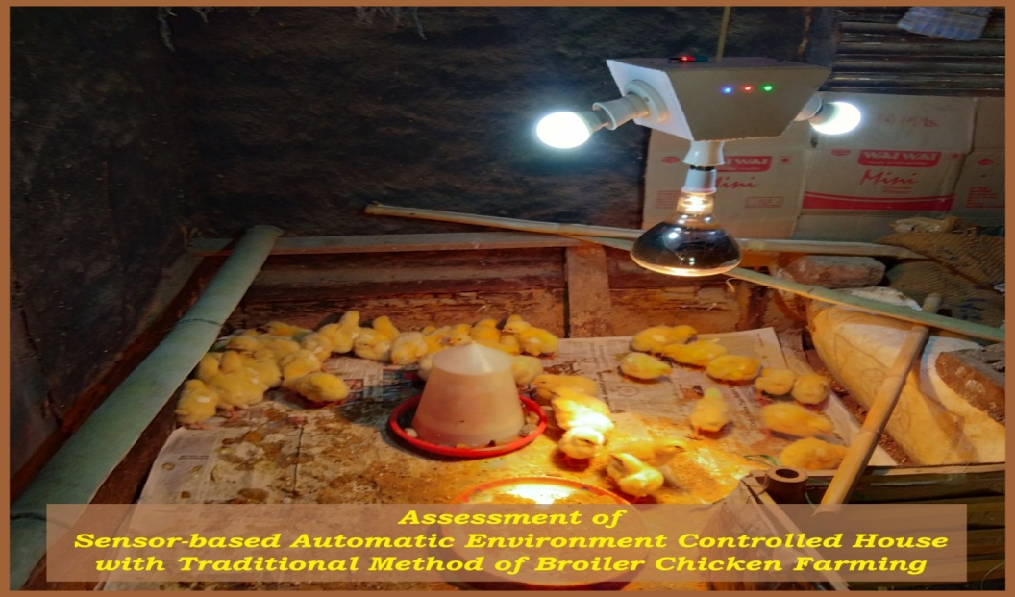

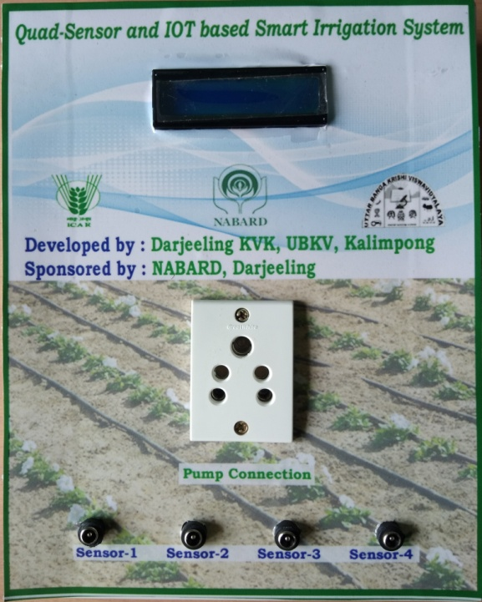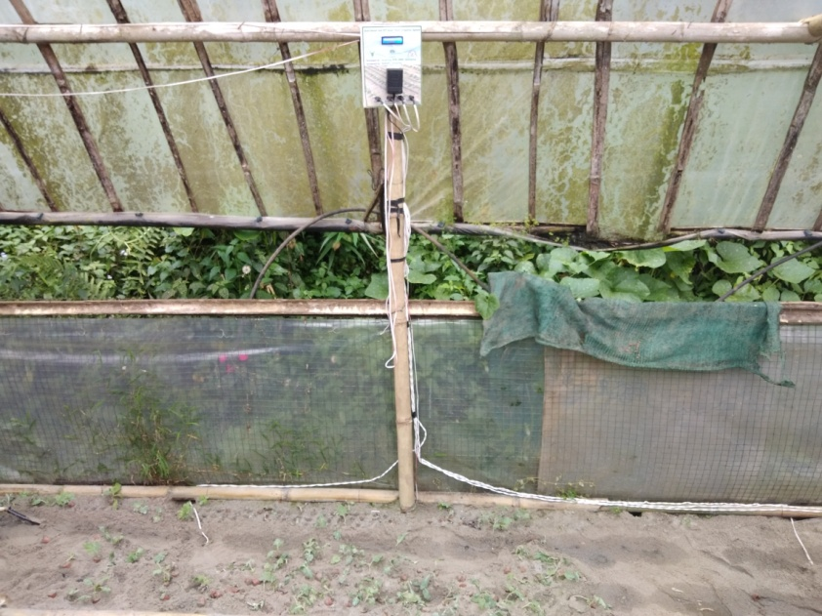

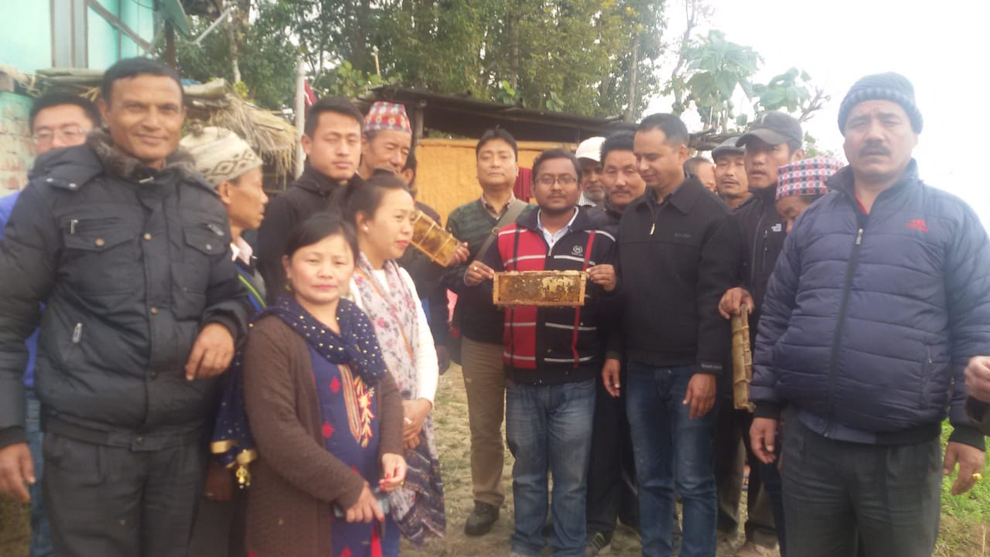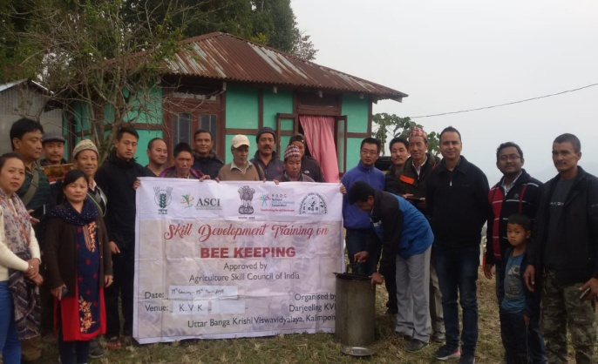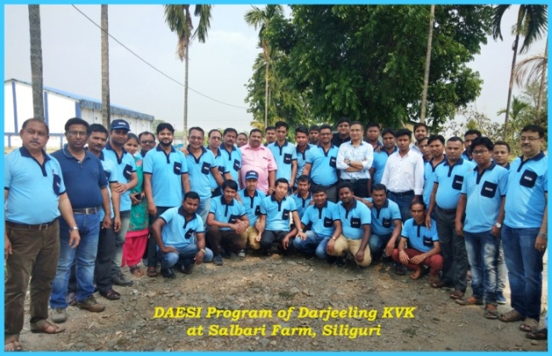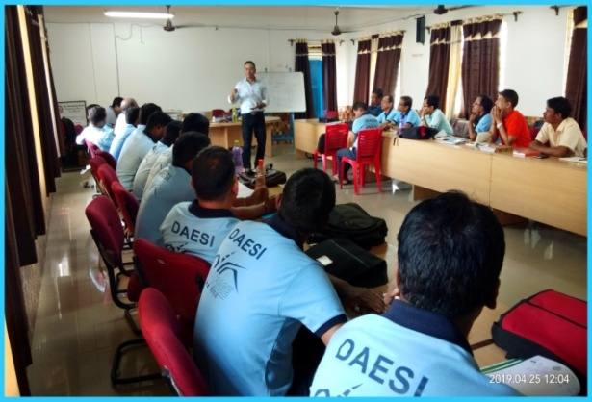

28. SC SP quarter-wise
Table-I: Schedule Caste Output & Outcome Achievement/Indicators for 2020-21 (QUARTER-WISE)
Physical Output 2020-2021
Sl. No. | Indicator/Activities | Unit of Indicator | Quarterly Breakup (Target) | Targets Achieved | No. of Beneficiaries | Outcome
1 | Farmers, farm women trained by KVKs | Number | Q-1  Q-2  Q-3  Q-4 :15 | Q-1  Q-2  Q-3  Q-4 : 16 | Q-1  Q-2  Q-3  Q-4 :459
2 | Extension personnel trained by KVKs | Number | Q-1  Q-2  Q-3  Q-4 : 6 | Q-1  Q-2  Q-3  Q-4 : 4 | Q-1  Q-2  Q-3  Q-4 : 139
3 | On-farm trials conducted by KVKs | Number | Q-1 :2  Q-2 :4  Q-3 :2  Q-4 :2 | Q-1 : 1  Q-2 : 1  Q-3 : 1  Q-4 : 2 | Q-1 3  Q-2 4  Q-3 : 3  Q-4: 8
4 | Frontline demonstrations conducted by KVKs | Number | Q-1 :2  Q-2 :3  Q-3 :4  Q-4 :3 | Q-1 : 1  Q-2 : 1  Q-3 :2  Q-4 : 3 | Q-1 : 12  Q-2 : 28  Q-3 : 32  Q-4 : 60
5 | Quantity of seeds produced | Quintal | Q-1  Q-2  Q-3  Q-4 | Q-1  Q-2  Q-3  Q-4 | Q-1  Q-2  Q-3  Q-4
6 | Planting materials Produced | Number | Q-1  Q-2  Q-3  Q-4 | Q-1  Q-2  Q-3  Q-4 | Q-1  Q-2  Q-3  Q-4
7 | Livestock strains and fingerlings produced | Number | Q-1  Q-2  Q-3  Q-4 | Q-1  Q-2  Q-3  Q-4 | Q-1  Q-2  Q-3  Q-4
8 | Soil & water samples tested | Number | Q-1  Q-2  Q-3  Q-4 | Q-1  Q-2  Q-3  Q-4 | Q-1  Q-2  Q-3  Q-4

